The Ones Who Mother Me

By
Angie Killian and Joelle Einerson
Sheet Music available on www.AngieKillian.com

It's the little things you do

And the big ways you care
It's the simple things you say

And the warmth that you share
It's the smile when you're near me
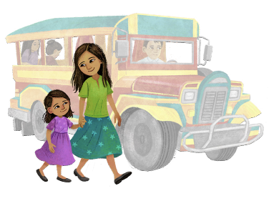
And kind ways you hear me
That show me you will be there

My world's a little brighter

Because of your love
I reach a little higher


When you lift me up

You show me
who I am

And what I can be
Oh, thank you, thank you

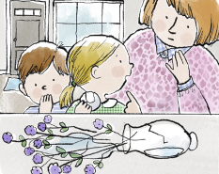
To the ones who mother me
It's the quiet ways you serve
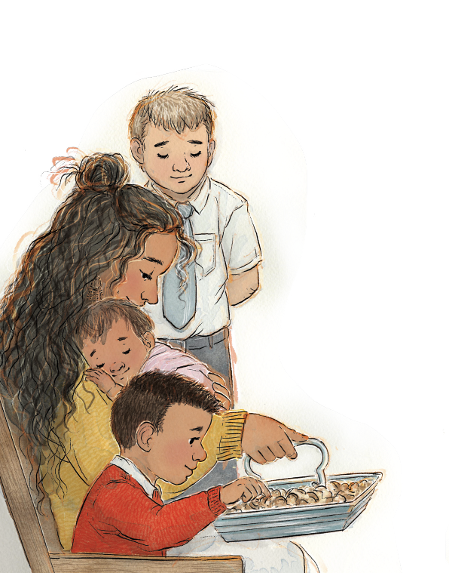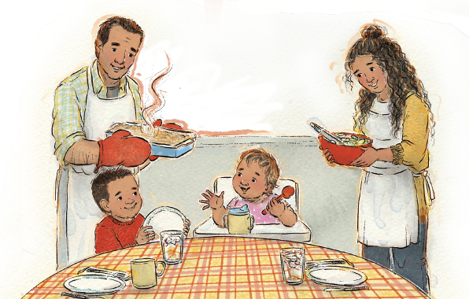
That teach me how to give
It's the courage in your heart
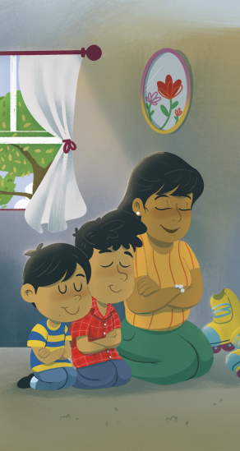
That shows me how to live
And your light is a reason

That I follow Jesus
You help me find
joy in Him
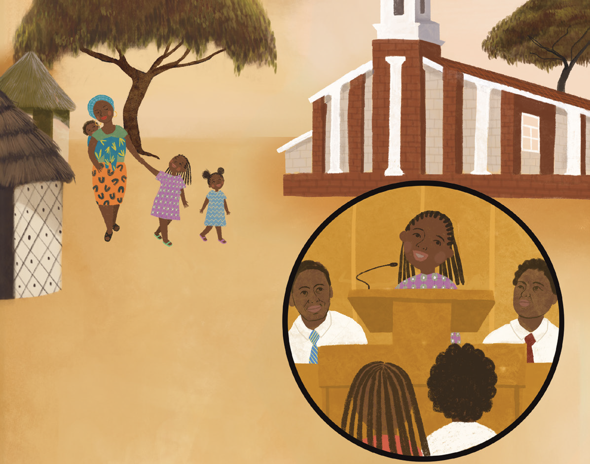

My world's a little brighter

Because of your love
I reach a little higher

When you lift me up
You show me who I am

And what I can be
Oh, thank you, thank you

To the ones who mother me
I have angels in Heaven
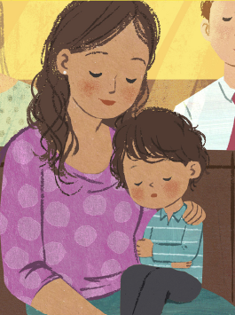
Who help and bless me, too
And I have a little Heaven on Earth

Because God
created you
My world's a little brighter

Because of your love
I reach a little higher
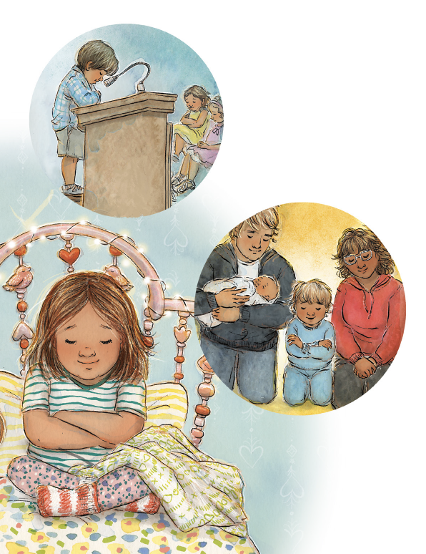
When you lift me up
You show me who I am

And what I can be
Oh, thank you, thank you

To the ones who mother me
To the ones who mother me
