Because He walked the path
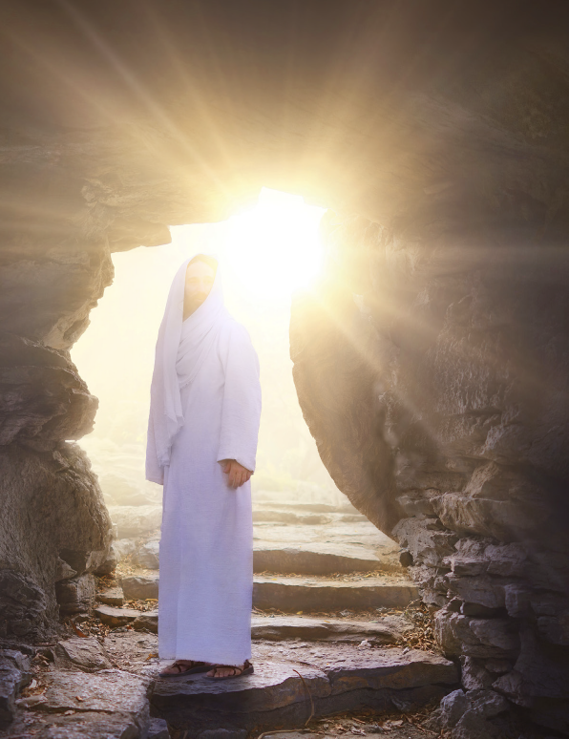
I know the way
Because He calmed the storm
I’m not afraid
Because He made the lame to walk
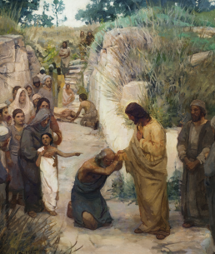
And caused the blind to see
And blessed the children one by one
I feel His love for me
And I will praise forever
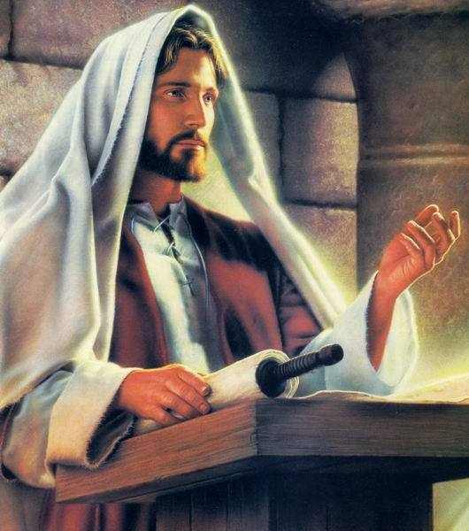
The Savior of the World
And I will sing together

With all the saints on earth
Because He gave to me everything
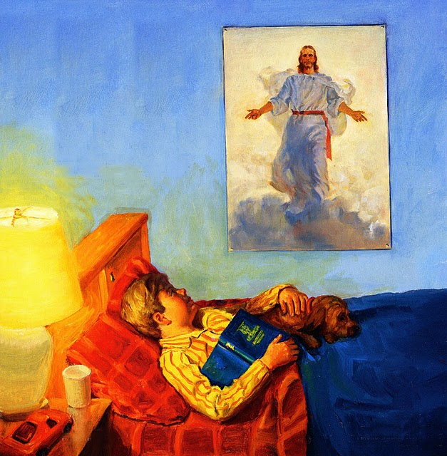
He had to give
I breathe, I see,
I hope, I love
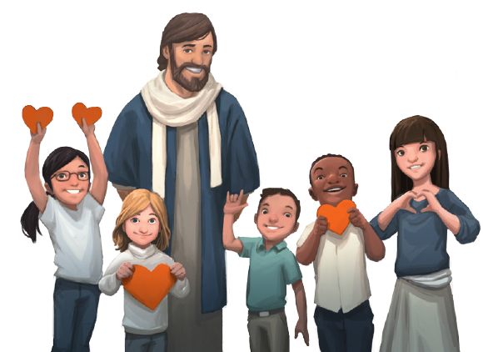
I live

Because He died for me
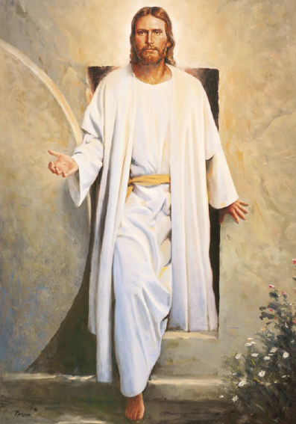
I’ll live again
Because He is my friend
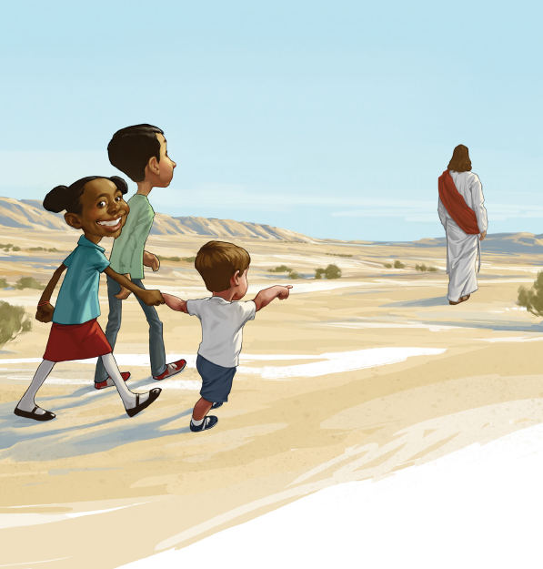
I’ll follow Him
Because He fills the world with light
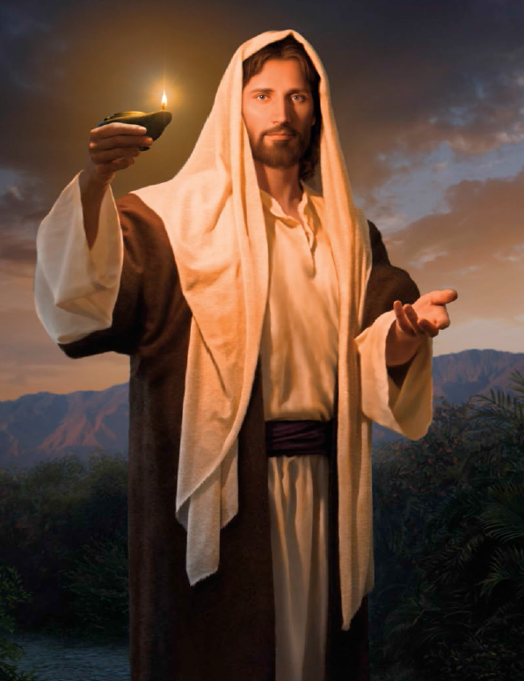
I’m filled with hope and peace
And when He comes to earth again
I’ll kneel before his feet

