We have been born as Nephi of old

To goodly parents who love the Lord
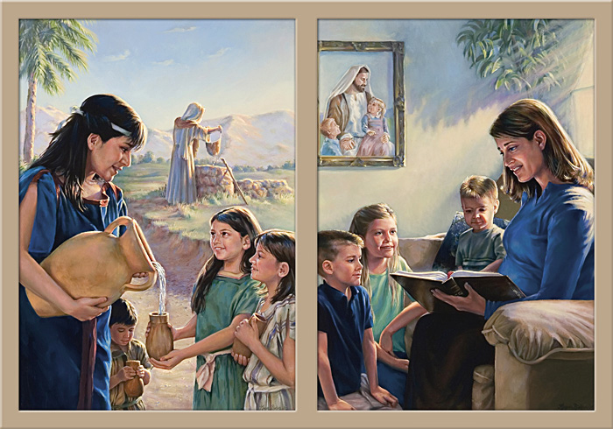

We have been taught, and we understand

That we must do as the Lord commands

We are as the army of Helaman 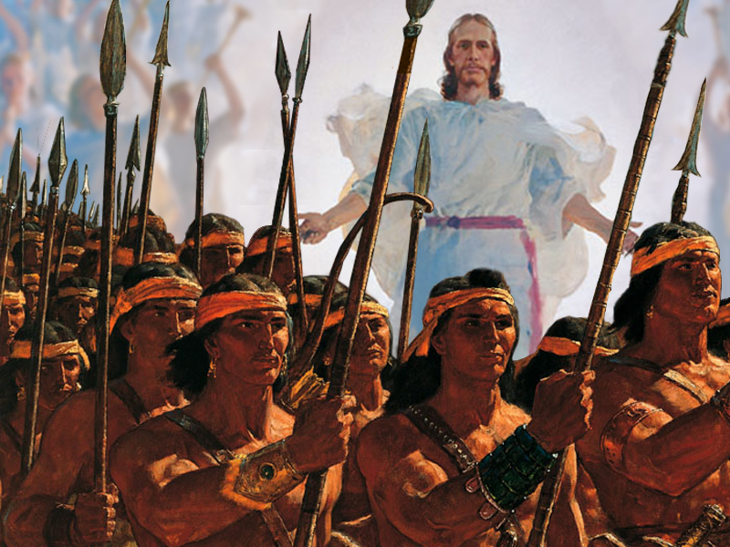
We have been taught in our youth
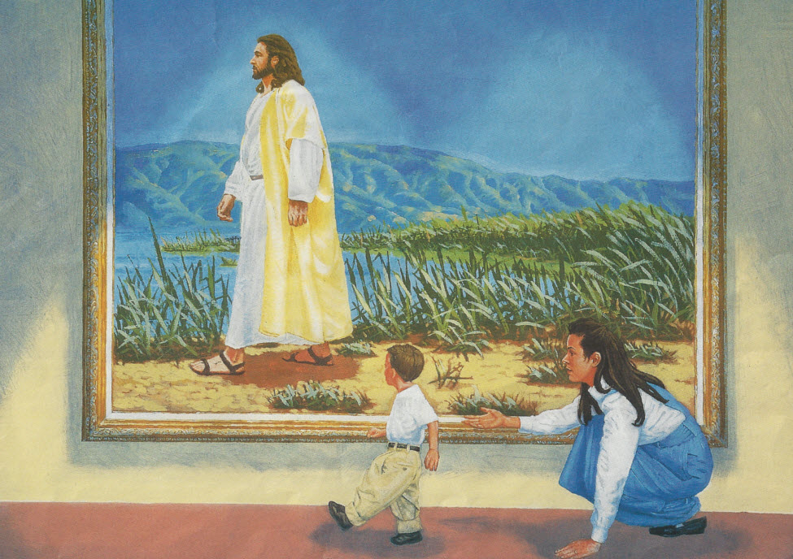

And we will be the Lord’s missionaries

To bring the world his truth

We have been saved for these latter days

To build the kingdom in righteous ways


We hear the words our pro phet declares
“Let each who’s worthy go forth and share.”
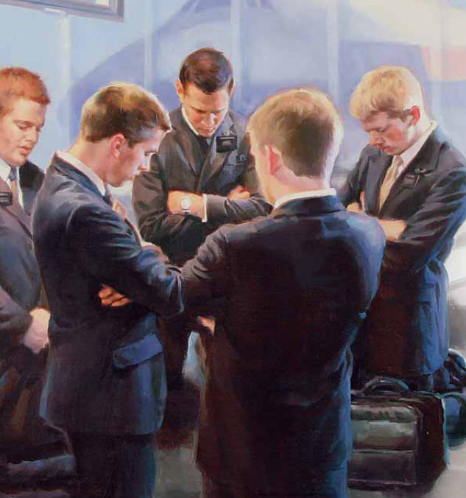
We are as the army of Helaman
We have been taught in our youth

And we will be the Lord’s missionaries
To bring the world his truth


We know his plan, and we will prepare
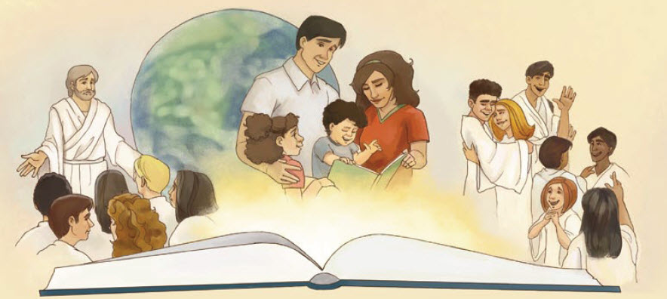

Increase our knowledge through study and prayer

Daily we’ll learn until we are called

To take the gospel to all the world


We are God's children
We have received
The blessings promised
To Abraham's seed
We'll share the gospel

This is our quest
'Til every nation on earth is blessed
We are as the army of Helaman
We have been taught in our youth

And we will be the Lord’s missionaries
To bring the world his truth

