Lullaby, lullaby, my little one
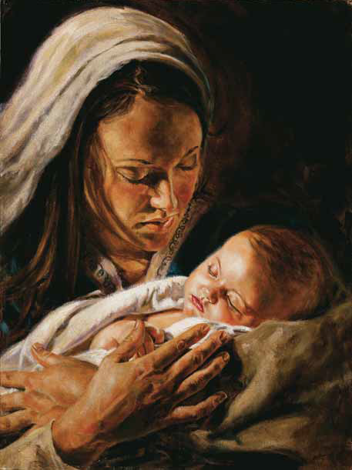
Lullaby my child so dear
Thy precious life has just begun
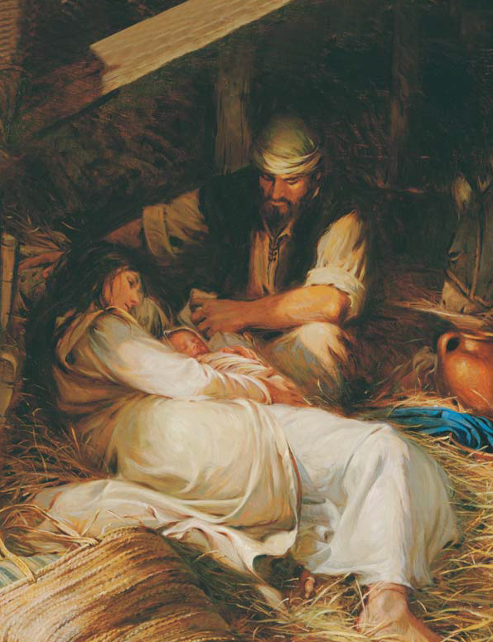
Thy mother holds thee near
While Joseph watches through the night
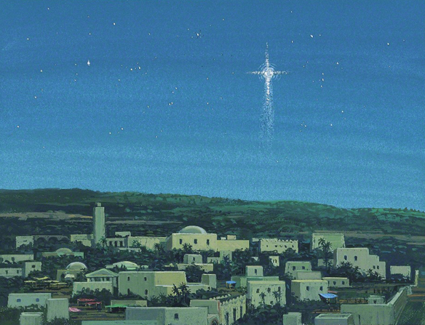
A star reflects thy radiant light
Lullaby, lullaby, my little one
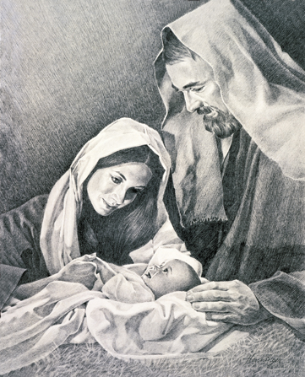
Lullaby my child so dear
Thy gentle head shall wear a crown
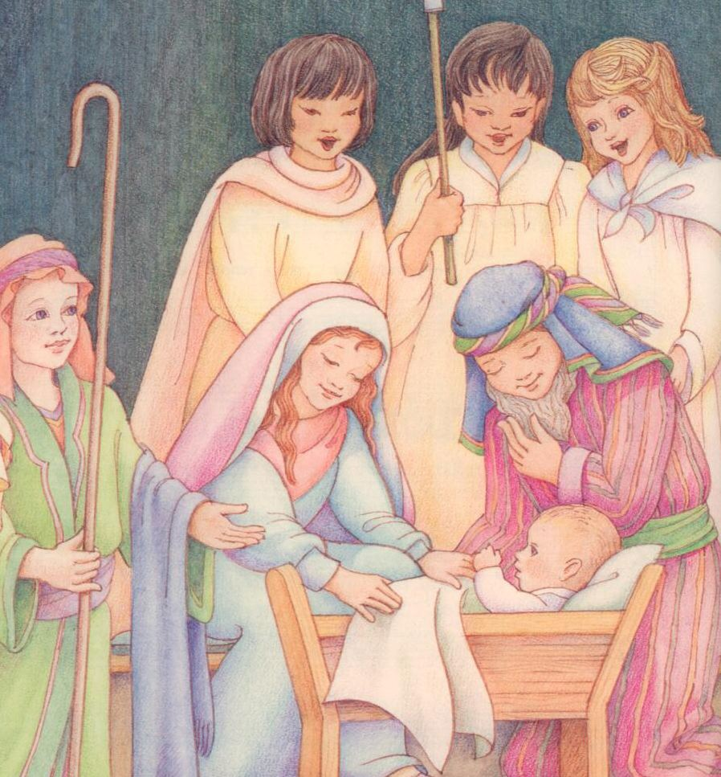
For thy Father is the King
Thy tender hands, so tiny now
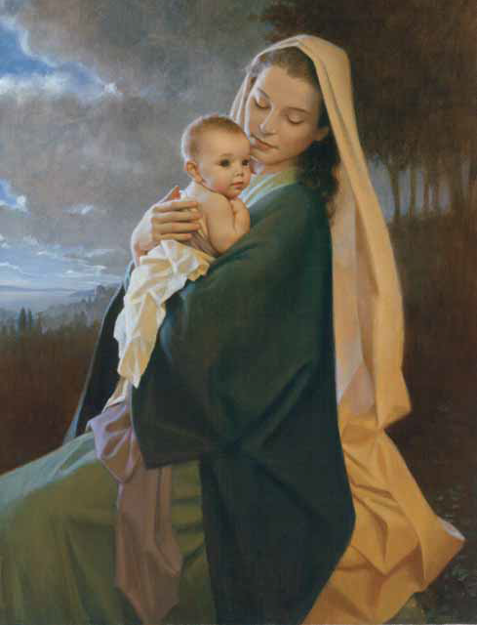
Have blessings great to bring
Let all creation join my song
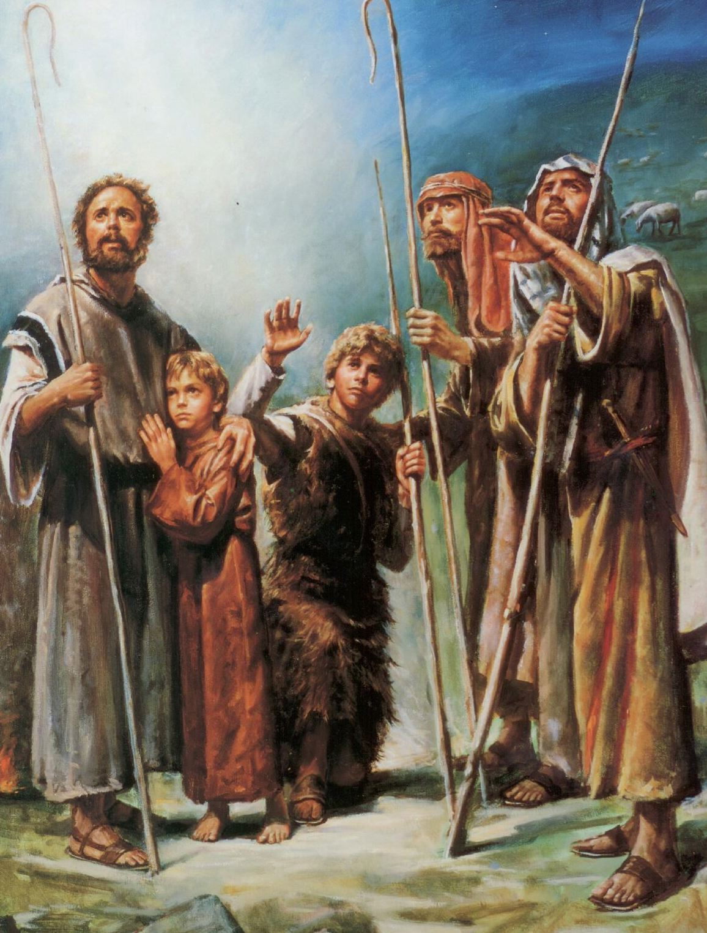
For peace and love this night are born
Lullaby, lullaby my little one
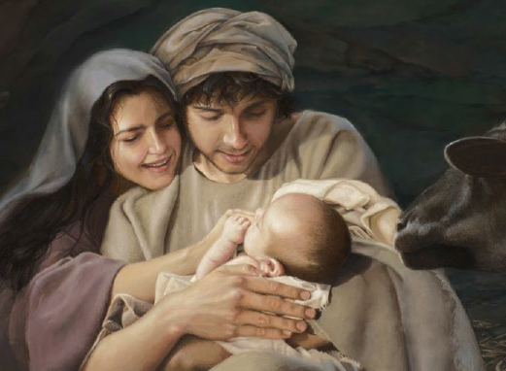
Lullaby my child so dear
DESCANTS

While Joseph watches through the night
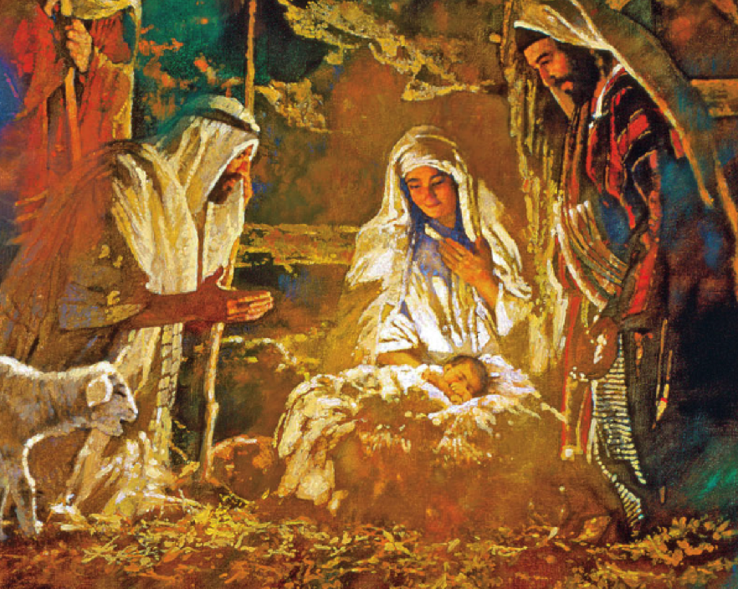
A star reflects thy light
Let all creation join my song
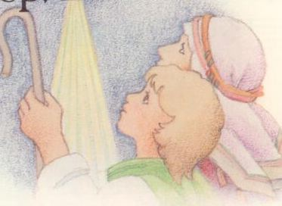
For peace and love are born

