Fairest little Jesus child
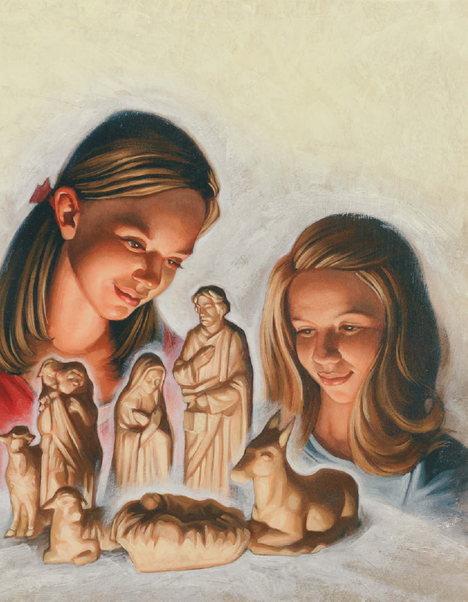
Came to earth so meek and mild
Came to earth to show the way
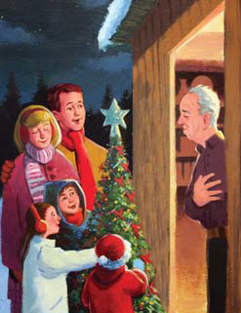
Praise we sing on Christmas Day!
Fairest little Jesus child
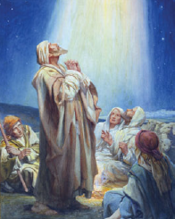
From the heavens angels smiled
We a gift before thee lay
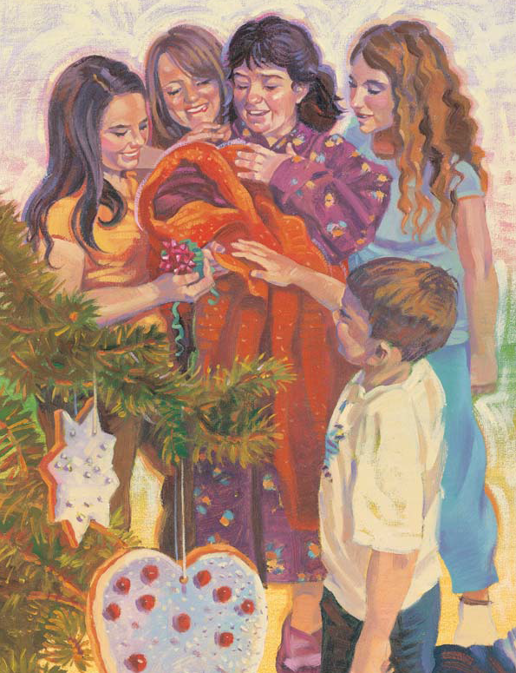
Praise we sing on Christmas Day!

