The wise man built his house
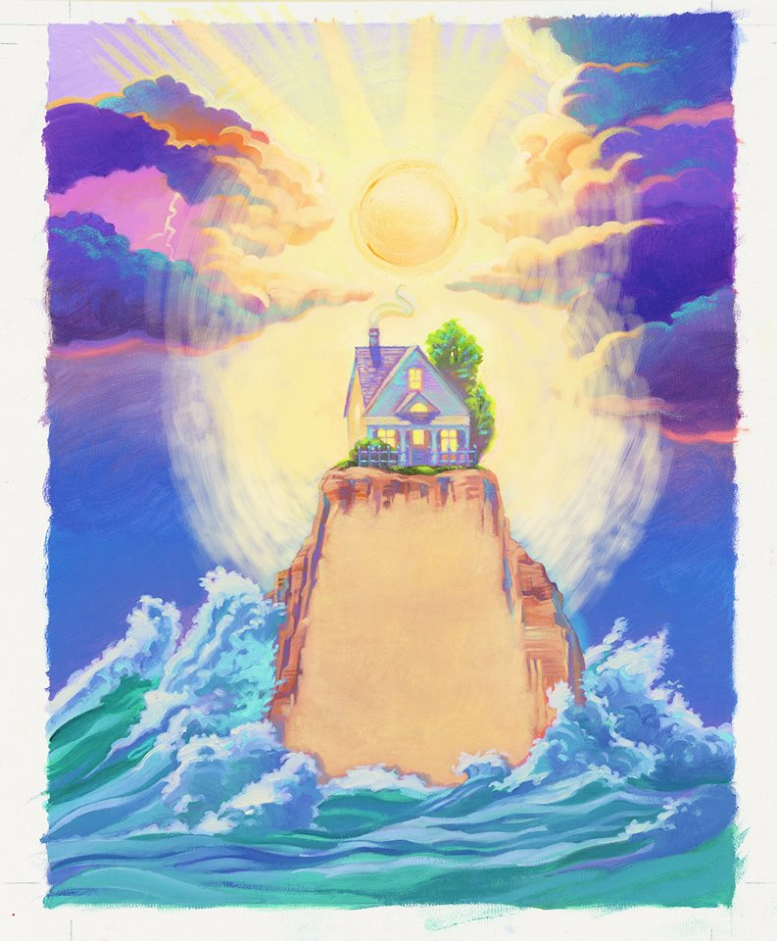
upon the rock
And the rains came tumbling down
The rains came down
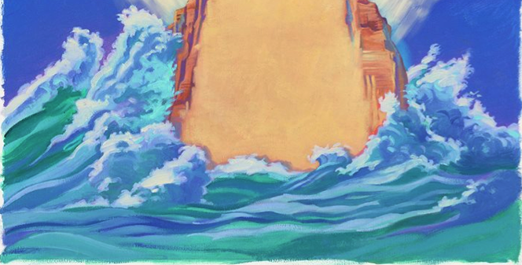
And the floods came up

And the house on the rock stood still.
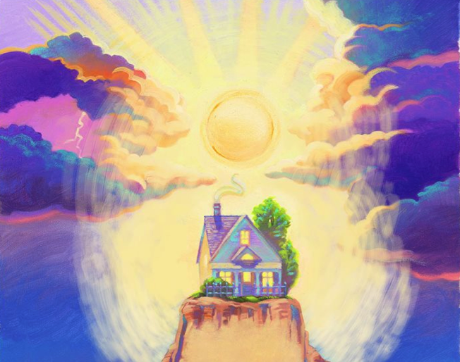

The foolish man built his house
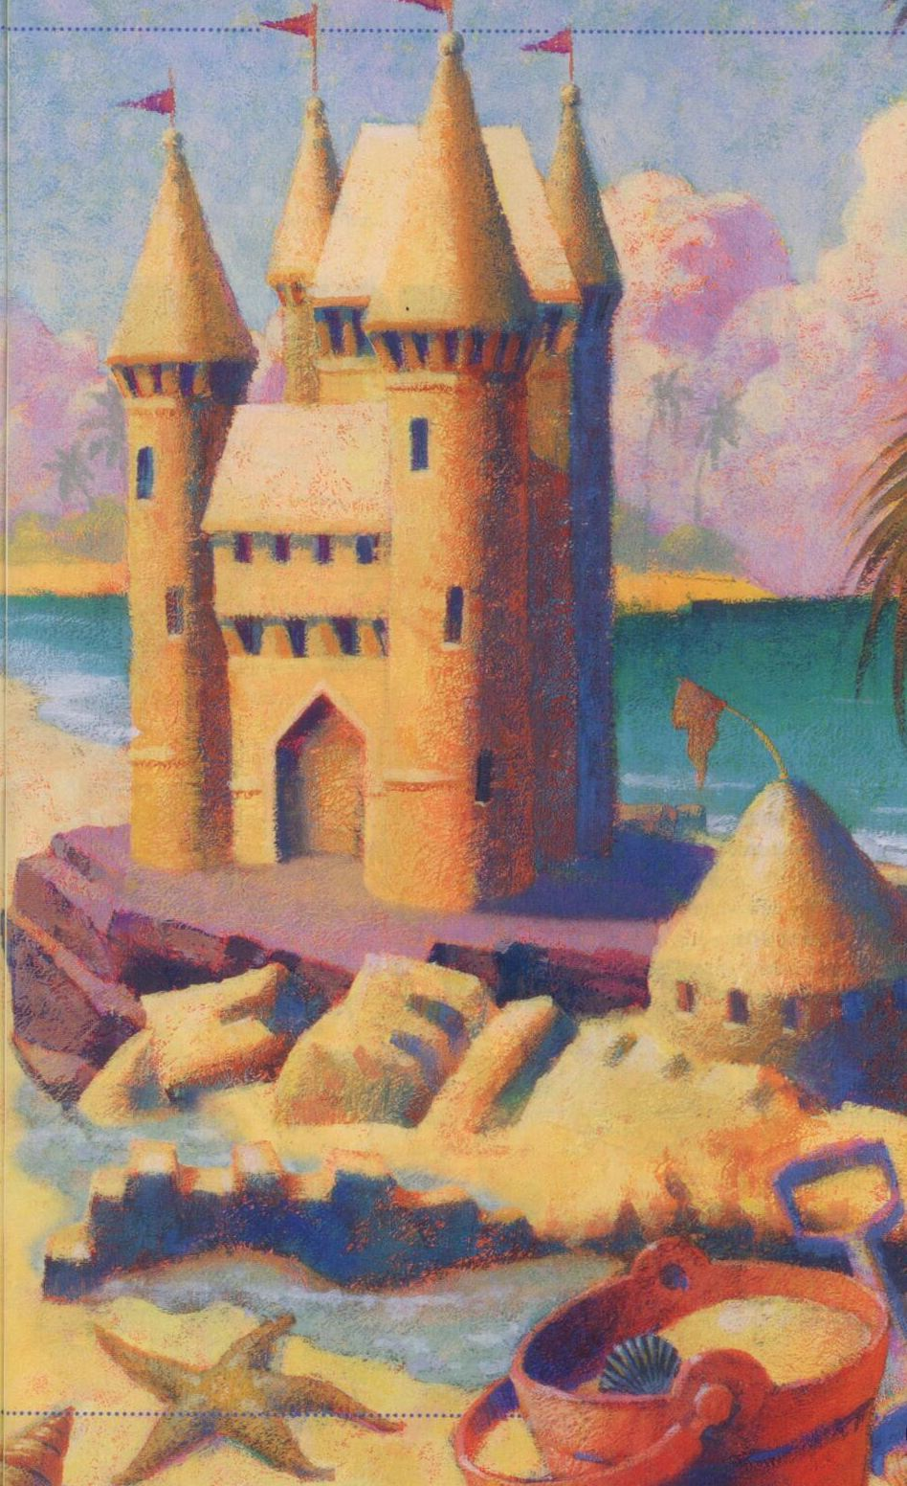
upon the sand
And the rains came tumbling down
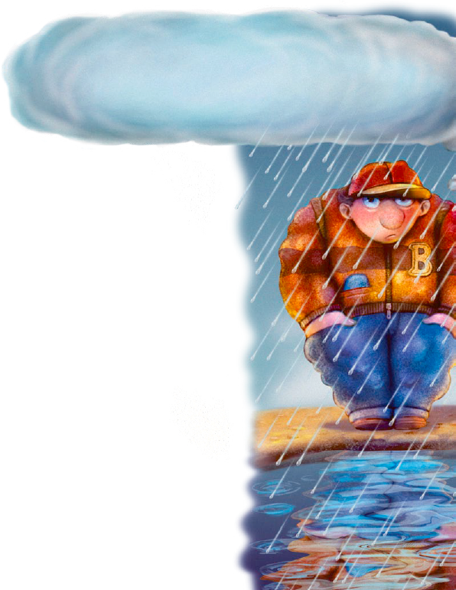
The rains came down
And the floods came up

And the house on the sand
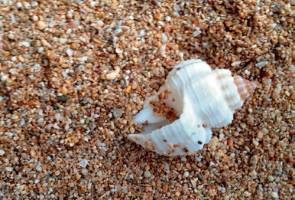
washed away
Faith is knowing the sun will rise
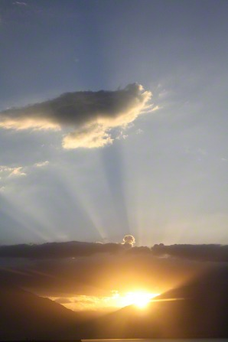
Lighting each new day
Faith is knowing the Lord will hear
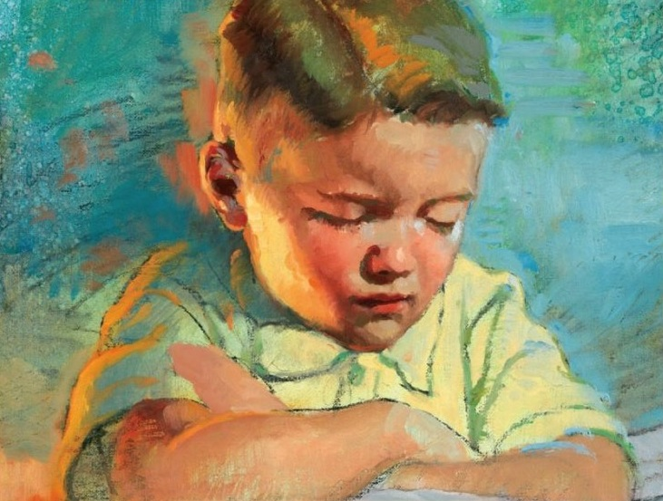
My prayers each time I pray
Faith is like a little seed
If planted it will grow
Faith is a swelling within my heart
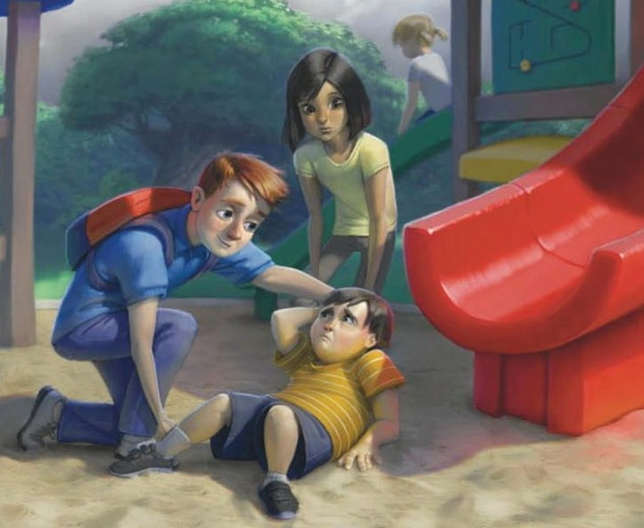
When I do right,
I know

