I’m trying to be like Jesus
I’m following in his ways
I’m trying to love as he did,
In all that I do and say
At times I am tempted to make a wrong choice
But I try to listen as the still small voice whispers
Love one another as Jesus loves you.
Try to show kindness in all that you do.
Be gentle and loving in deed and in thought
For these are the things Jesus taught
As I have loved you
Love one another
This new commandment
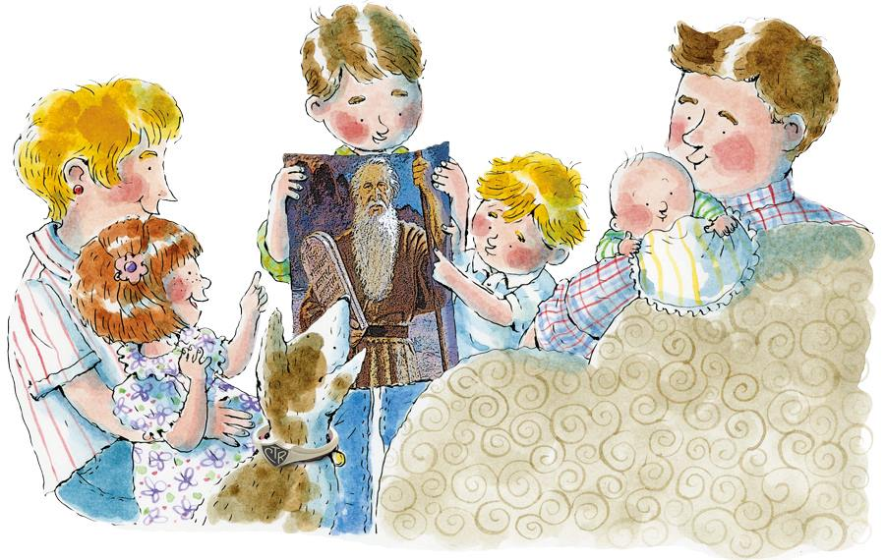

Love one another
By this shall men know

Ye are my disciples

If ye have love
One to another
Love one another as Jesus loves you
Try to show kindness in all that you do

Be gentle and loving in deed and in thought
For these are the things Jesus taught

