I’m trying to be like Jesus
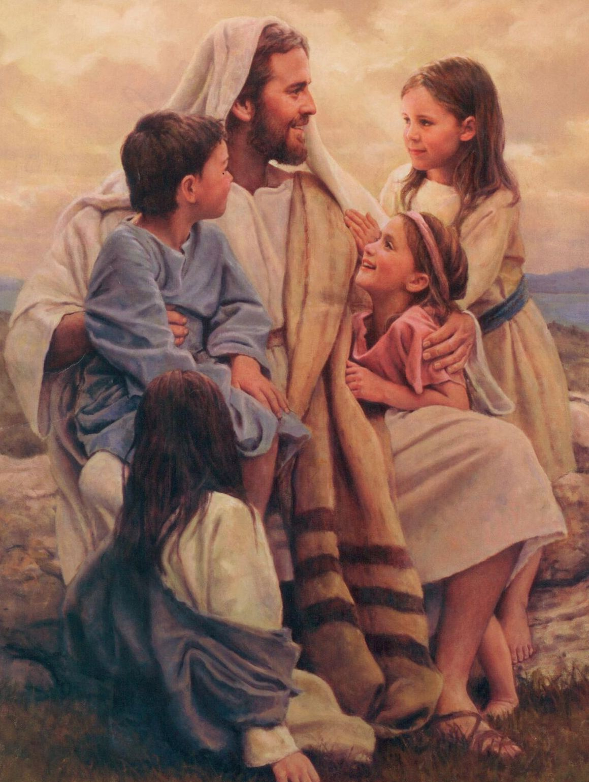
I’m following in his ways
I’m trying to love as he did
In all that I do and say
At times I am tempted to make a wrong choice
But I try to listen as the still small voice whispers
Love one another as Jesus loves you
Try to show kindness in all that you do
Be gentle and loving in deed and in thought
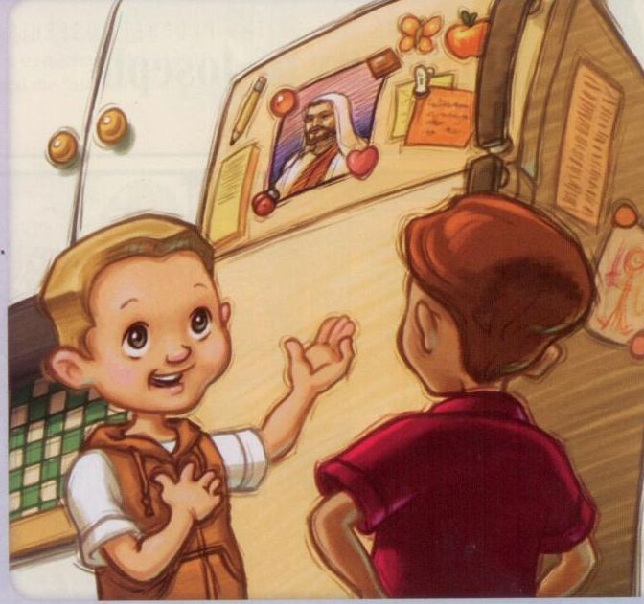
For these are the things Jesus taught
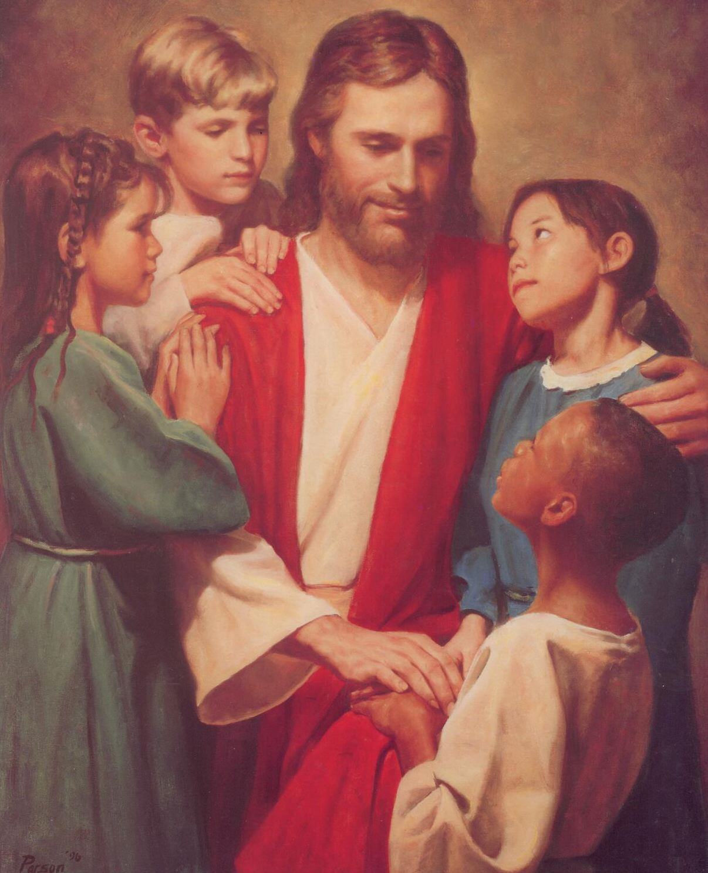
I see my mother kneeling
with our family each day
I hear the words she whispers
as she bows her head to pray
Her plea to the Father
quiets all my fears
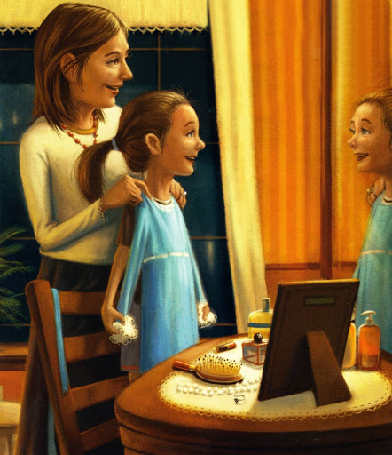

And I am thankful
love is spoken here
Mine is a home
where ev’ry hour
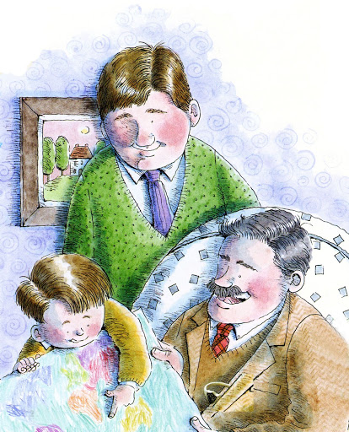
Is blessed by the strength
of priesthood pow’r
With father and mother
leading the way
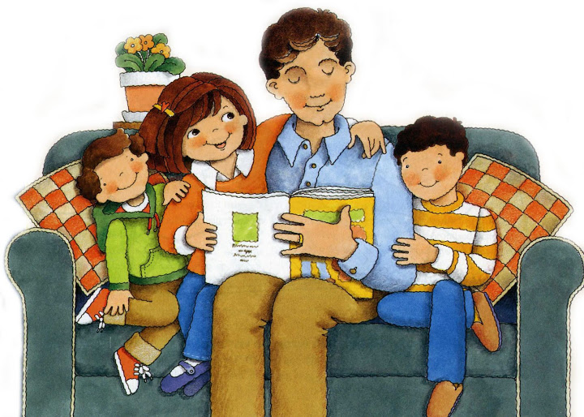
Teaching me how to
trust and obey
And the things they teach
are crystal clear
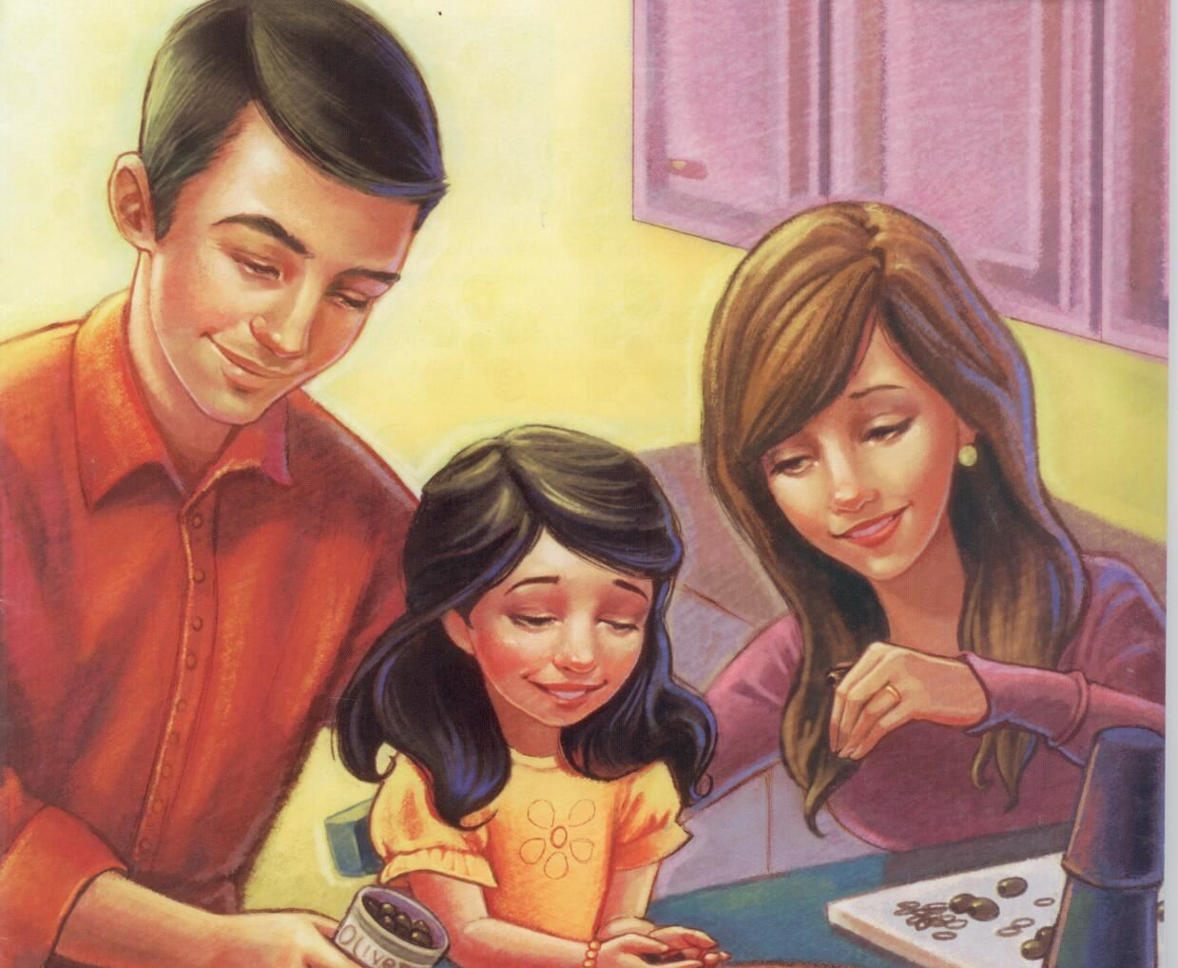
For love is spoken here
I can often feel
the Savior near
When love is spoken here

