I wonder when he comes again
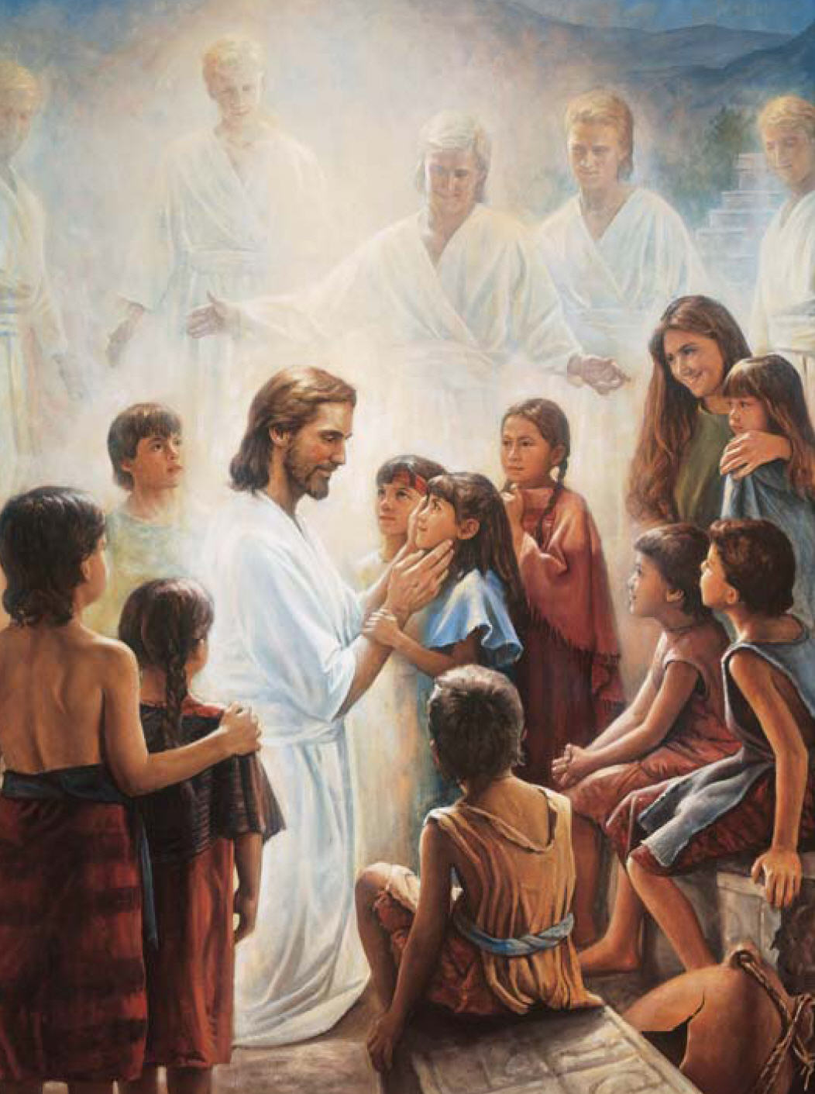
Will herald angels sing?
Will earth be white with drifted snow?
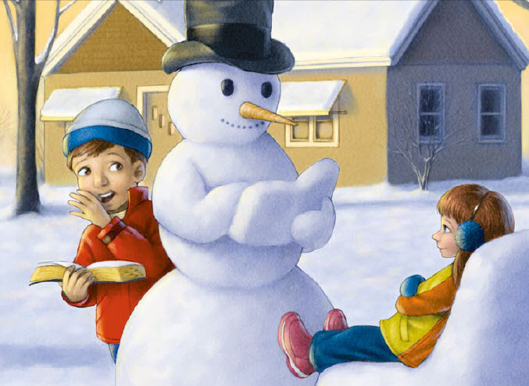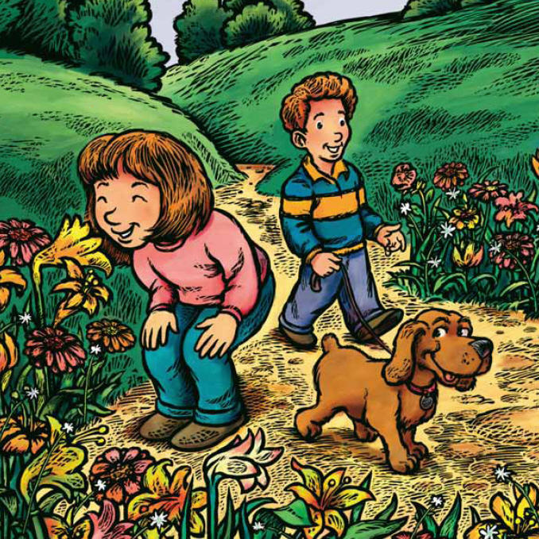

Or will the world know spring?
I wonder if one star will shine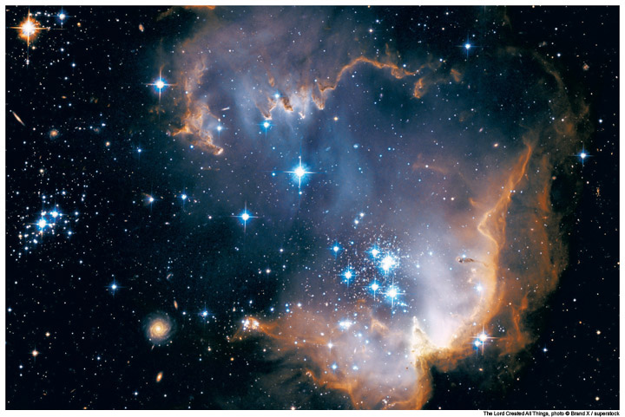
Far brighter than the rest
Will daylight stay the whole night through?

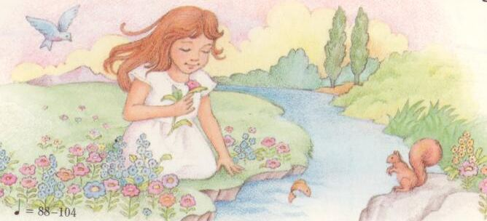
Will song birds leave their nests?
I’m sure he’ll call his little ones
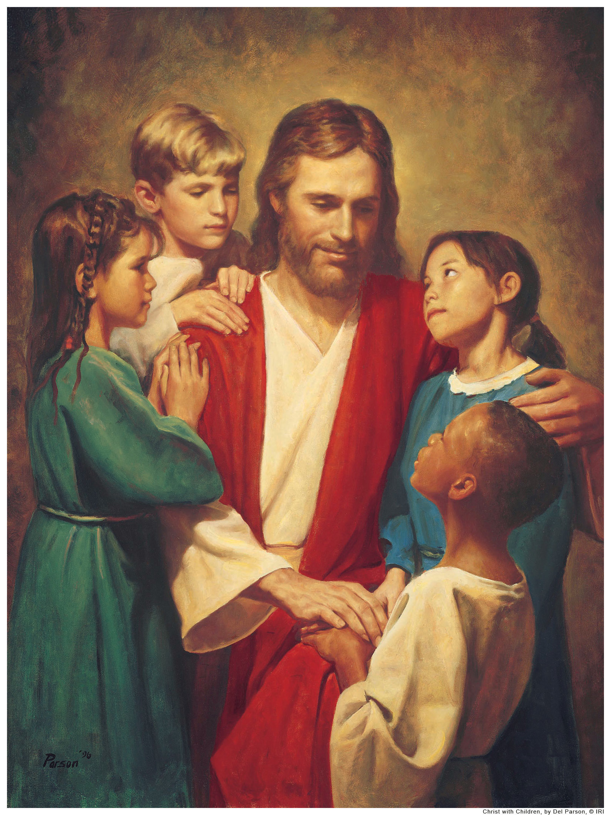
Together round his knee
Because he said in days gone by,
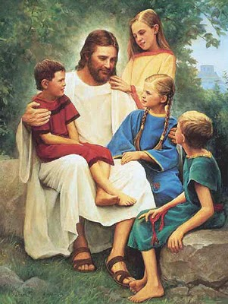
“Suffer them to come to me.”
I wonder when he comes again
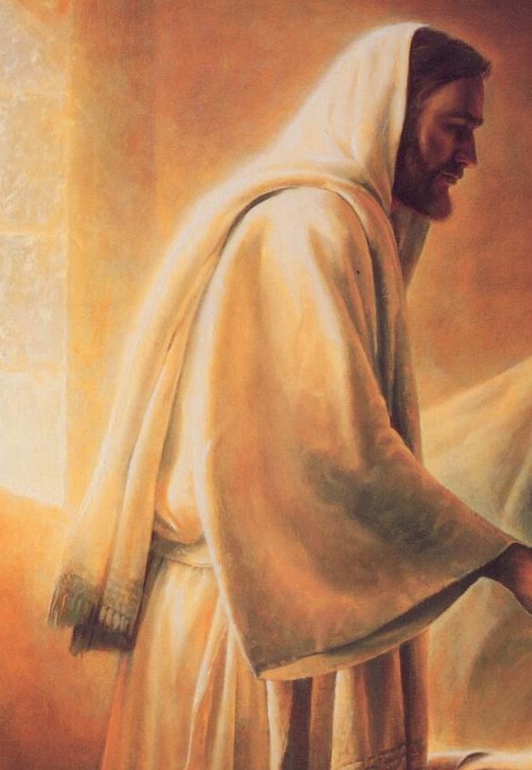
Will I be ready there
To look upon his loving face 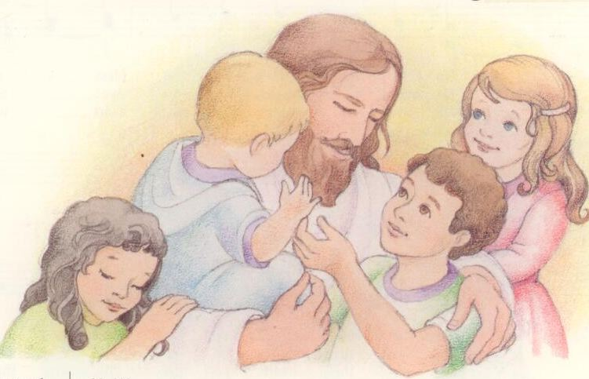
And join with him in prayer
Each day I’ll try to do his will
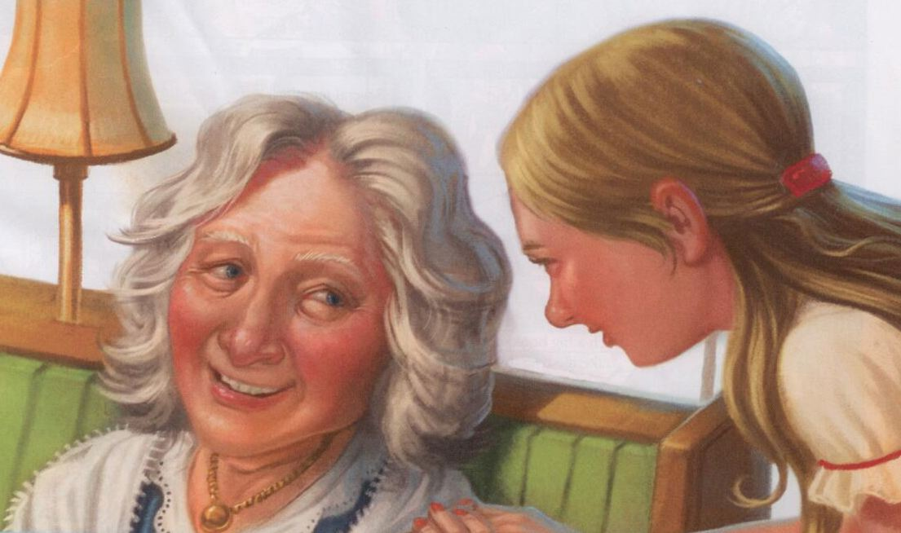
And let my light so shine
That others seeing me may seek
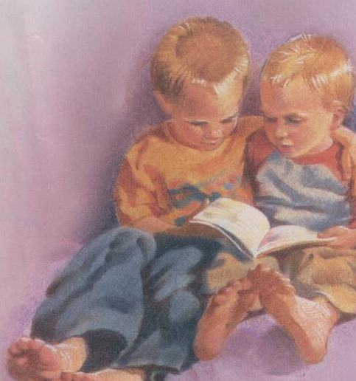
For greater light divine
Then, when that blessed day is here,
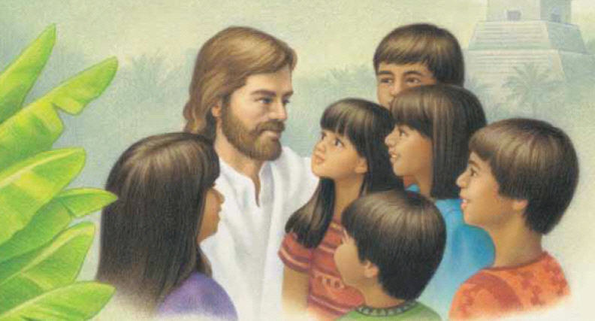
He’ll love me and he’ll say,

“You’ve served me well, my little child
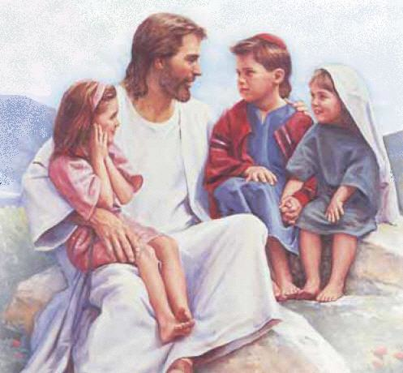
Come unto my arms to stay.”

