My life is a gift
My life has a plan
My life has a purpose
In heav’n it began
My choice was to come
To this lovely home on earth
And seek for God’s light
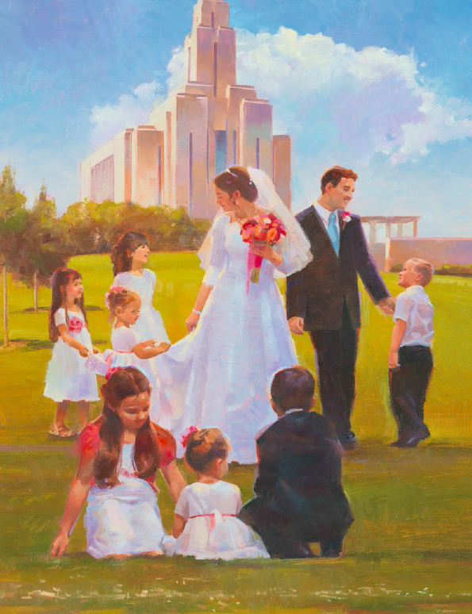
To direct me from birth
I will follow God’s plan for me
Holding fast to his word and his love
I will work, and I will pray
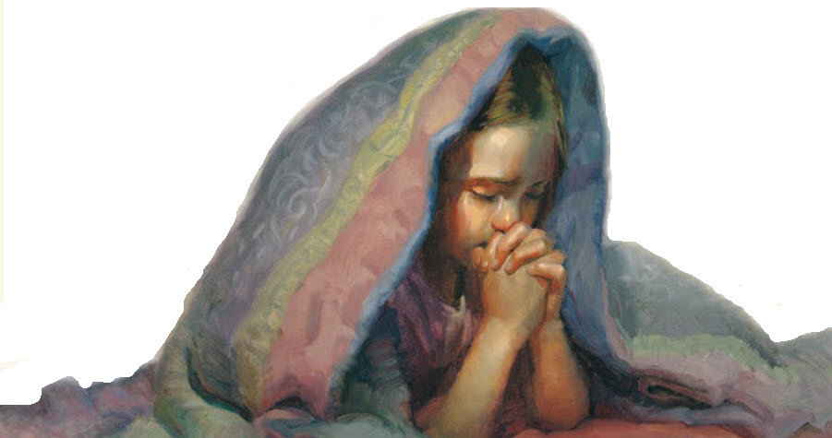
I will always walk in his way
Then I will be happy on earth
And in my home above
Fam’lies can be together forever
Through Heav’nly Father’s Plan
I always want to be with my own family
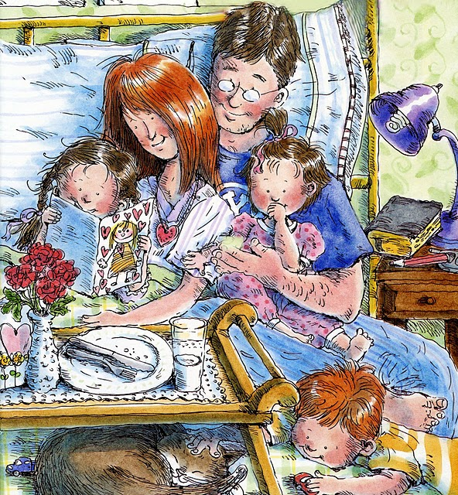
And the Lord has shown me how I can
The Lord has shown me how I can

Then I will be happy on earth
And in my home above

