We’re a million children strong
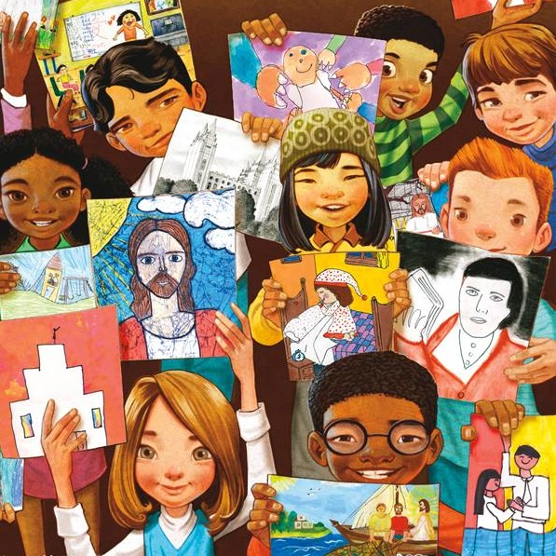
Around the world today
Each one a special child of God
Unique in ev’ry way
We’re one in a million
Growing in faith and might
We’re one in a million
Walking in His light

Uniquely individual

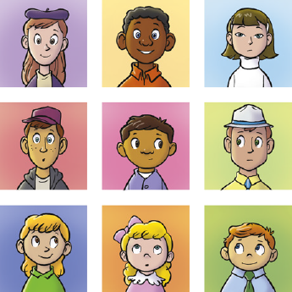

One of a kind
We’ll be what Heav’nly Father
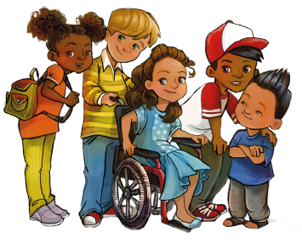

Has in mind
I’m learning to be kind
Obedient, and true
I try to show I love the Lord
In all I say and do
I’m one in a million
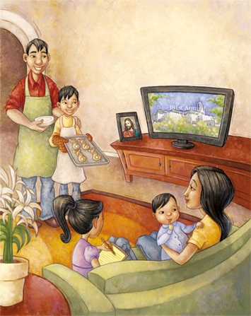
Growing in faith and might!
I’m one in a million
Walking in His light
Uniquely individual
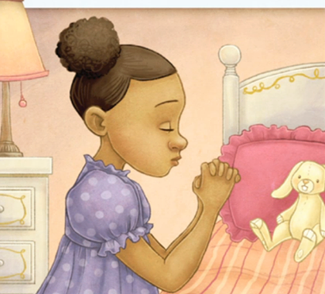

One of a kind

I’ll be what Heav’nly Father

Has in mind for me!

I’ll be what Heav’nly Father
Has in mind

