At inYuwaʼ, ma wankat aran?
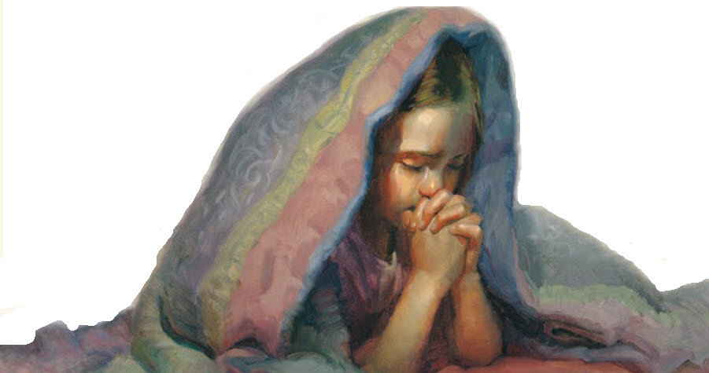
Ut laa kokʼal, ma taawabʼi xtijebʼ aʼan?
Wan nekeʼxye naq chi najt wankat
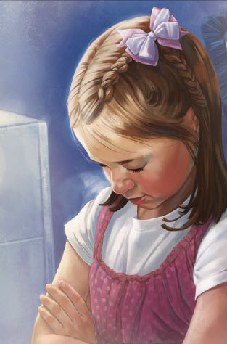
Naq nintijok nakatweekʼa chinkʼatq
At inYuwaʼ
ak jultik chik we
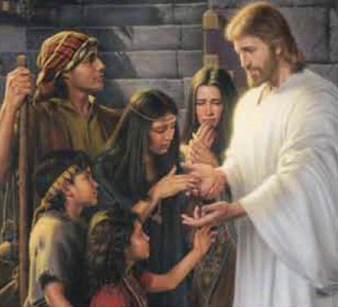
Naq li Jesus chirix ebʼ li kokʼal kixye
“Chekanabʼebʼ chi chalk wikʼin”
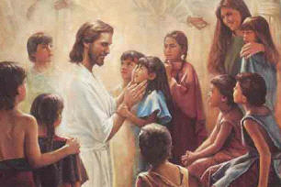
At inYuwaʼ, chinxik raj aawikʼin
Kim, chattijoq
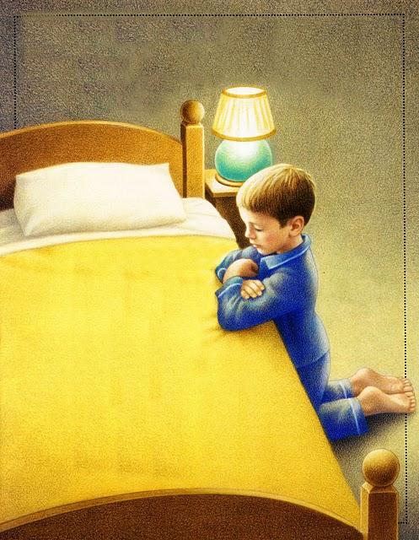
Yoo chi abʼink
Laaʼat li ralal;
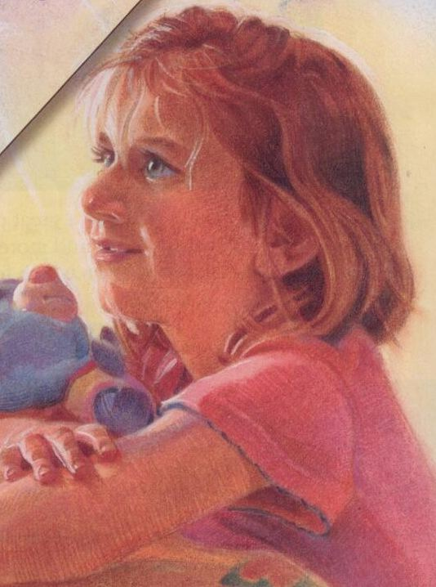
Ut yoo chawilbʼal
Aʼan tatrabʼi
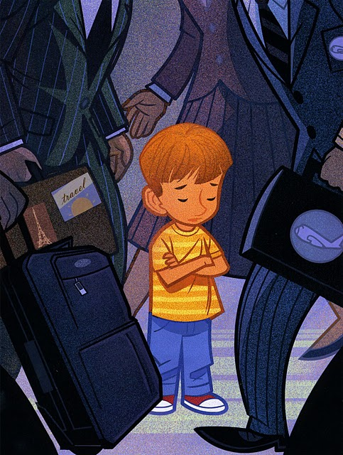
Naxra li kokʼal
Rehebʼ aʼan li

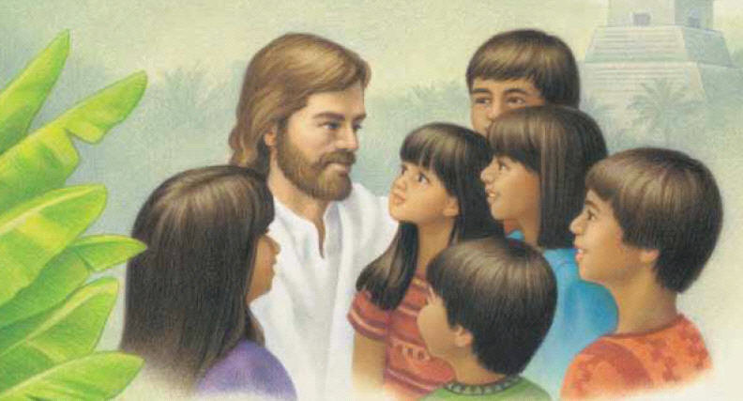

Rehebʼ aʼan li

