Laaʼin jun ralal li Dios
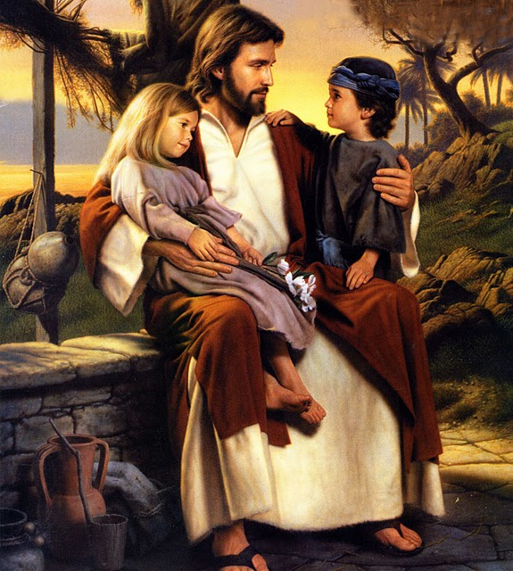
Ut xinixtaqla arin
Kixkʼe lin naʼ ut lin yuwaʼ
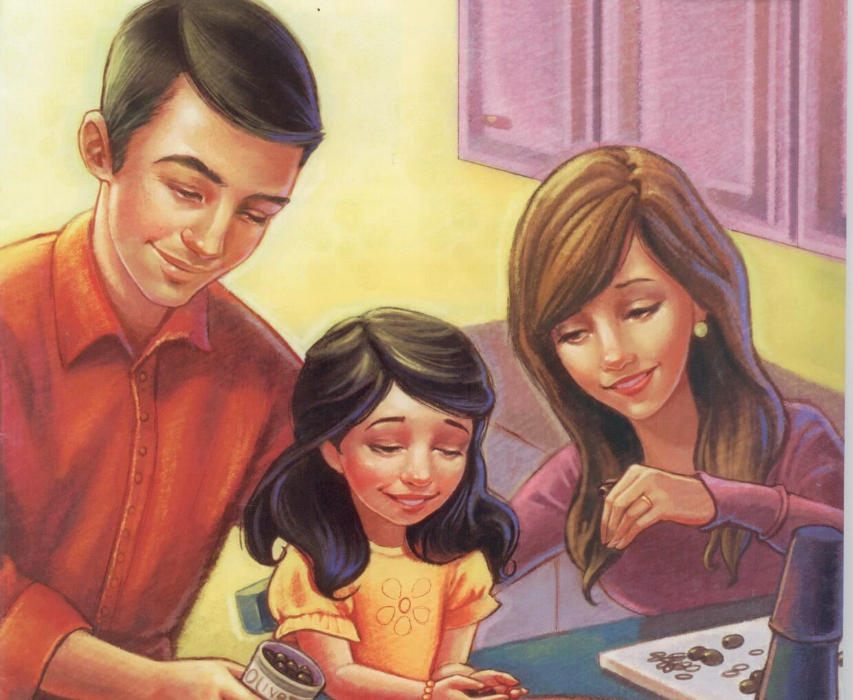
Chaabʼil xchʼoolebʼ wikʼin
Chinaatenqʼa, chinaatzol
Chatbʼeeq laaʼat wikʼin
Kʼut chiwu li tinbʼaanu
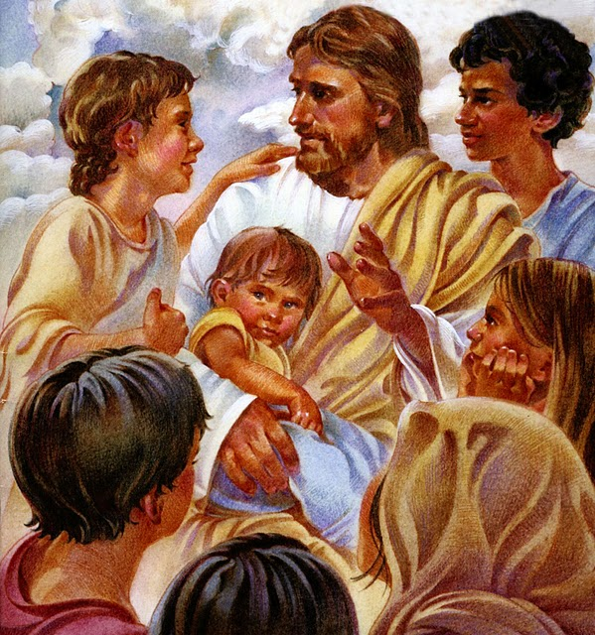
Re tinsutqʼiiq rikʼin

Laaʼin jun ralal li Dios
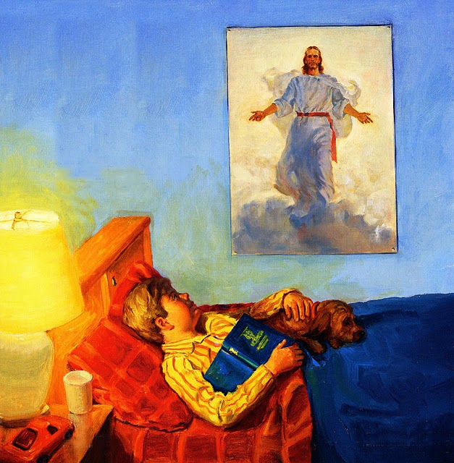
Naabʼal ajbʼil inbʼaan
Kʼehin chixtawbʼal ru raatin
Naq inhoonal toj wan
Laaʼin jun ralal li Dios
Saʼ chaabʼilal wanqin
Wi tinbʼaanu rajom aʼan
Tinwanq wiʼchik rikʼin
Laaʼin jun ralal li Dios
Tzʼaqal li yeechiʼinbʼil
Wi toj saʼ rosoʼjik tinpaabʼ
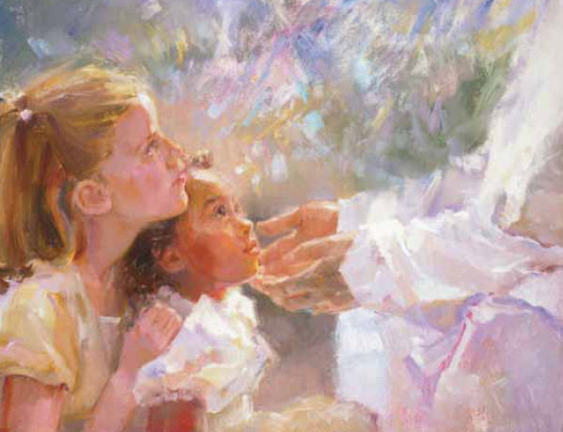
Tinkʼul li loqʼalil.
5. Laaʼin jun ralal li Dios
Saʼ chaabʼilal wanqin
Wi tinsikʼ rajom Aʼan

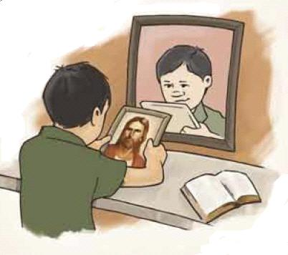
Tinwanq wiʼchik rikʼin

