Fam’ly History-

I am doing it

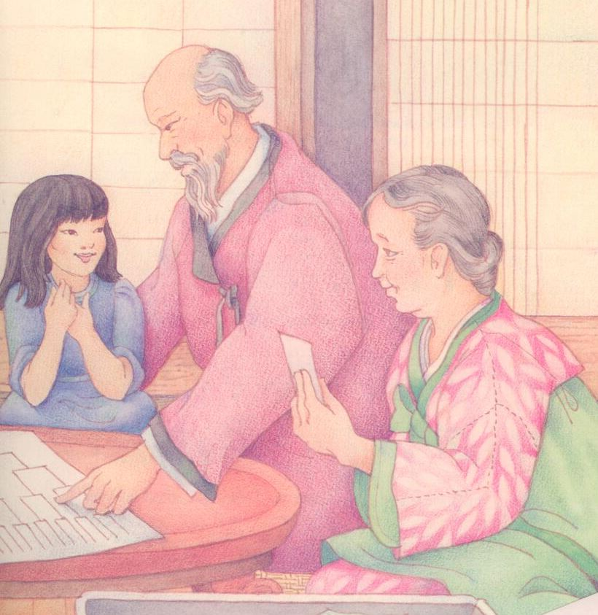

My Fam’ly history

And the love I feel when I’m doing it

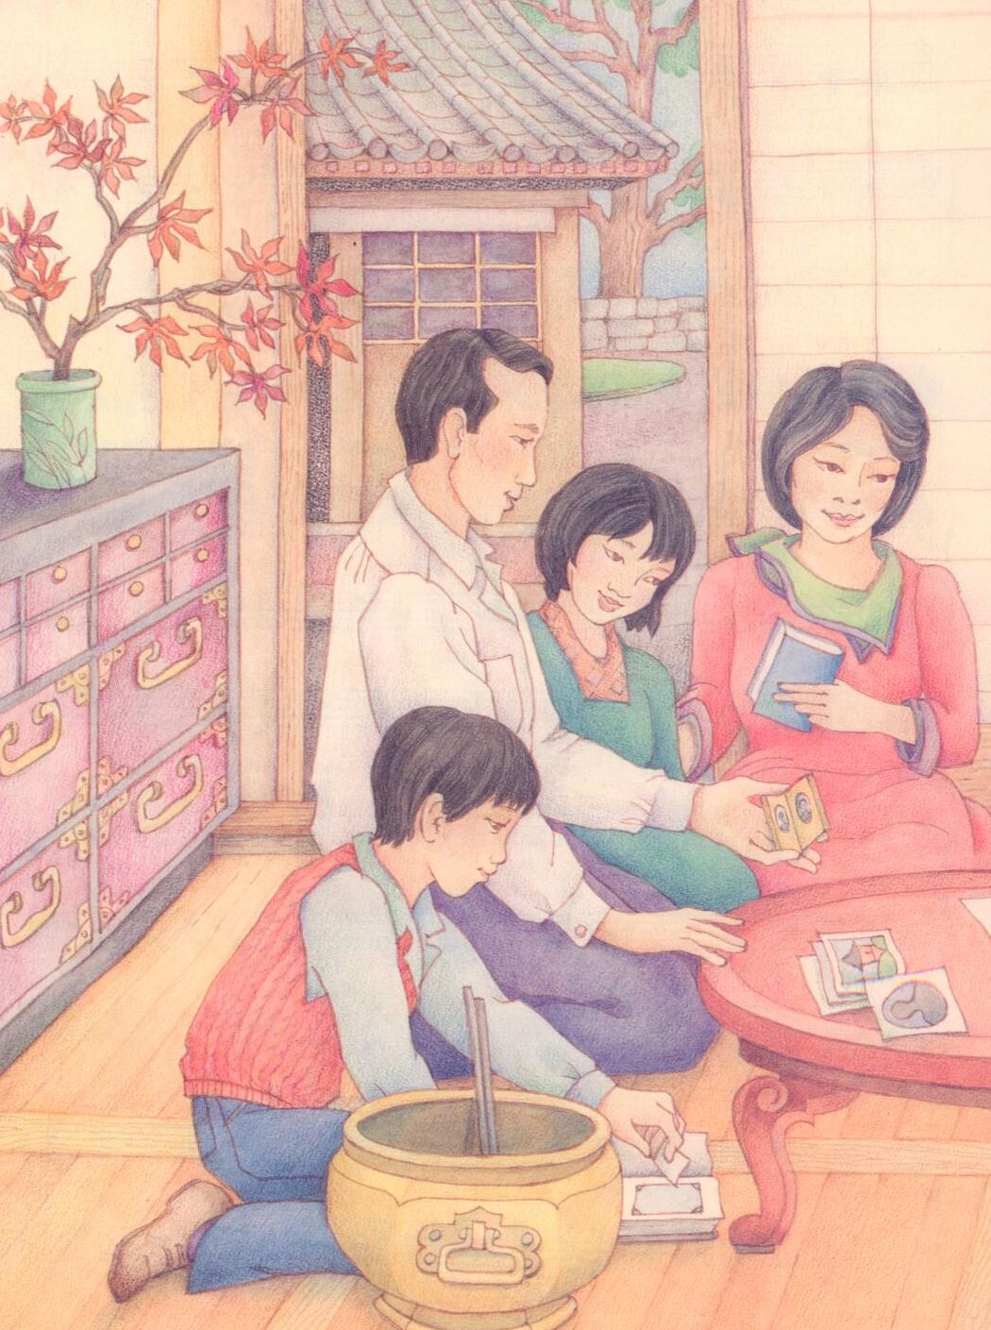

Is very sweet to me

I learn stories of my progenitors

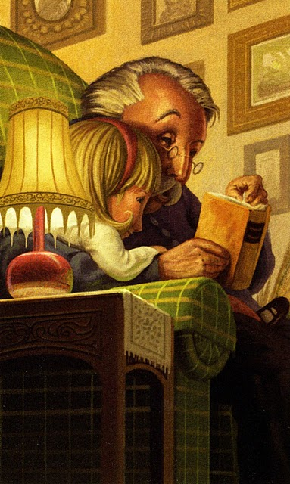

I write their history

I keep records of my loved ones

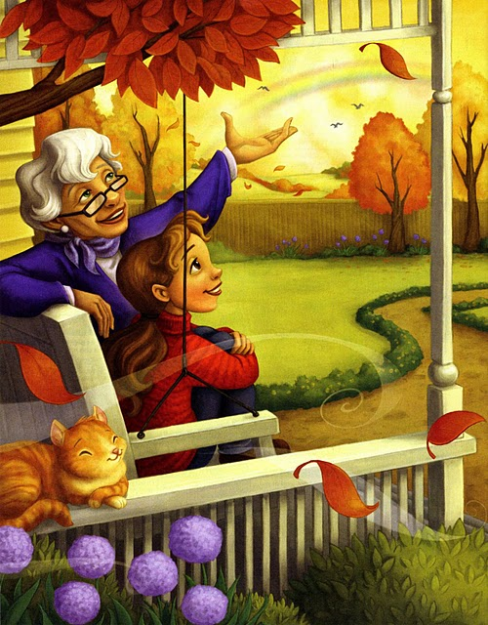

On my own fam’ly tree

Fam’ly living now and the ones who’ve died

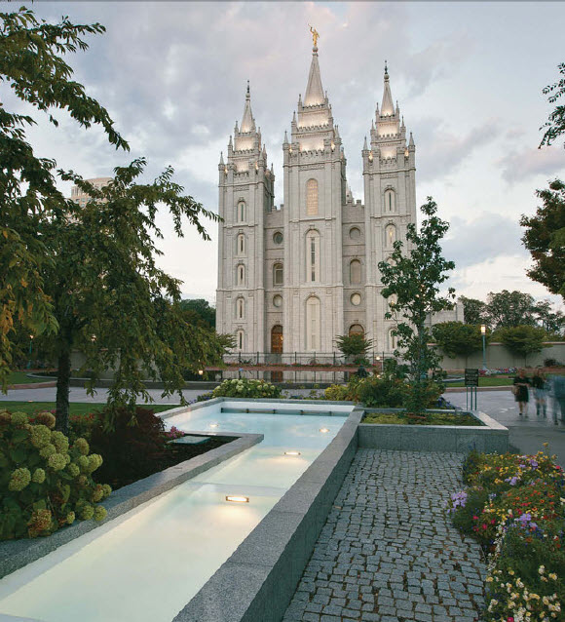

Can all be sealed to me

And someday I’ll meet ev’ry one of them

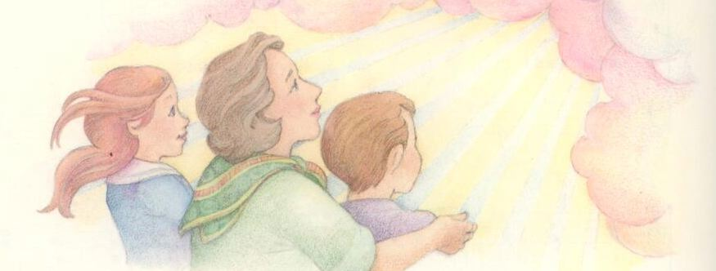

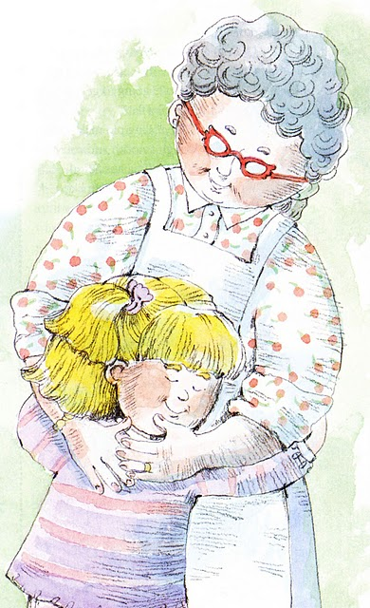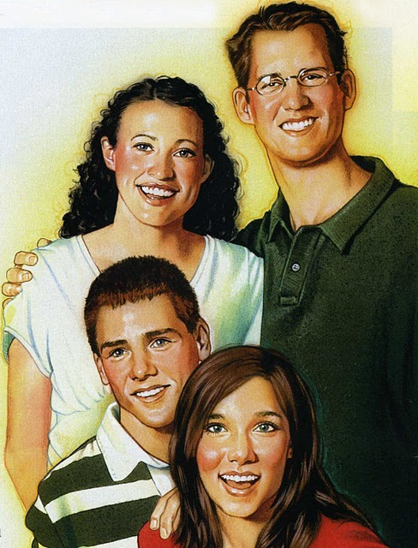

I’m sure as I can be

Oh what joy we’ll have when they say to me

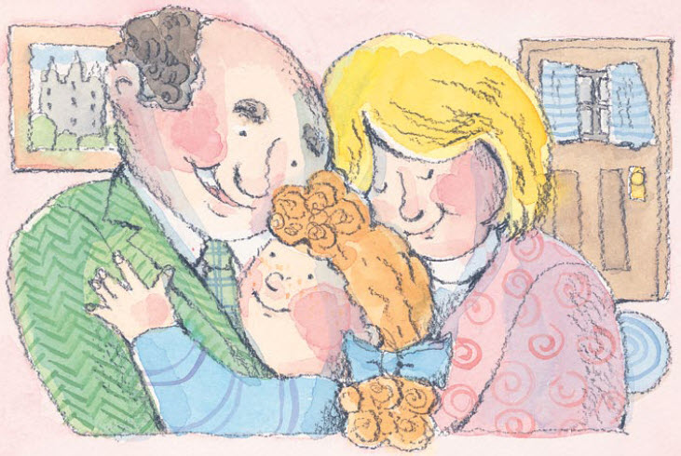

“We’re all a family”

I am yours and you are mine now

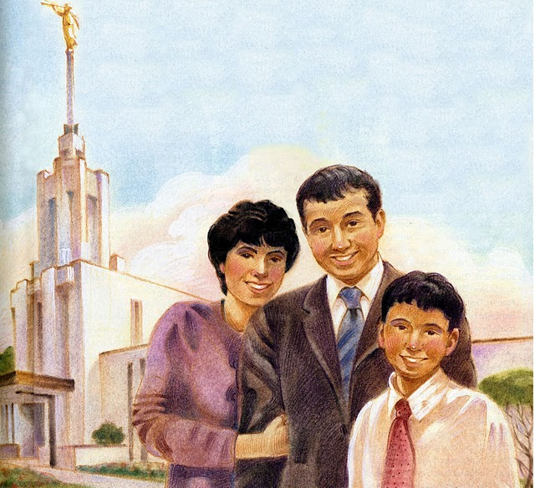

Through all eternity