Jesus came to John the Baptist,
In Judea long ago,
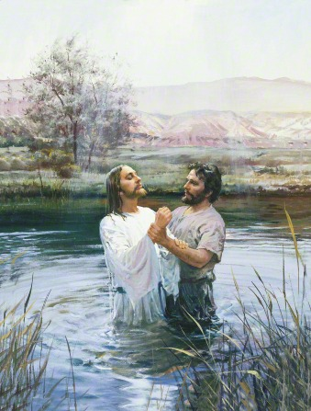
And was baptized by immersion
In the River Jordan’s flow.
“To fulfill the law,” said Jesus,
When the Baptist questioned why,
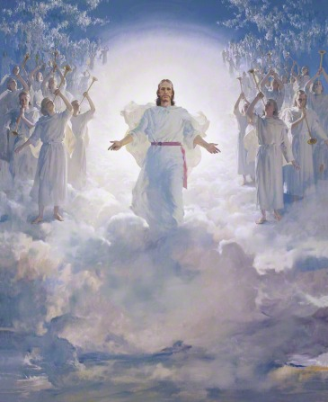
“And to enter with my Father
In the kingdom up on high.”
Now we know that we must also
Witness faith in Jesus’ word,
Be baptized to show obedience,
As was Jesus Christ, our Lord.

