And God said, “Let there be light,”
And there was light
The sun and glittering stars
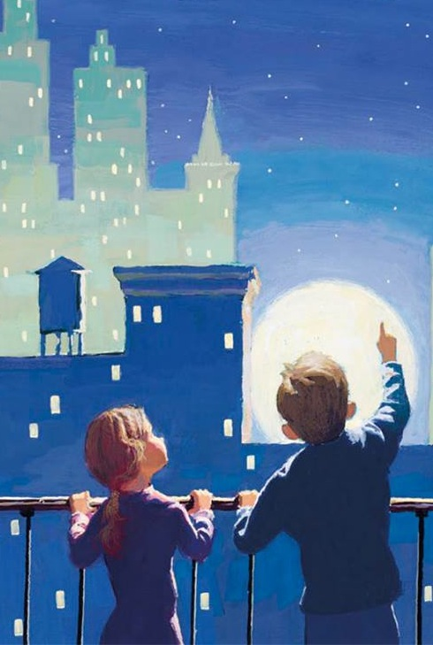
And moon shone bright
With priesthood power
He made the earth and sea
And with His power
He blesses you and me
Our Savior raised
A young maiden from the dead
He spoke and thousands
Of hungry souls were fed
With priesthood power
He made the blind man see
And with His power
He blesses you and me
God shares His power
With us in latter days
To guide, to lift, and
To heal in wondrous ways
Each priesthood ordinance
Helps me clearly see
That with His power
He blesses you and me
The God who created the universe
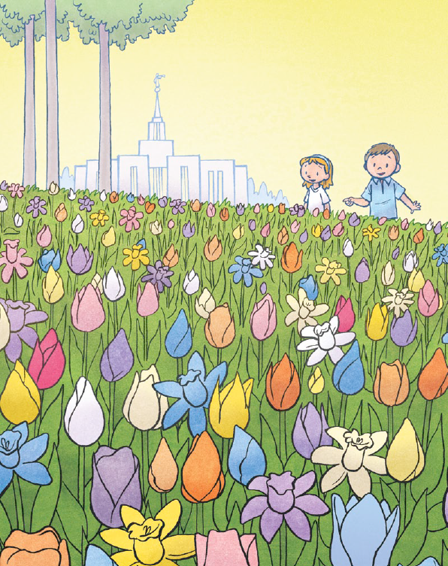
And ev’ry tiny flow’r
Delights to bless me lovingly
Through sacred priesthood pow’r

