Whenever I have to choose
I think of what my parents say
And teachers who have taught the way
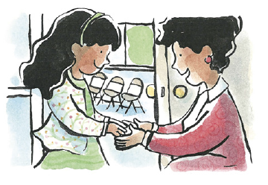

And then I close my eyes and pray
That my heart will want what’s right
Whenever I have to choose
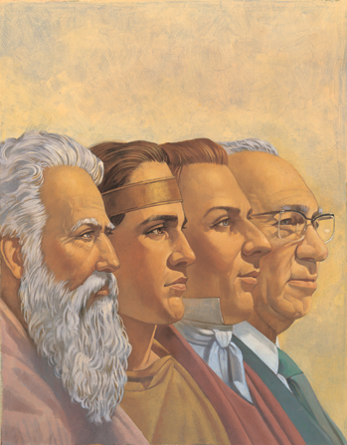
I think of what the prophets said
I ponder all I’ve heard and read
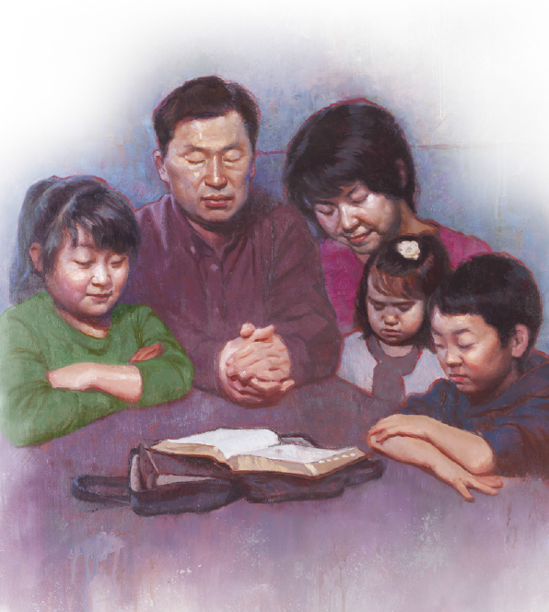
And then I pray that I’ll be led
To walk in heaven’s light
Then I listen to the Spirit
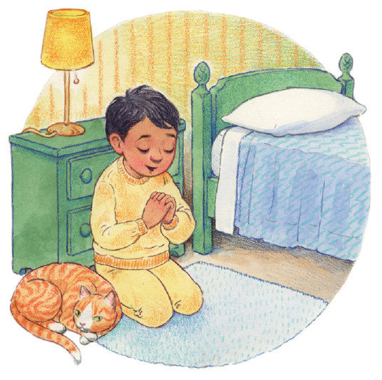
As I pray He’ll let me know
And if I am still
I’ll hear it
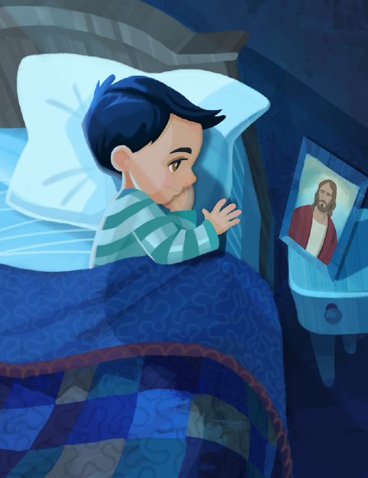
And peace will fill my soul
Whenever I have to choose
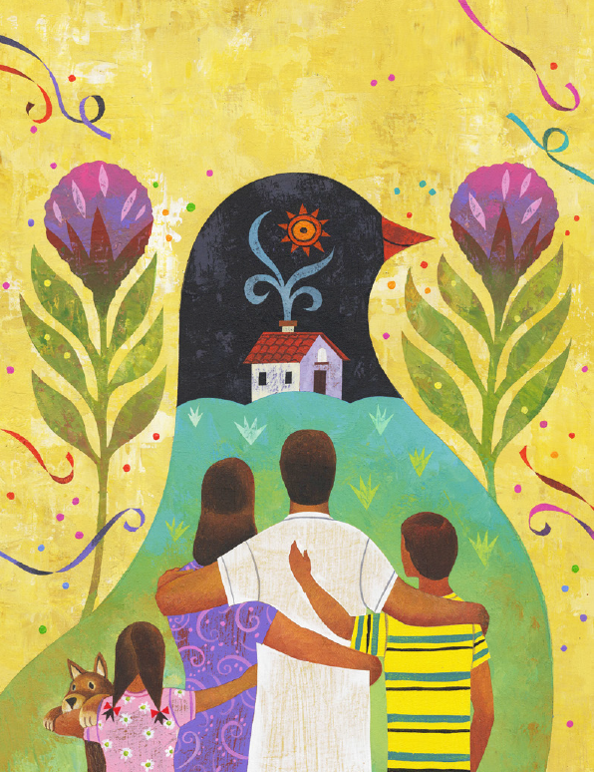
I think what Jesus Christ might do
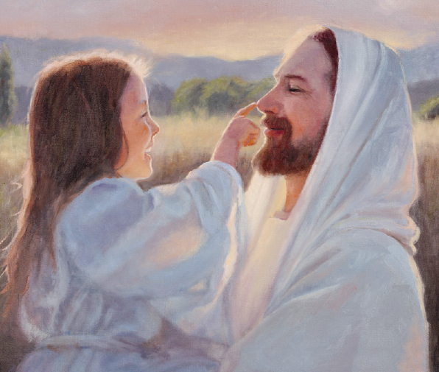
Of how much He loves me and you
Of ev’rything that’s good and true
And then I choose the right

