Abinidi stood strong and bold
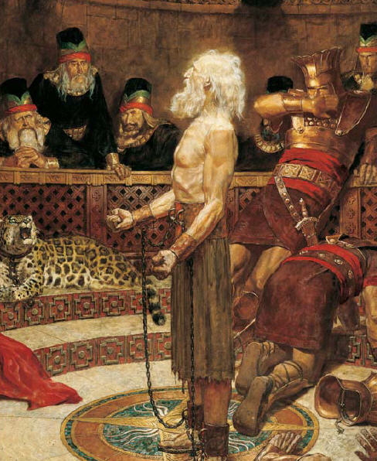
When he warned the Wicked King,
We have a Prophet here today
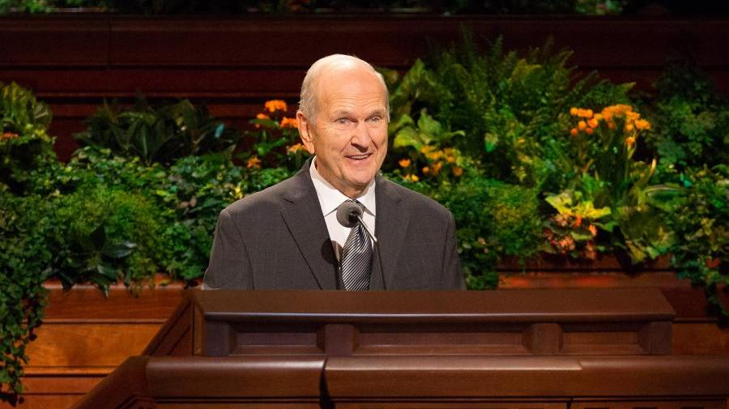
Who warns us just the same

And when the Prophet speaks to me
I feel so warm inside
I know he is God’s messenger
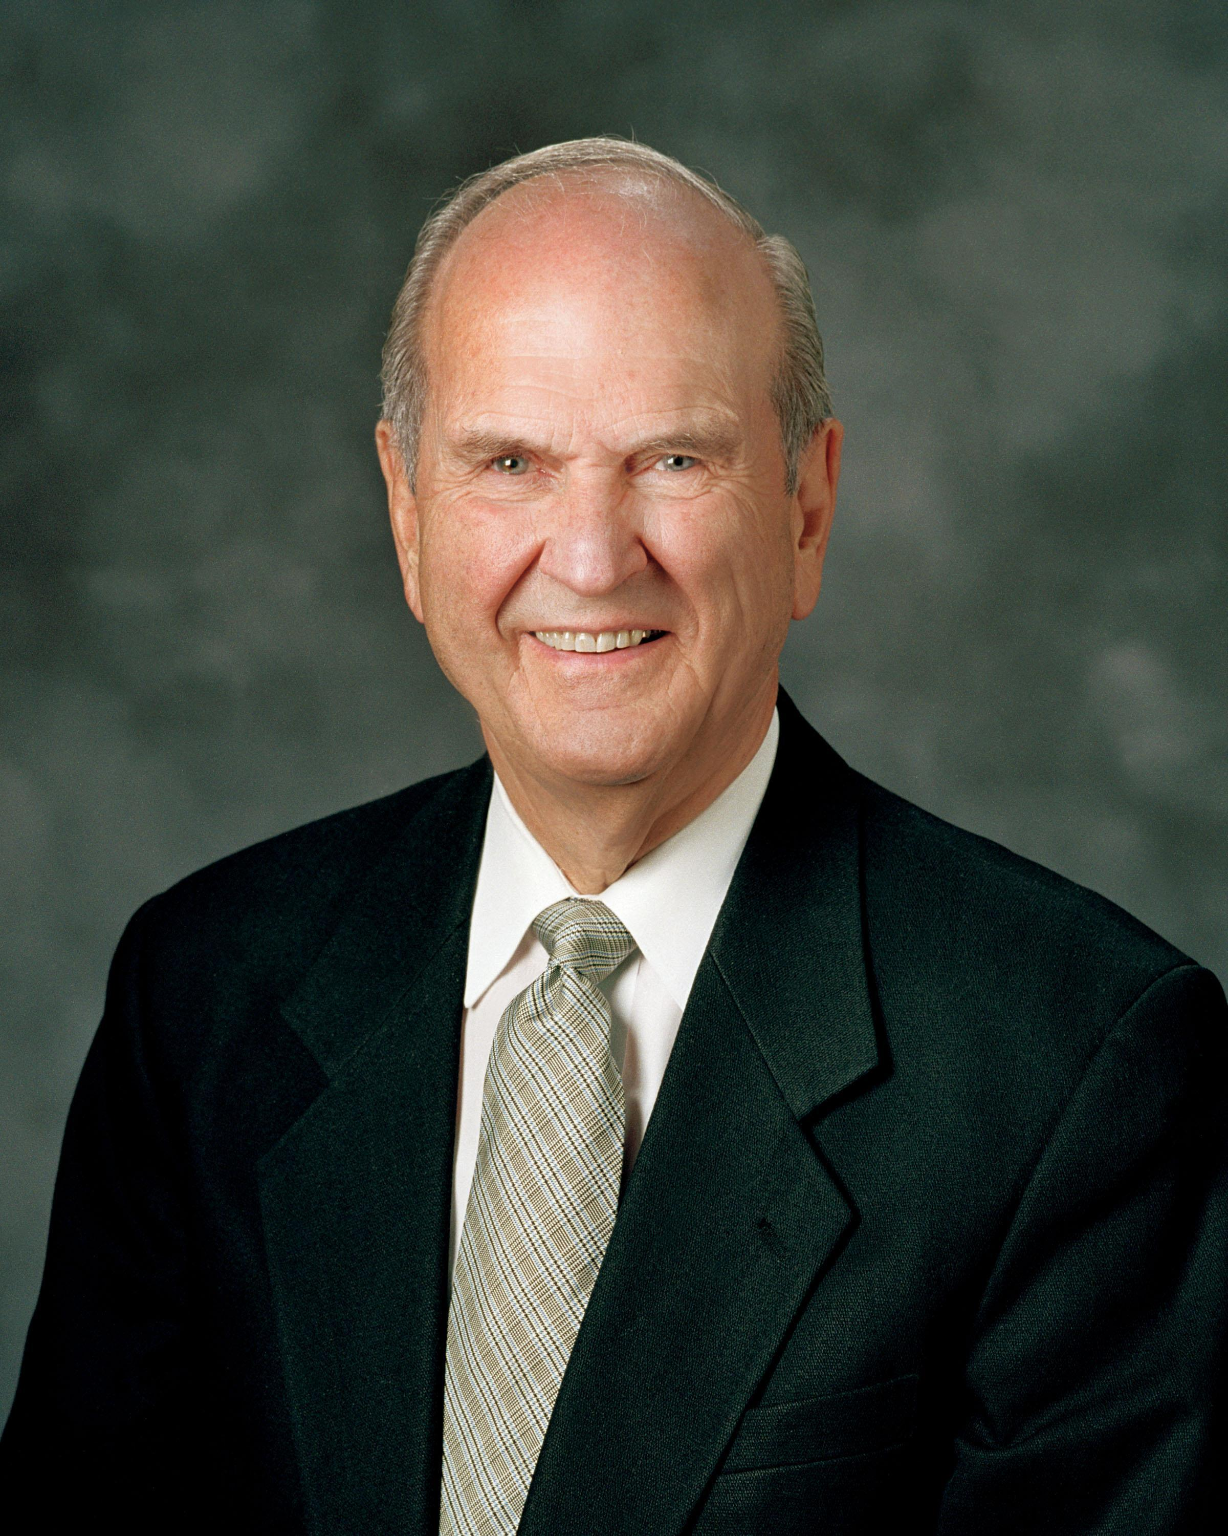
For the Spirit testifies
When a Prophet speaks for God
I know that it is true
If I kneel and pray, listen and obey
I’ll know what I must do
When a Prophet speaks for God
We feel our Fathers love
By revelation we can know the truths
From up above
When a Prophet speaks for God.
So turn your hearts dear children
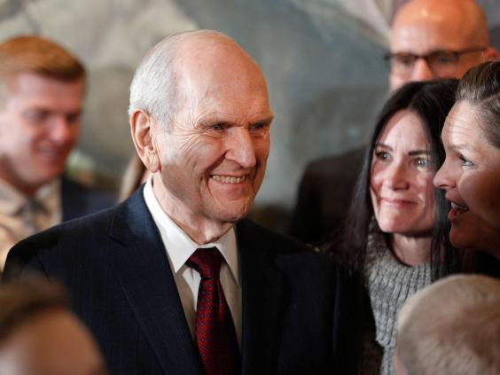
To the Prophet we have now
Abinidi and Prophets past
Have surely shown us how
We listen to His message and know
We’re not alone
By following the Prophet we’ll reach
Our Heaven’ly home
When a Prophet speaks for God
I know that it is true
If I kneel and pray, listen and obey
I’ll know what I must do
When a Prophet speaks for God
We feel our Fathers love
By revelation we can know the truths
From up above
When a Prophet speaks for God
