When We Seek Him

By
Shauna Edwards

Sheet Music at ShaunaEdwardsMusic.com
The wise men were watching and praying
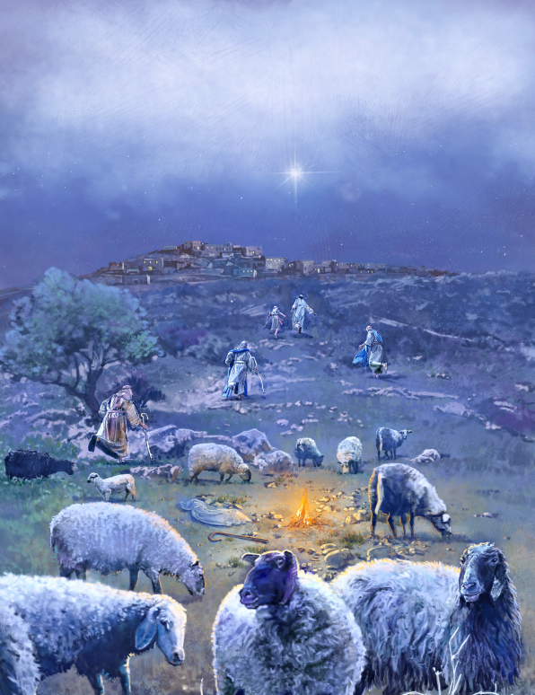
For heavenly signs of His birth
They followed the star light
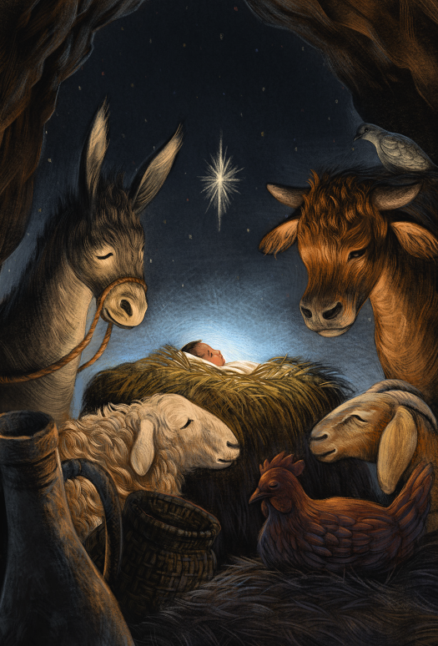
Through long days and dark nights
To worship the Lord of the Earth
If miles lay between us
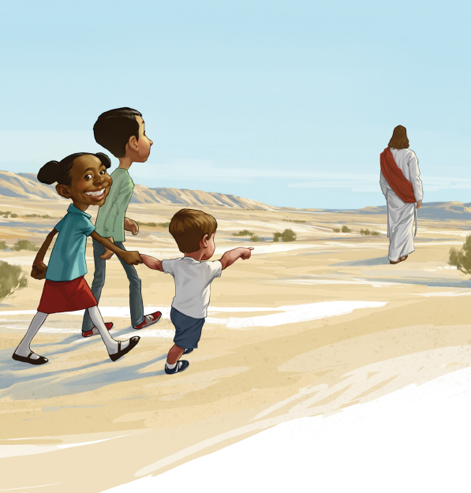
Then I’d walk to Jesus
O’er Mountain and Desert
I’d follow that star
But he doesn’t ask us to journey so far
For he will be with us wherever we are
When we seek him
Like wisemen, I’m seeking the Savior
By learning and living His ways
His light shines inside me
Like star light it guides me
Closer to him every day
I don’t have gold to lay down before him
But I’ll give my heart to show I adore him
If miles lay between us
Then I’d walk to Jesus
O’er Mountain and Desert
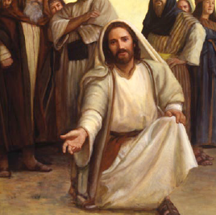
I’d follow that star
But he doesn’t ask us to journey so far,
For he will be with us wherever we are
When we seek Him
When we seek Him

