When Joseph went to Bethlehem
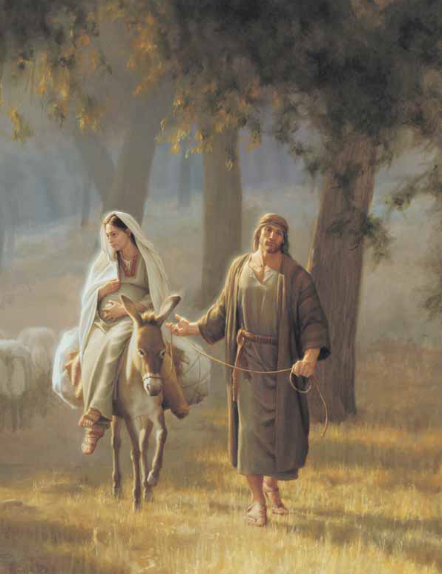
I think he took great care
To place his tools and close his shop
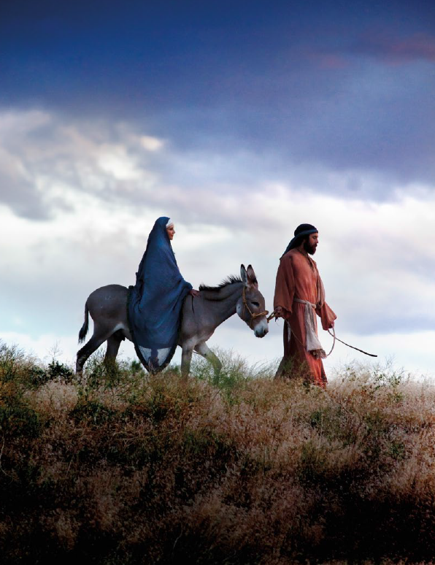
And leave no shavings there
He urged the donkey forward
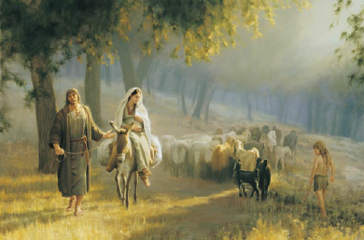
Then with Mary on its back
And carried bread and goat cheese
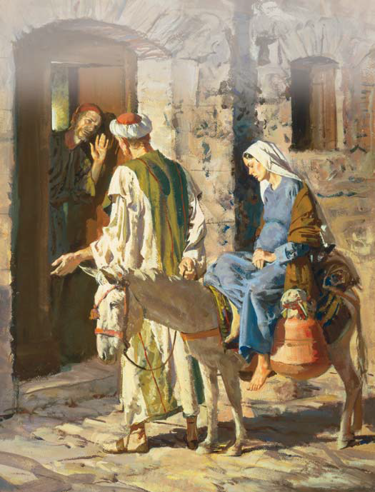
In a little linen sack
Hosanna! Hosann
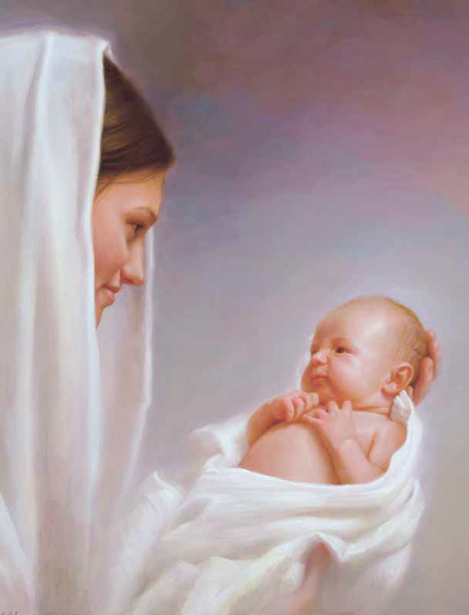
Oh, let us gladly sing
How blessed that our Lord was born
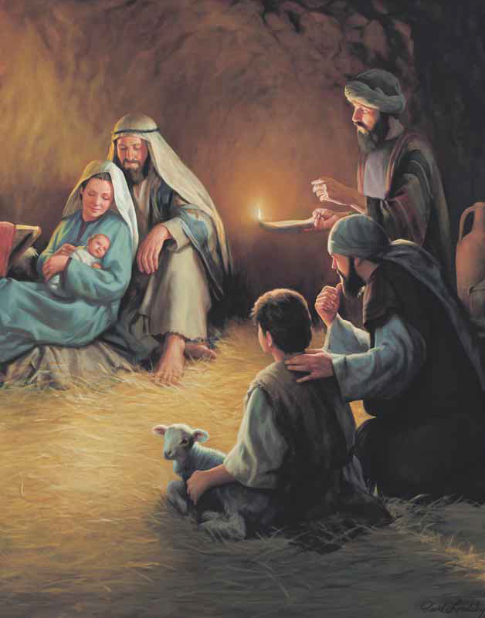
Let earth receive her King!
I think there at the busy inn
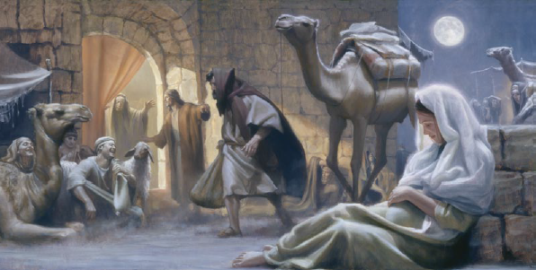
That he was meek and mild

And awed to be the guardian
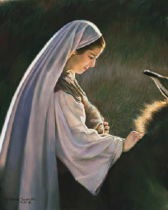
Of Mary's sacred child
Perhaps all through the chilly hours
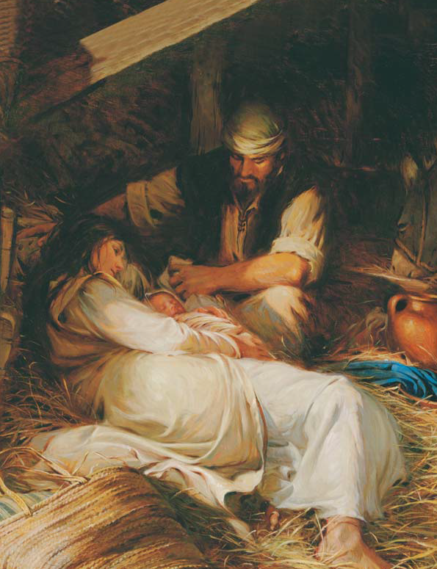
He smoothed the swaddling bands
And Jesus felt the quiet strength
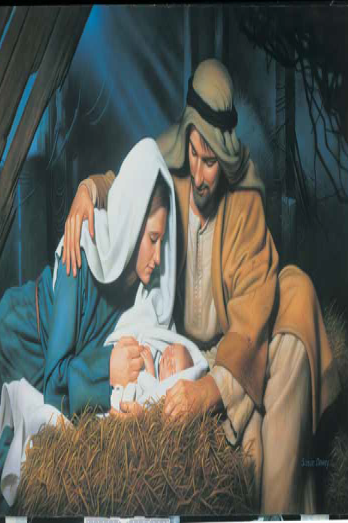
Of Joseph's gentle hands
And close beside the manger bed
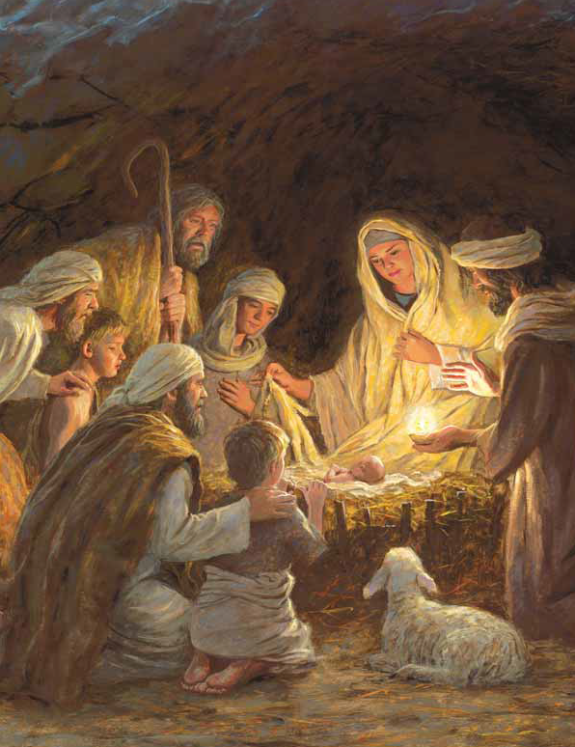
He dimmed the lantern's light
And held the little Jesus close
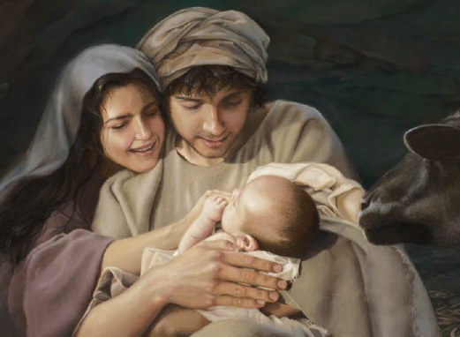
Upon that holy night
Hosanna! Hosann
Oh, let us gladly sing
How blessed that our Lord was born
Let earth receive her King!
Let earth receive her King!
