The Shepherd loves His little lambs
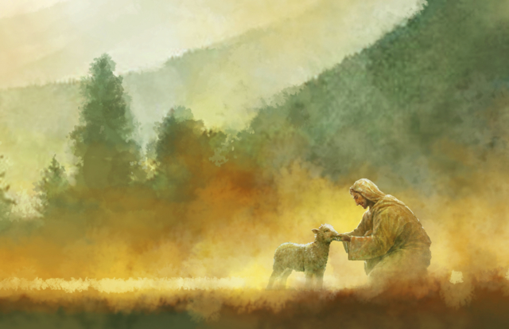
And when they go astray
He seeks them as they wander
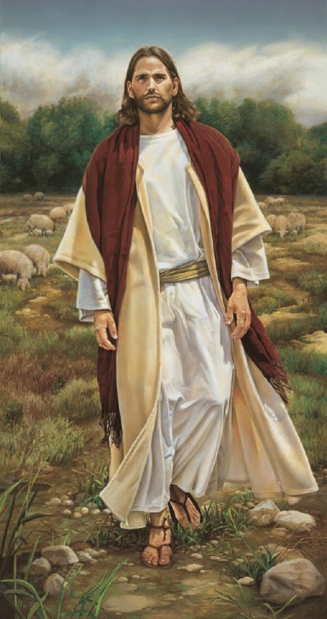
He calls each one by name
They listen for the Shepherd’s voice
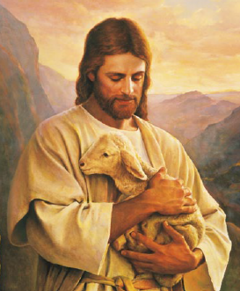
They run to Him
and then
He welcomes them with loving arms
When they return to Him
The Savior loves His little ones
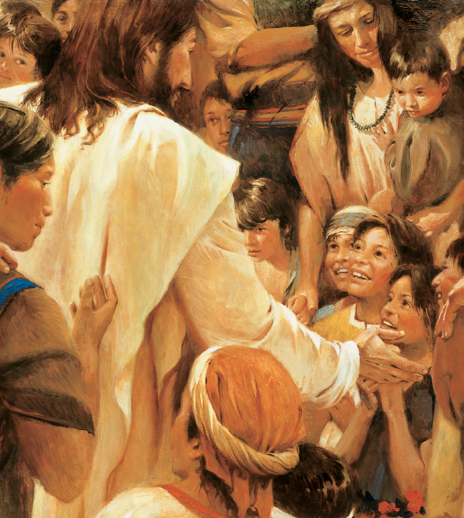
And if I leave His side
He seeks me as I wander
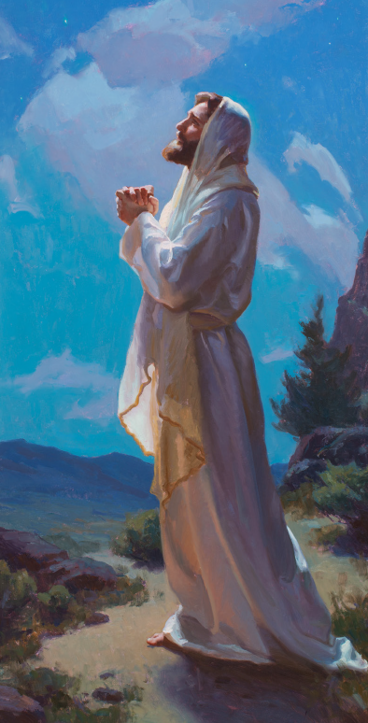
By day or darkest night
I’ll listen for the Savior’s call
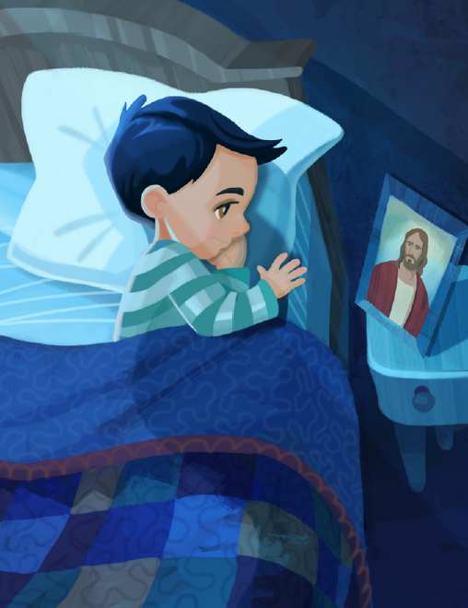
I’ll come to Him
and then
He’ll welcome me with loving arms
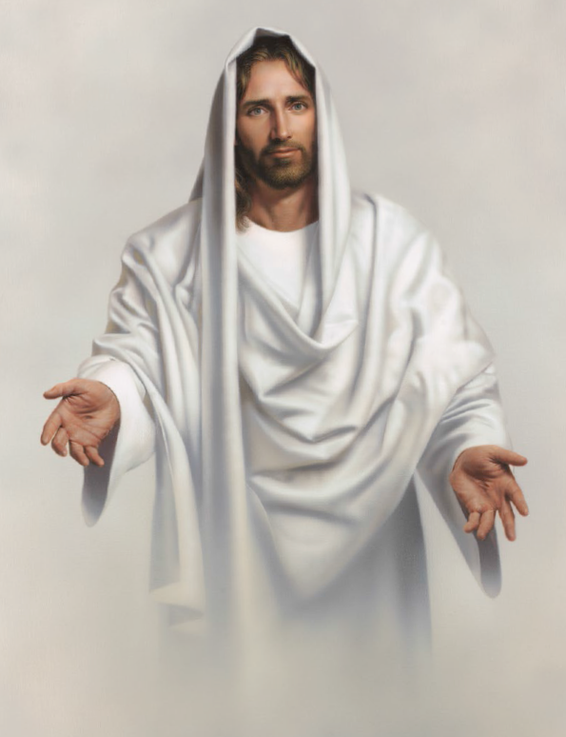
When I return to Him
The Savior marks the path for me
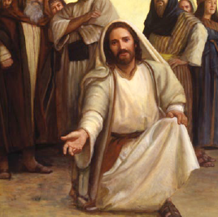
He shows me how to live
And if I stray or wander
I know He will forgive
So I will heed the Savior’s voice
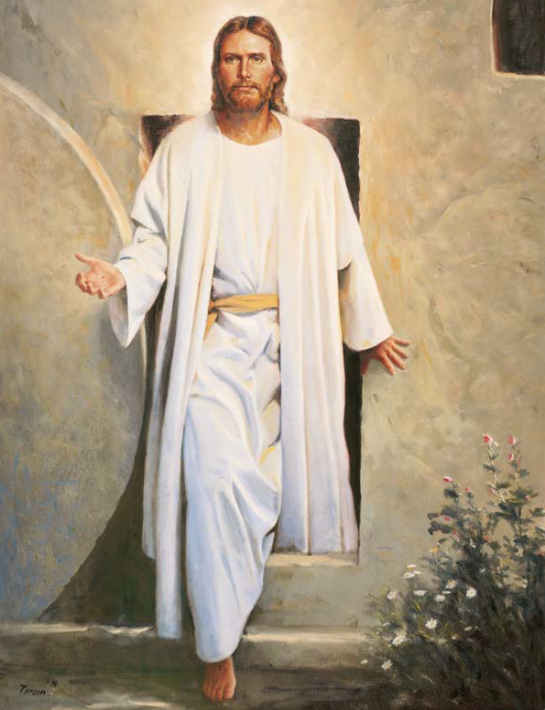
I’ll turn away from sin
And He will fill my heart with joy
When I return to Him

