When I hear the prophet’s voice
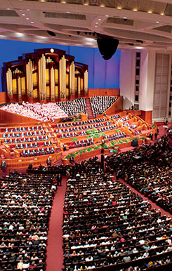
I feel closer to God
I listen and feel the Savior’s love
Deep within my heart
When I hear the prophet’s voice
I will gladly obey
I know that the Savior speaks through him
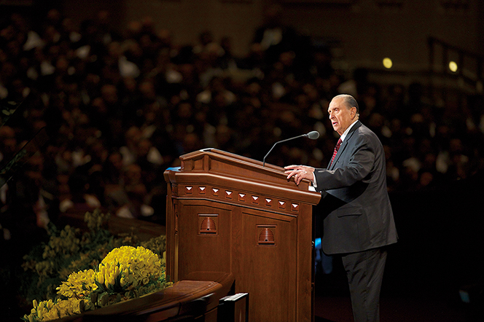
For our day

