When I hear of pioneer children



Of trials and courage and faith

I want to be willing as they were



To look to the Lord for my strength

I’ll follow the prophets as they did



For I want to build Zion too!

I’ll try to have faith to do hard things

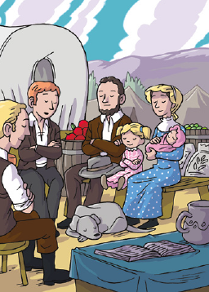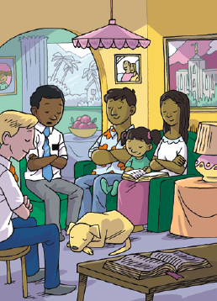

When that’s what He needs me to do

When I hear of pioneer children

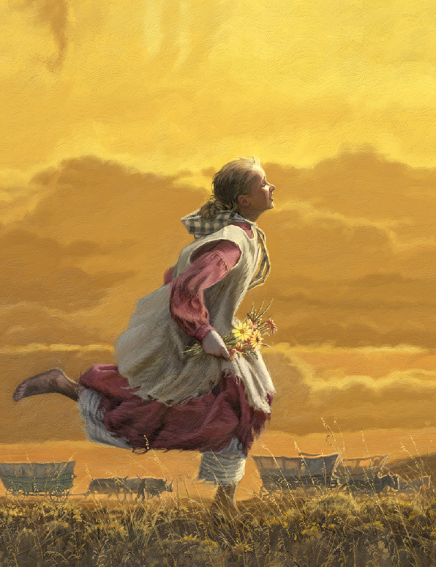

I want to be strong for my day

I’ll try to keep all the commandments

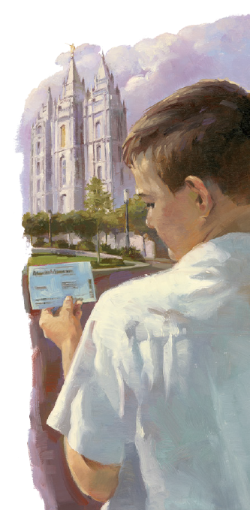

And be a true Latter-day Saint

I’ll stand as a shining example

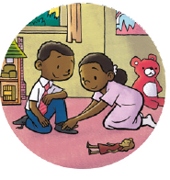

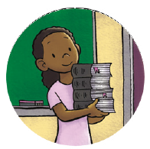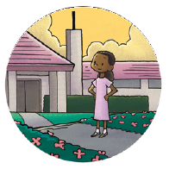

That others who follow will see

I’ll be like those pioneer children

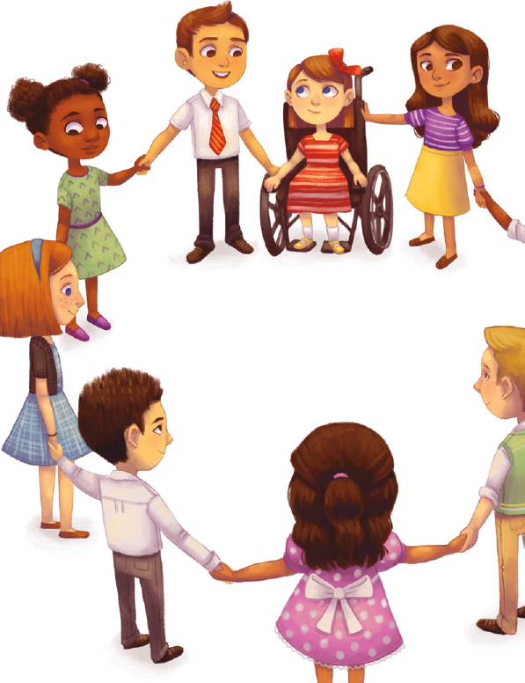

The Lord is depending on me