I like to look for rainbows
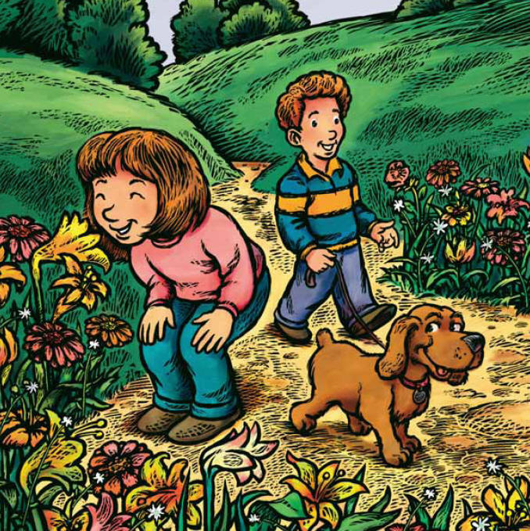
Whenever there is rain
And ponder on the beauty of an earth made clean again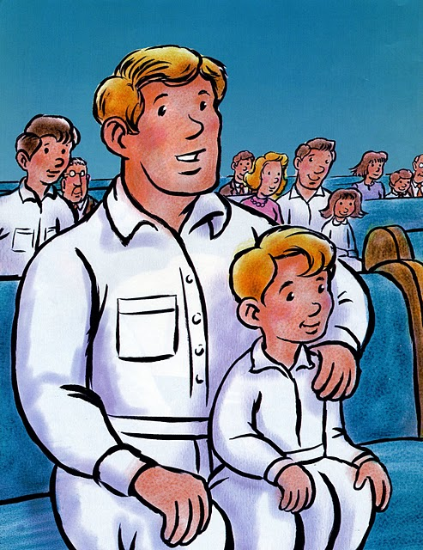
I want my life to be as clean as earth right after rain
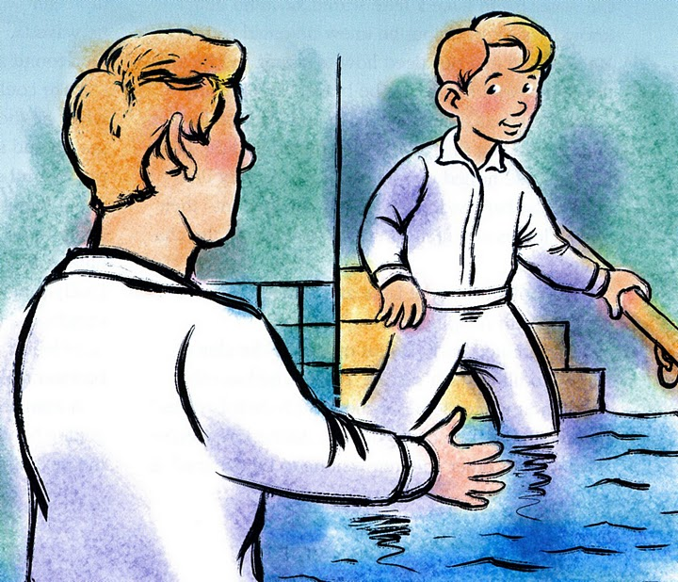
I want to be the best I can and live with God again
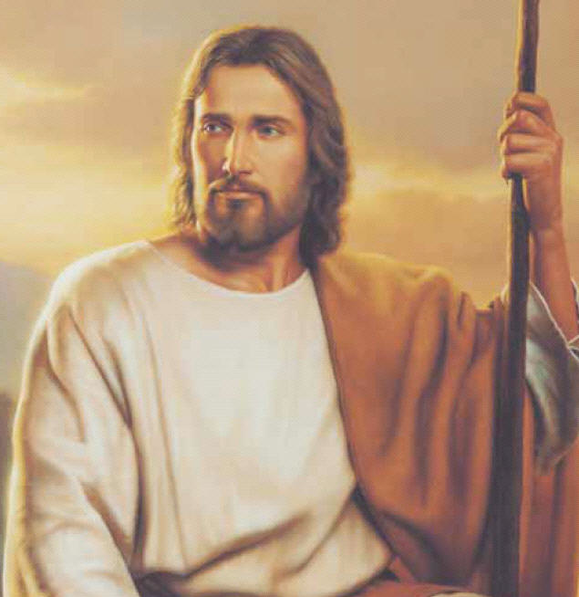
I know when I am baptized
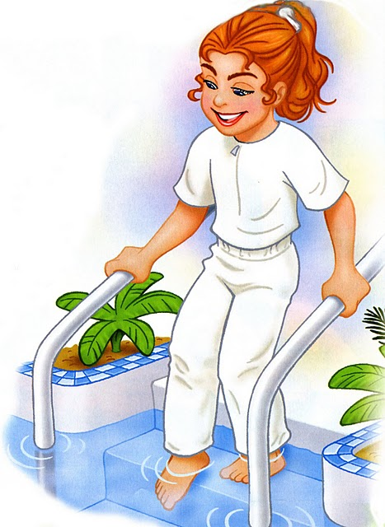
My wrongs are washed away
And I can be forgiven and improve myself each day
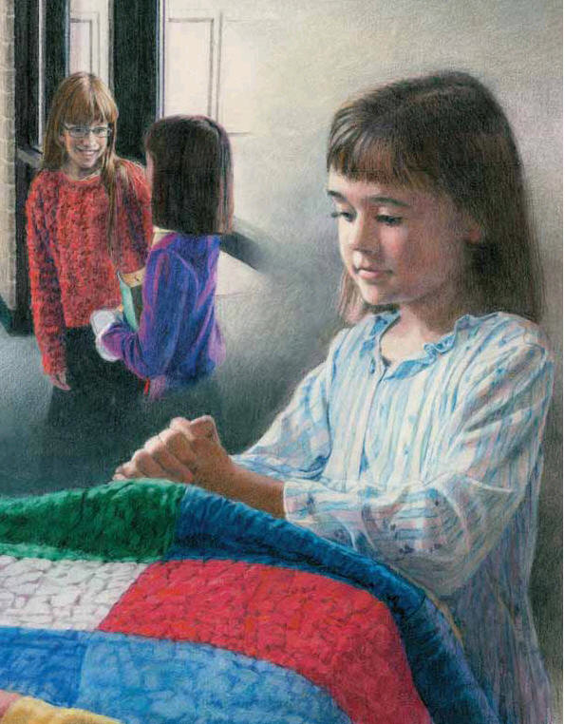
I want my life to be as clean as earth right after rain
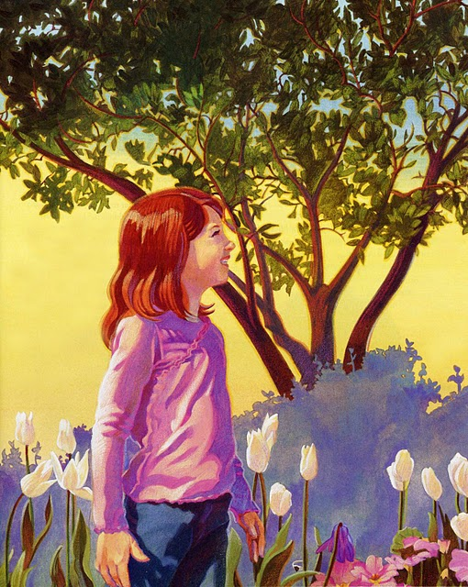
I want to be the best I can and live with God again
