We listen to a prophet’s voice
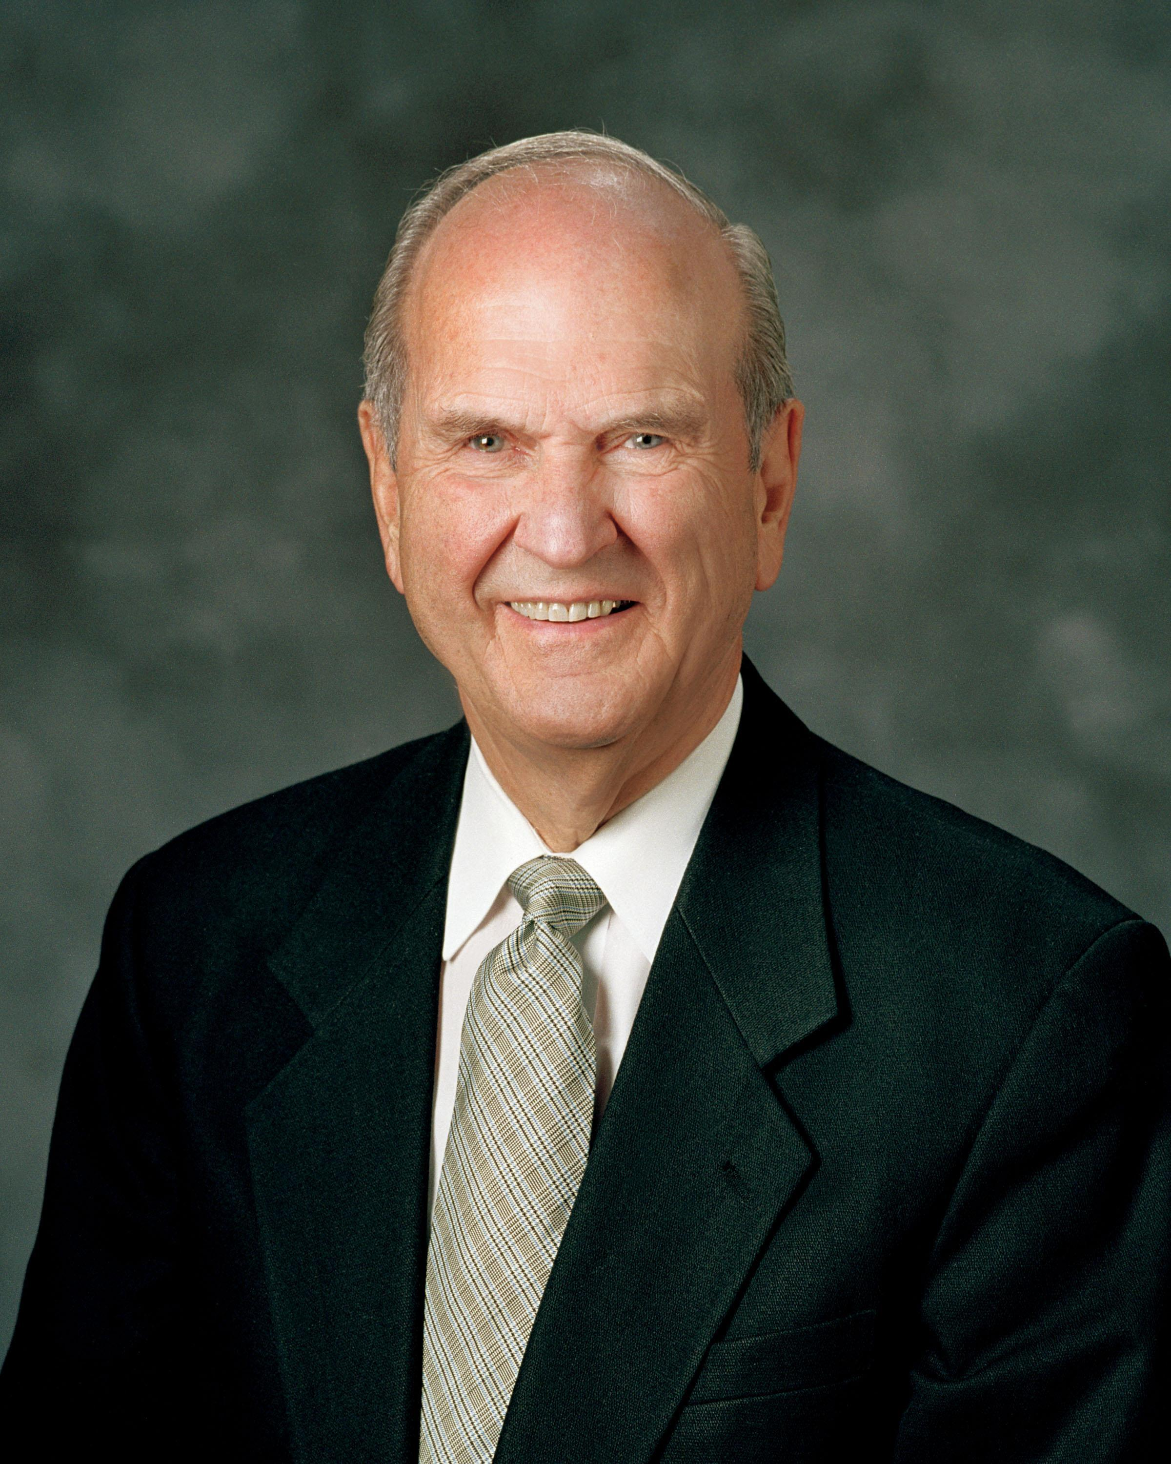
And hear the Savior too
With love he bids us do the work
The Lord would have us do
The Savior calls his chosen seer
To preach the word of God
That men might learn to find
The path marked by the iron rod
In ev’ry land, in ev’ry tongue
Our prophet will be heard
How swiftly round the world
His voice reveals the gospel word!
The sacred message that he brings
Will witness and agree
With ev’ry prophet called of God
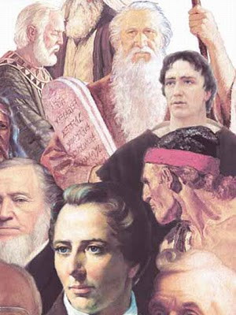
Throughout earth’s history
Hosanna! Let our praise ascend
Unto the Savior’s throne
Rejoice! The prophet has confirmed
That by Him we are known
Attend, ye earth! The prophet speaks
Come listen and obey
He is the man who holds the keys
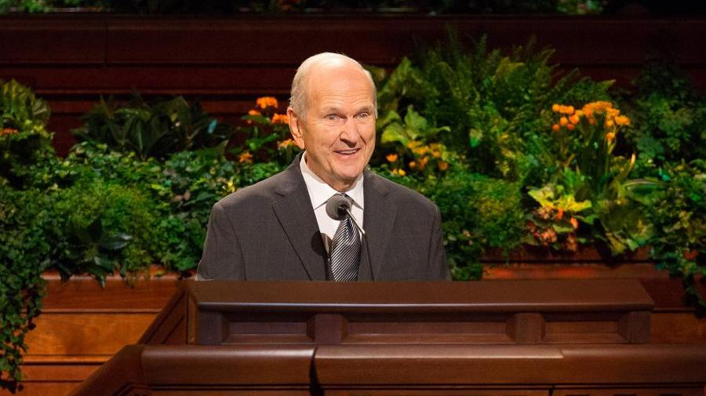
Of priesthood pow’r today

