We follow the prophet
We love to obey
We listen and learn
As he shows us the way
We follow him gladly
With faith in his word
For he speaks

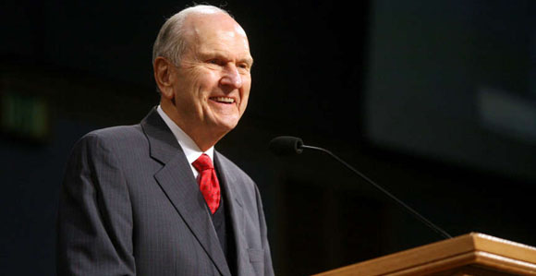

The will of the Lord

We honor the prophet
We lengthen our stride
We speak of him kindly
In love and in pride
We pray for the prophet
That he may be strong
Defending the right
And condemning the wrong

