I know you and you know me
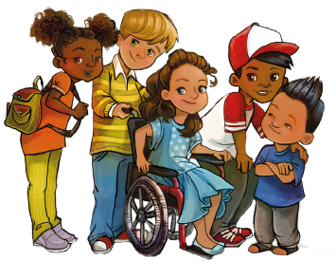
We are as different as the sun and the sea
I know you, and you know me
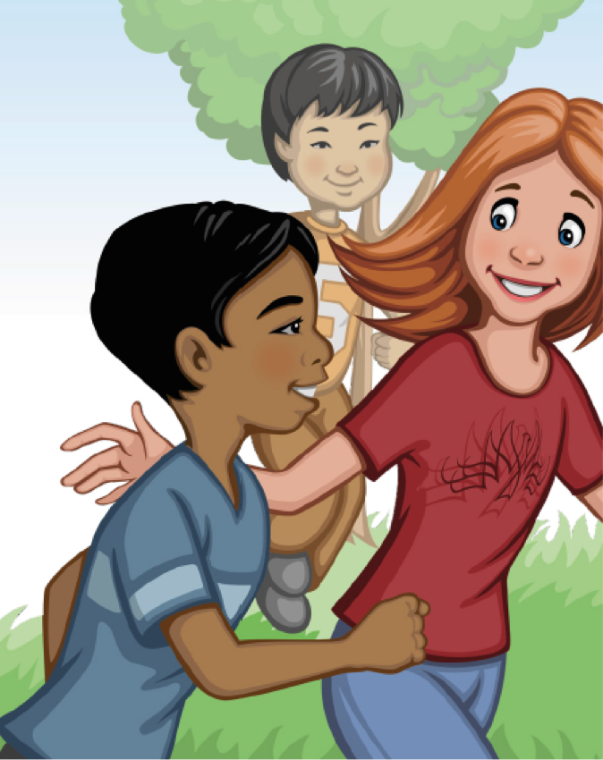
And that's the way it’s supposed to be
I help you, and you help me
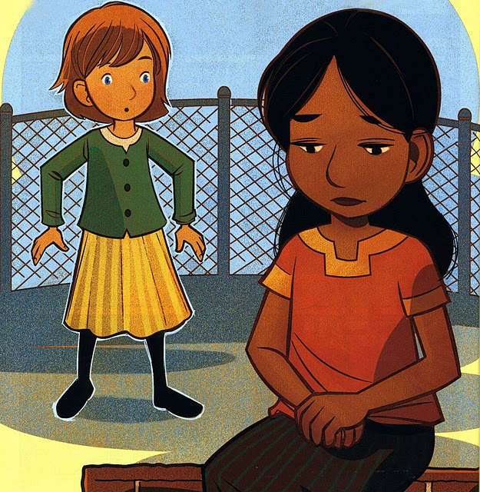
We learn from problems and we're starting to see
I help you and you help me
And that's the way it’s supposed to be
I love you, and you love me
We reach together for the best we can be
I love you, and you love me
And that's the way it’s supposed to be

