Visions of Christmas fill my mind
And dance before my eyes
I see a world of joy
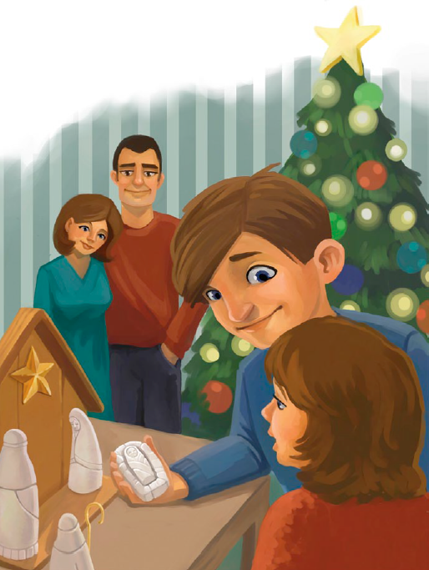
For ev’ry girl and boy
And feel the love of God
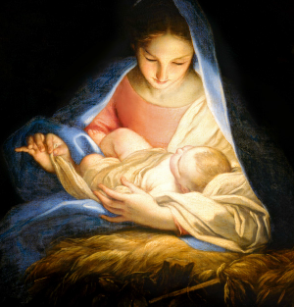
And feel the love of God
Visions of Christmas shine so bright
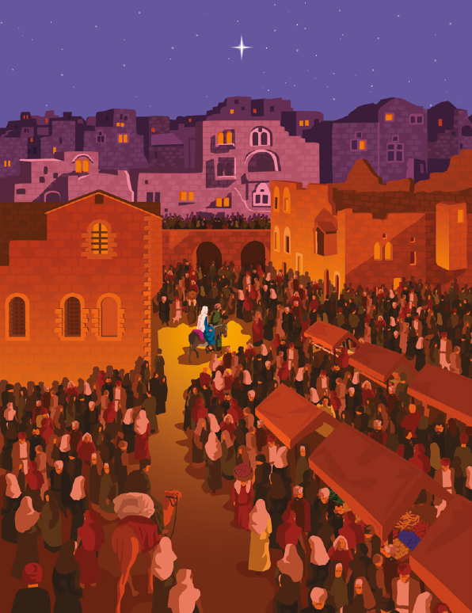
They speak of long ago
When Jesus came to earth
And angels sang His birth
And Wise Men brought Him gifts
And Wise Men brought Him gifts
Visions of Christmas in my heart
I understand them now
All men will live again
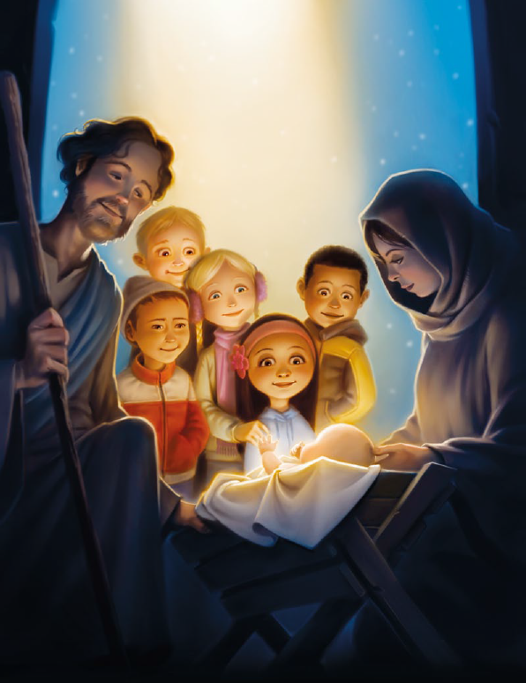
And Christ will come to reign
And He will bring us peace
And He will bring us peace
Visions of Christmas filled with love
For God and for all men
Gone will be hurt and fear
I’ll feel my Savior near
And He will hold me close
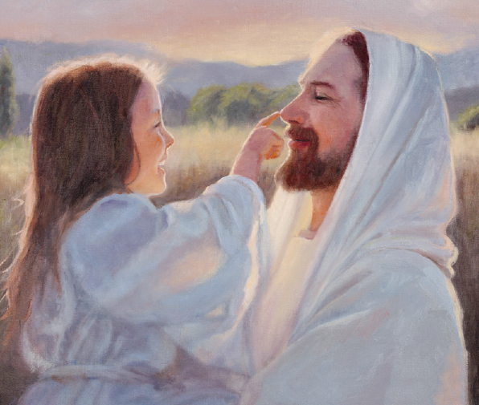
And He will hold me close

