Two thousand stripling warriors
Young men of pow’r and might
Responded to the battle cry
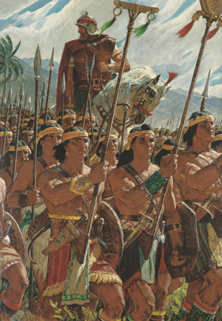
O who will stand and fight?
Behold, our God is with us!
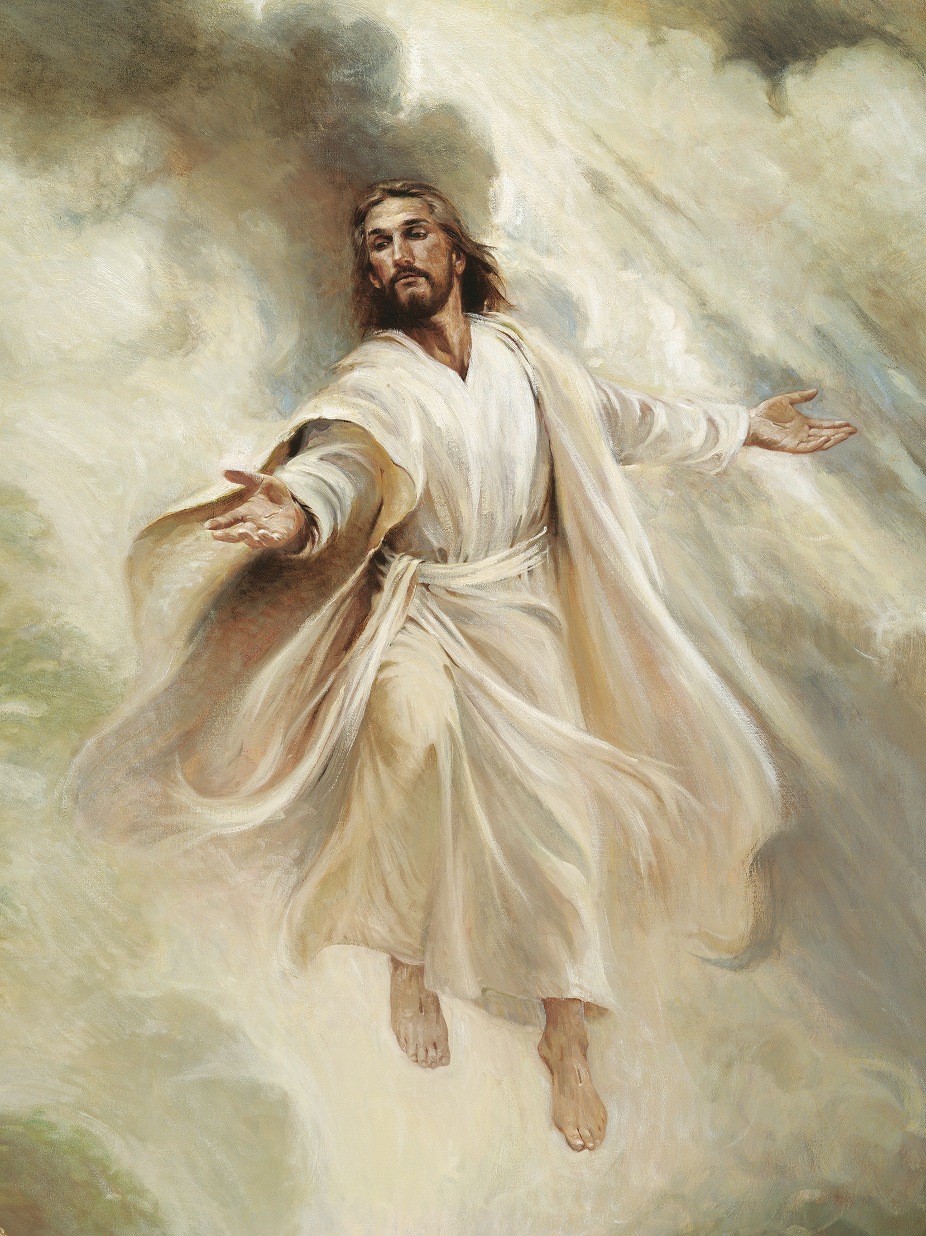
We serve at His command
They did not fear to give their lives
But boldly took a stand
This willing band of brothers

Were by their mothers taught
To trust in God continually
Be true in deed and thought
For God would then protect them
Their faith He would reward
They did not doubt their mothers knew

They trusted in the Lord
With Helaman
their leader
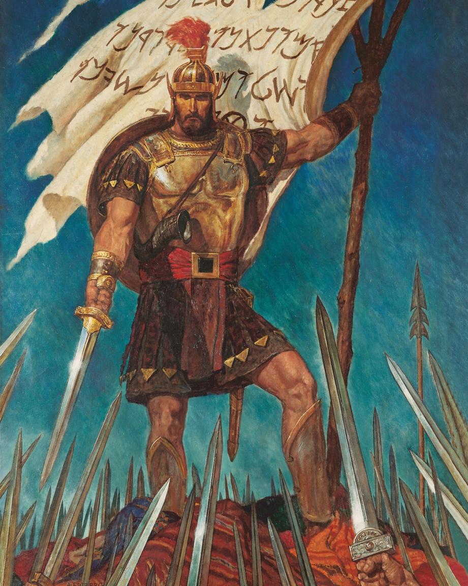
This valiant brotherhood
United in exceeding faith
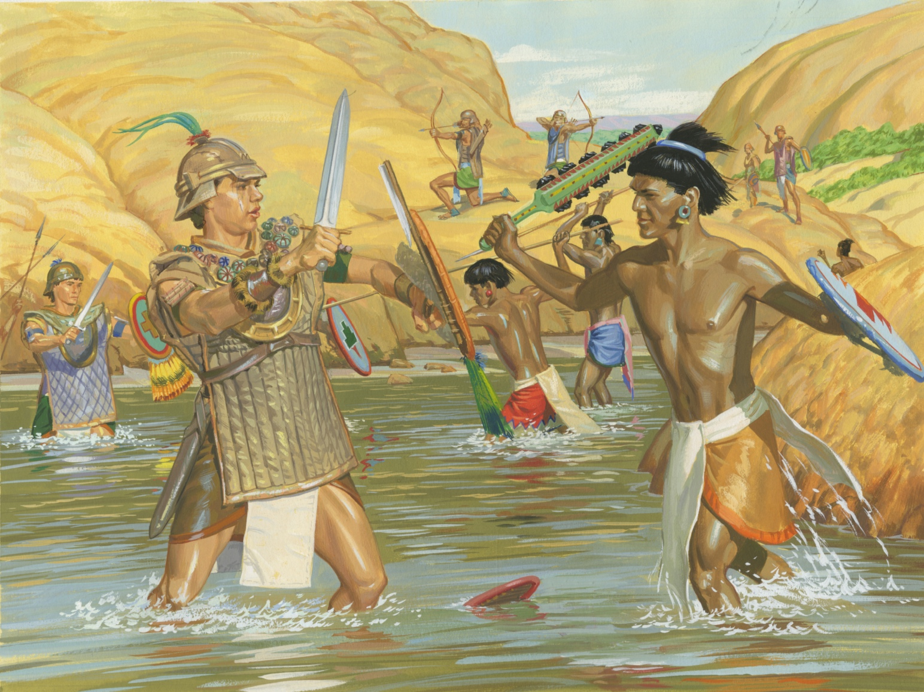
And fearlessly they stood
With no desire for bloodshed
but wanting to be free
They fought for life and liberty
For God and family
Two thousand stripling warriors
Courageous for their cause
Went forth as with the strength of God
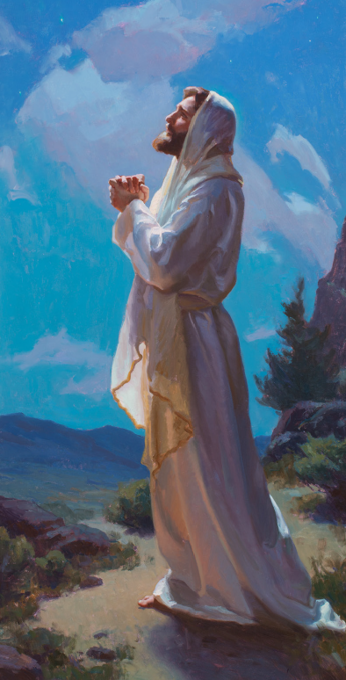
And not one soul was lost
Their faith had made them mighty
Their strength was multiplied
They fought with pow’r beyond their own
For God was on their side

