Joseph Smith when humbly praying
Saw the Father and the Son
As They are in all Their glory
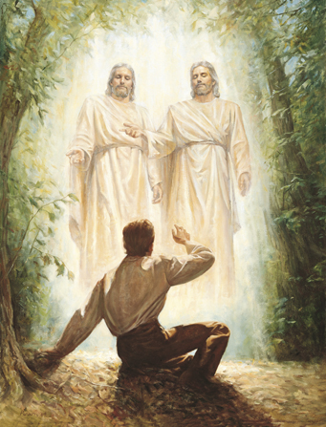
Brighter than the noonday sun
Give Them glory give Them honor
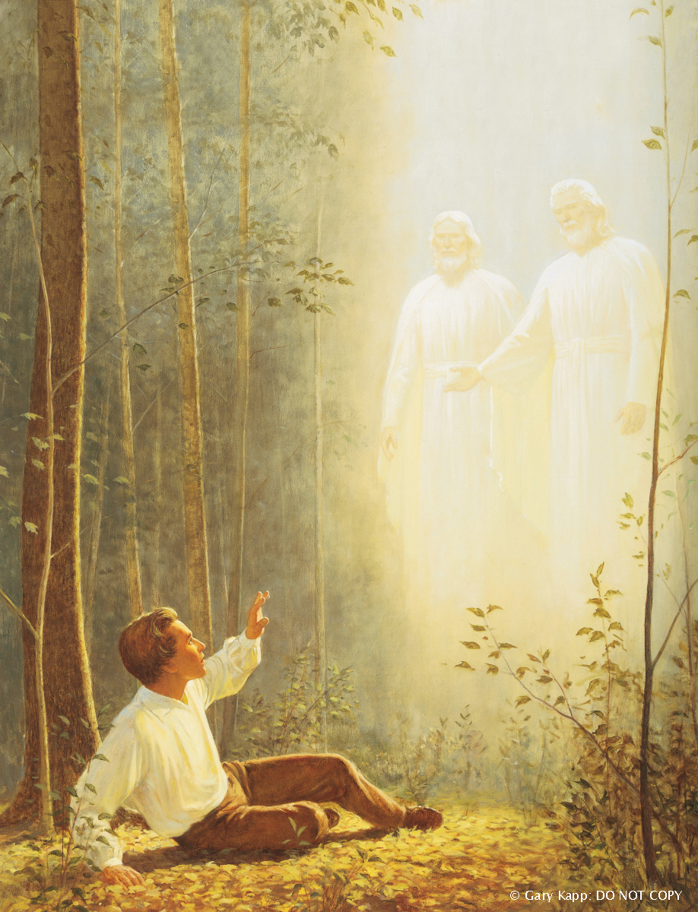
For the truths restored through prayer
God above shall beam His light
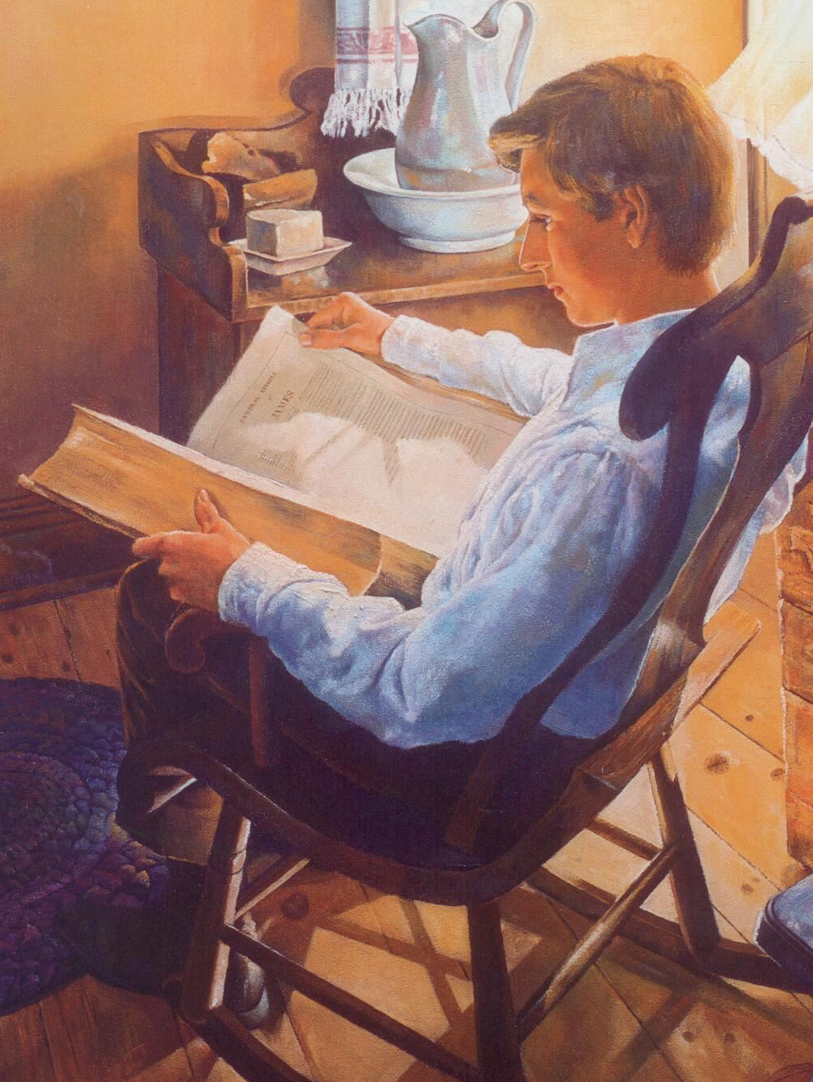
Into your heart these truths to share
Joseph then was called by God
To bring to light His holy word
In the Book of Mormon we will find
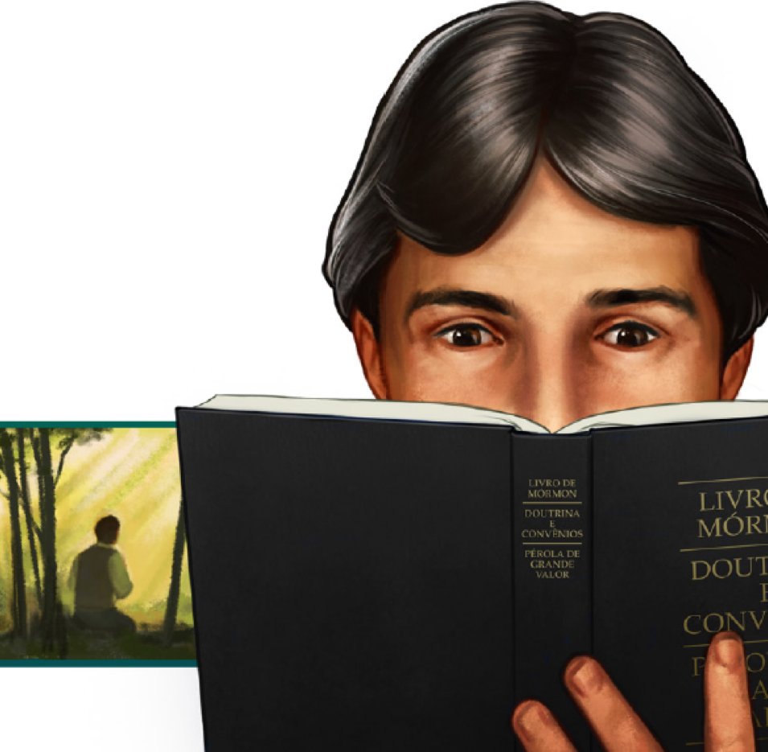
God’s precious truth restored
Read it daily, seek and ponder
And lift up your soul in prayer
God above shall beam His light
Into your heart its truth to share

