Tree of Life

by Shawna Edwards
(music available at www.shawnaedwardsmusic.com)

The prophet Lehi had a vision
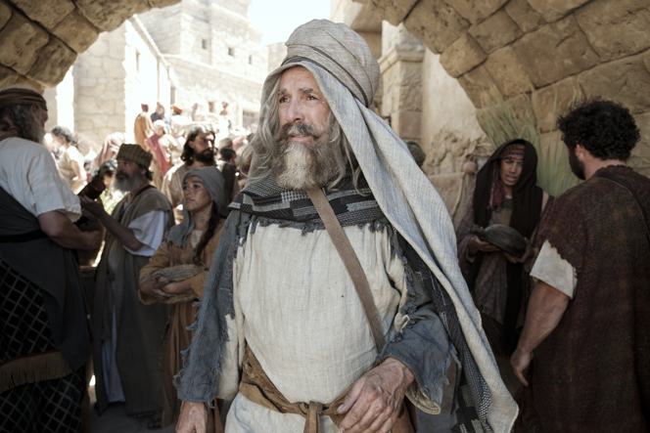
of the Tree of Life
He saw it shining in the distance
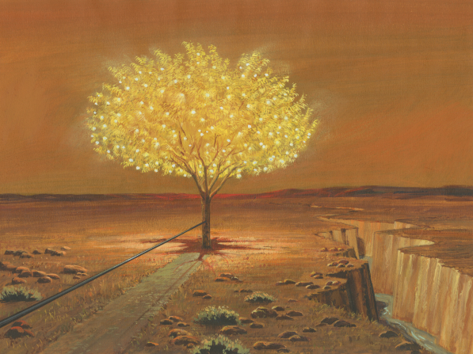
so beautiful and bright
The sweetest fruit he ever tasted
and white as white could be
It filled his soul
with joy and gladness
He beckoned to his family
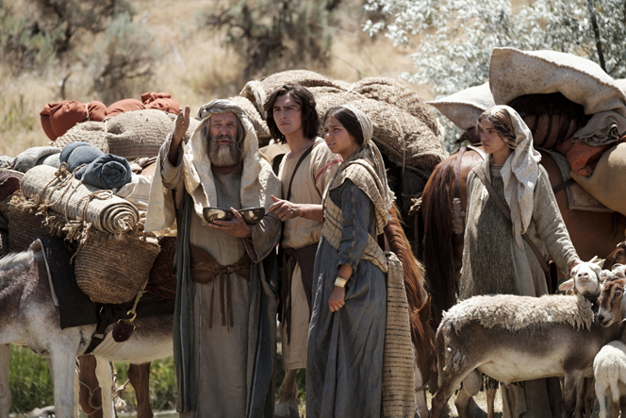

Come to the Tree of Life
partake of the fruit
I feel the love of God
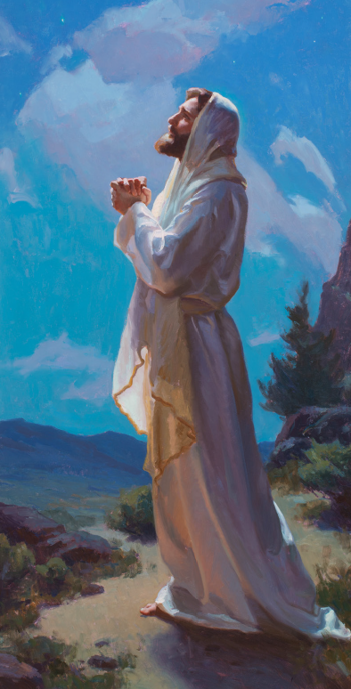
And you’ll feel it too
When you come to the Tree of Life
There’s joy here and peace
The greatest place in all the world
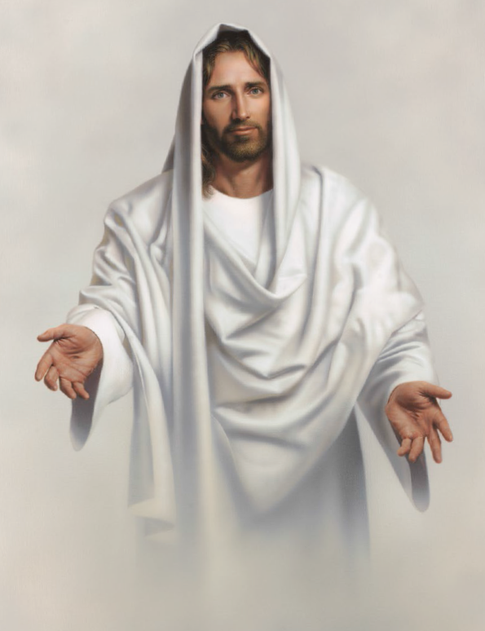
to be is at the Tree
The Tree of Life is just a symbol
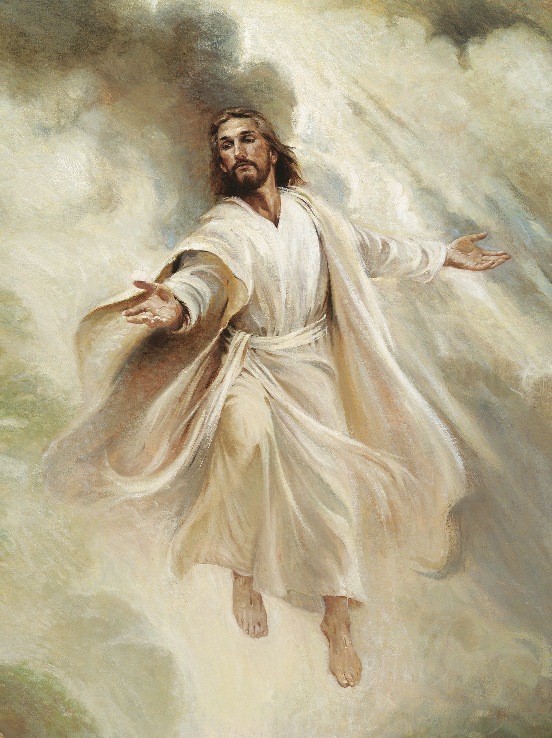
of the Love of God

The pathway there
is straight and narrow
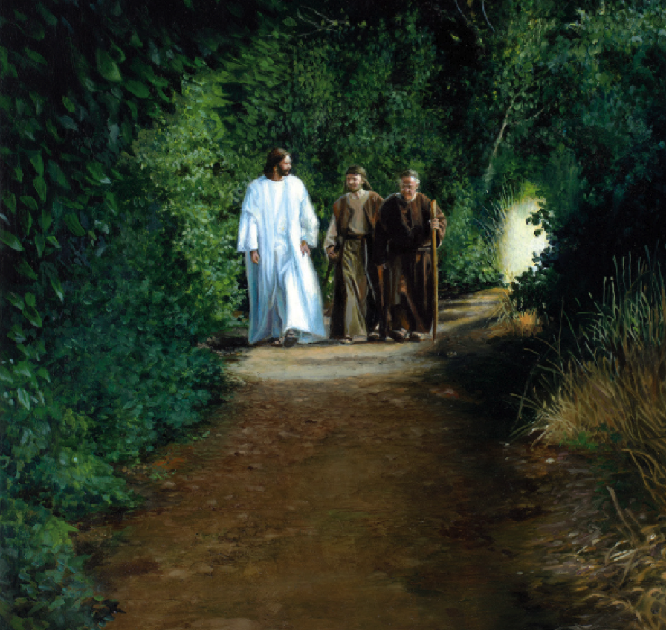
so hold on to the rod
His words will guide us through
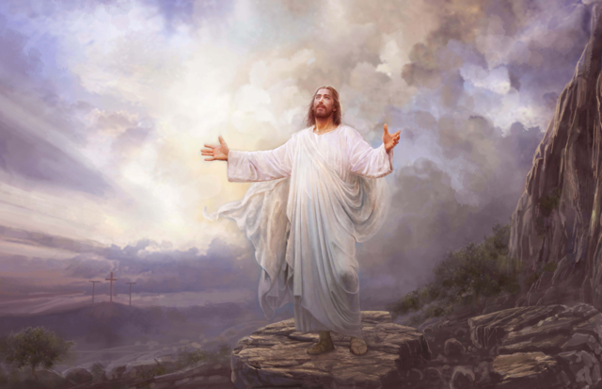
the darkness and past the mist of gray
The enemies of God may mock us
but we will boldly stand and say
The greatest place in all the world
to be is at the Tree

