It shouldn’t be hard to sit very still
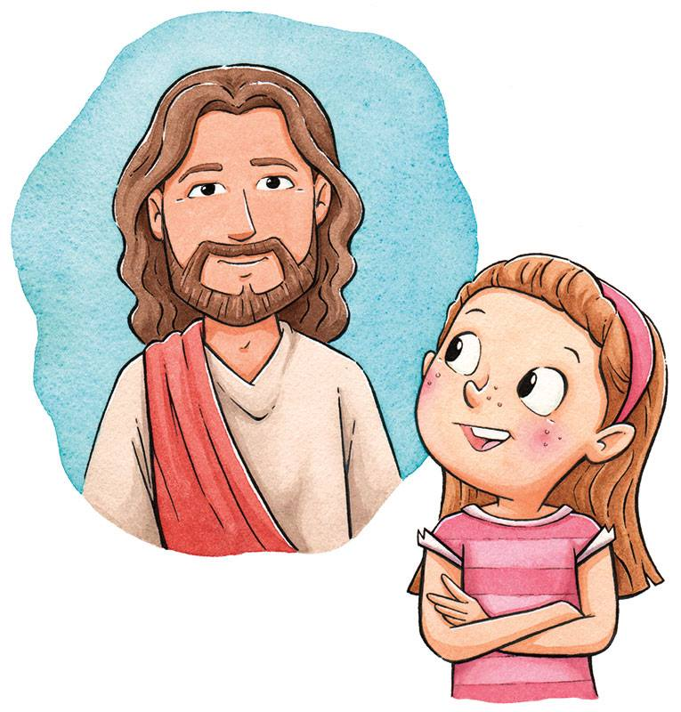
And think about Jesus, his cross on the hill
And all that he suffered and did for me
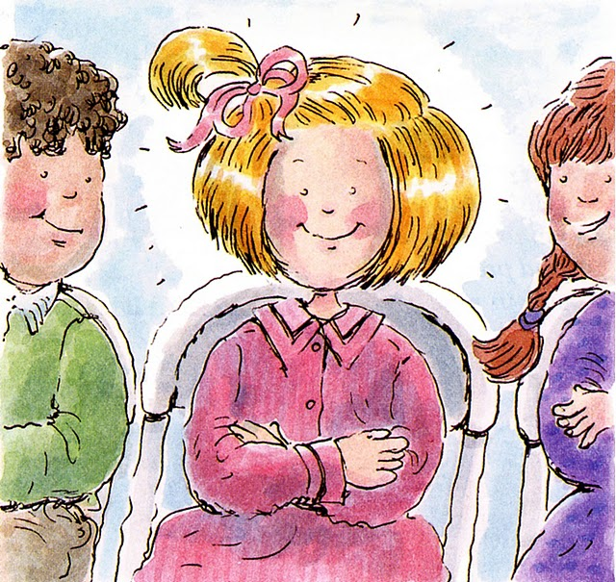
It shouldn’t be hard to sit quietly
It shouldn’t be hard even though I am small
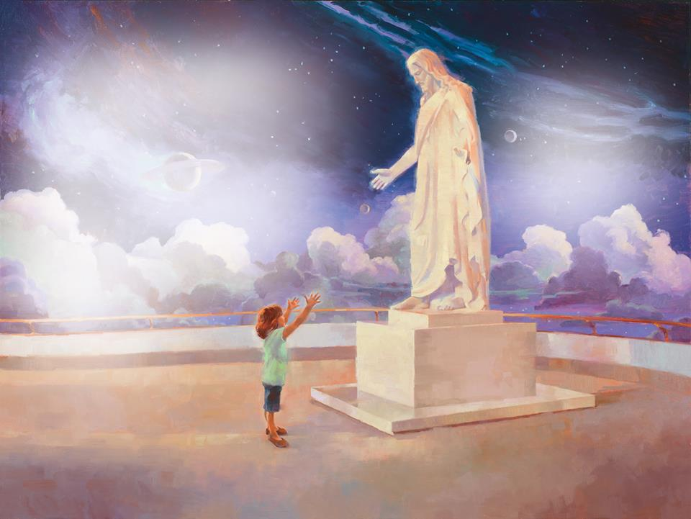
To think about Jesus not hard at all
I think of the miles he walked in the dust
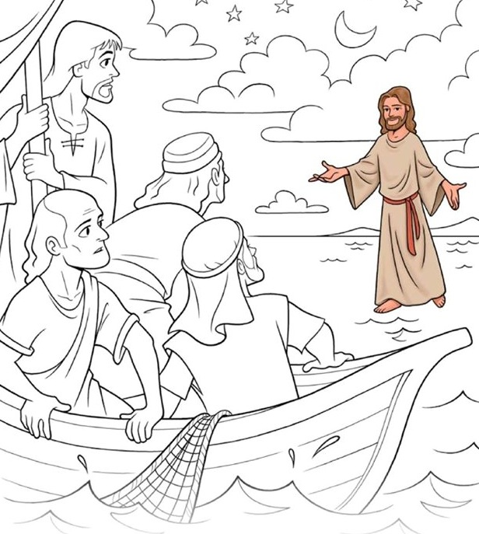
And children he helped to love and to trust
It shouldn’t be hard to sit tall in my seat
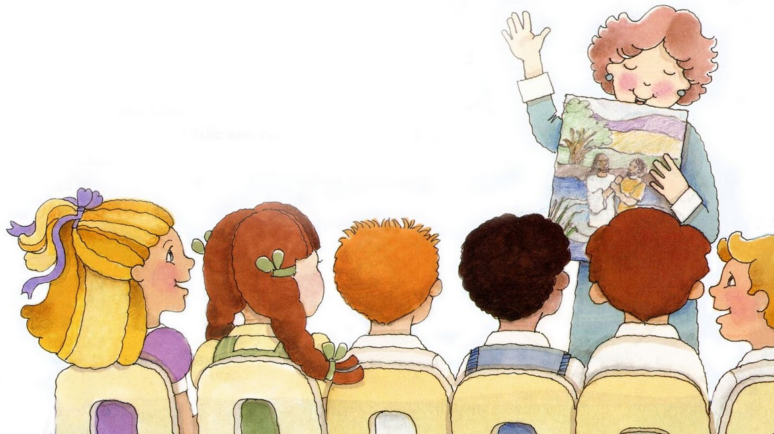
To listen politely to quiet my feet
It shouldn’t be hard even though I am small
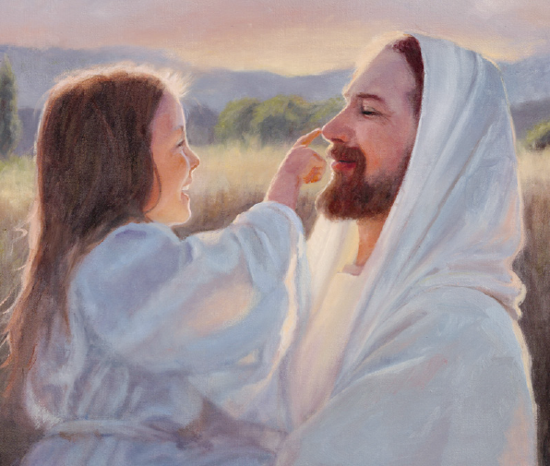
To think about Jesus not hard at all

