One, two, I stretch up tall
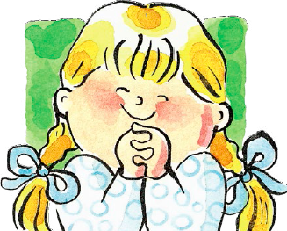
Then I turn around

Three, four, I sit up tall
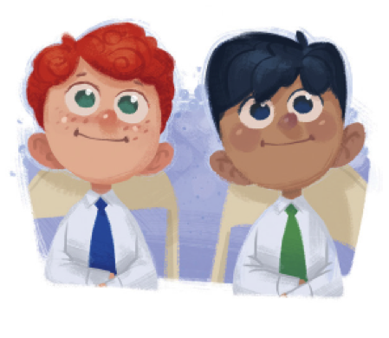
And never make a sound

