There is a green hill far away
Without a city wall
Where the dear Lord was crucified
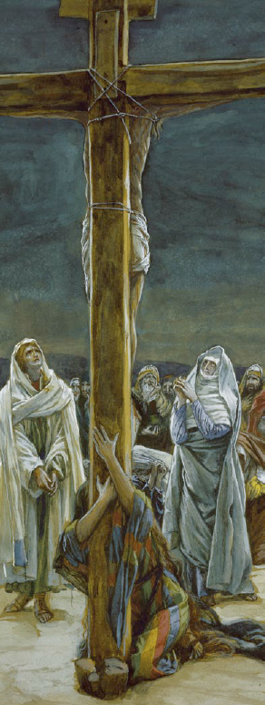
Who died to
save us all
We may not know
we cannot tell
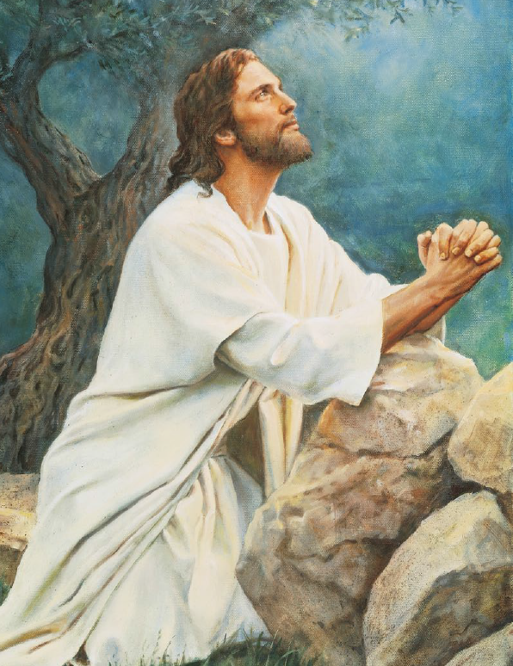
What pains he had to bear
But we believe it was for us
He hung and suffered there
There was no other good enough
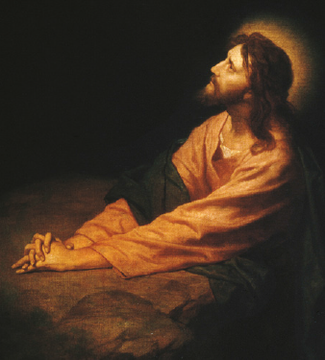
To pay the
price of sin
He only could unlock the gate
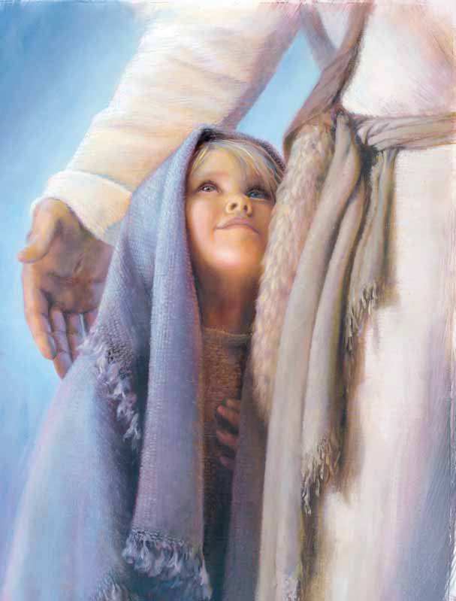
Of heav'n and
let us in
Oh, dearly, dearly has he loved!
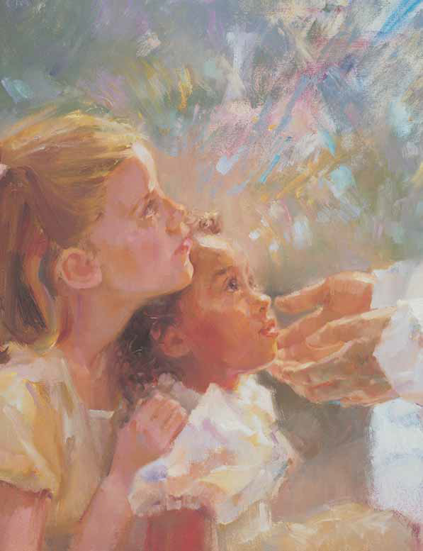
And we must love him too
And trust in his redeeming blood
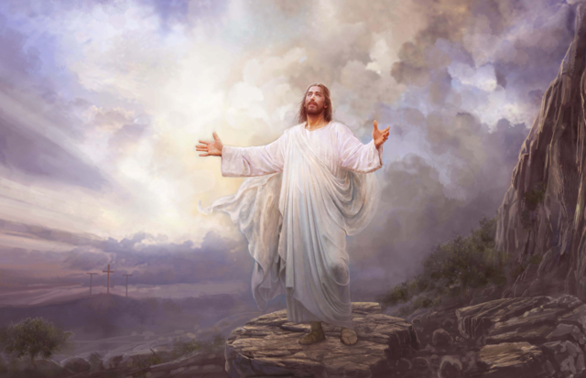
And try his
works to do

