Their Mothers Knew

by Monica Scott

www.monicascottmusic.com

Taught by their mothers while in their youth

Armed with the light of His truth
They knew the Lord would always be near
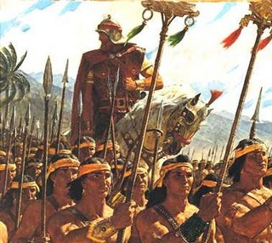
Into battle they did not fear
Helaman’s two thousand
Knew their mothers loved the Lord
At their mother’s knees
They learned to trust in His word
With courage and faith they stayed true
They did not doubt
Their mothers knew
Taught by our mothers while in our youth,
Armed with the light of His truth
Preparing for the battles in store

Like the warriors who came before
They did not doubt
Their mothers knew

