Shepherds, shepherds leave your lambs
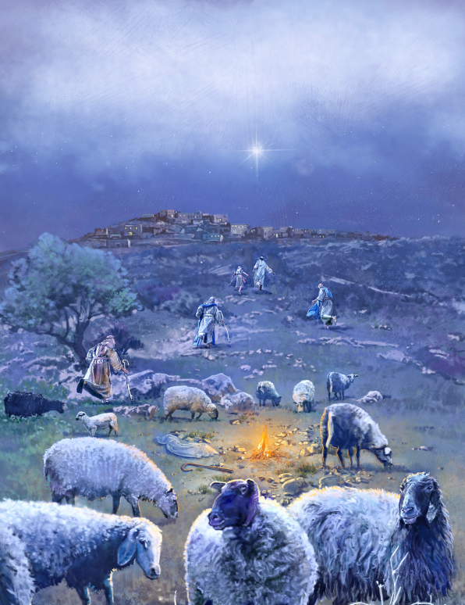
And find the way to Bethlehem
For the Baby sleeping there
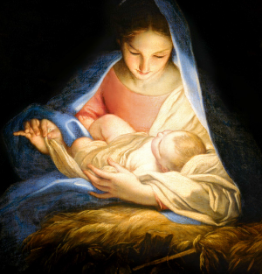
Is your Savior good and fair
Wise Men, look up to the sky
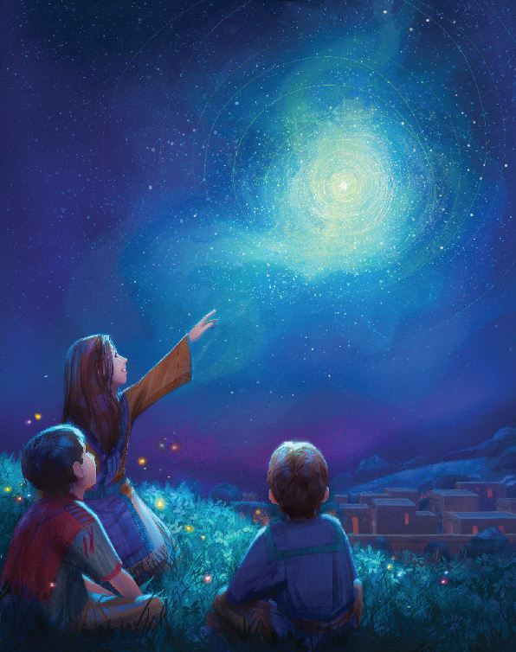
For one bright star to travel by
Bring your gold and precious things
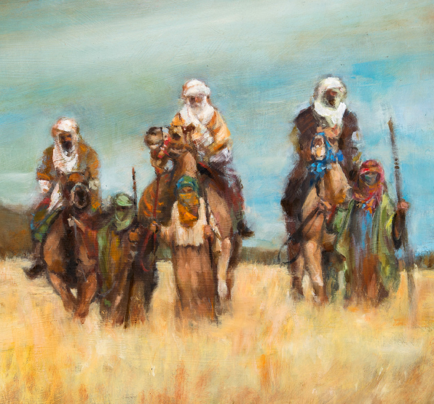
Kneel before the King of kings
See how Mary holds her Son
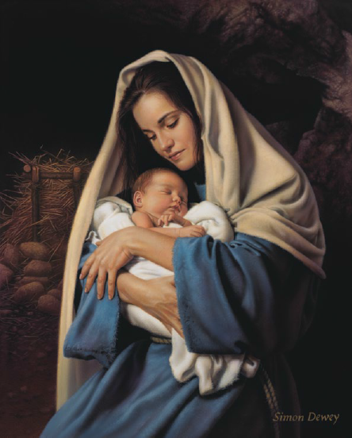
Jesus Christ, the Holy One
Joseph guards with tender care
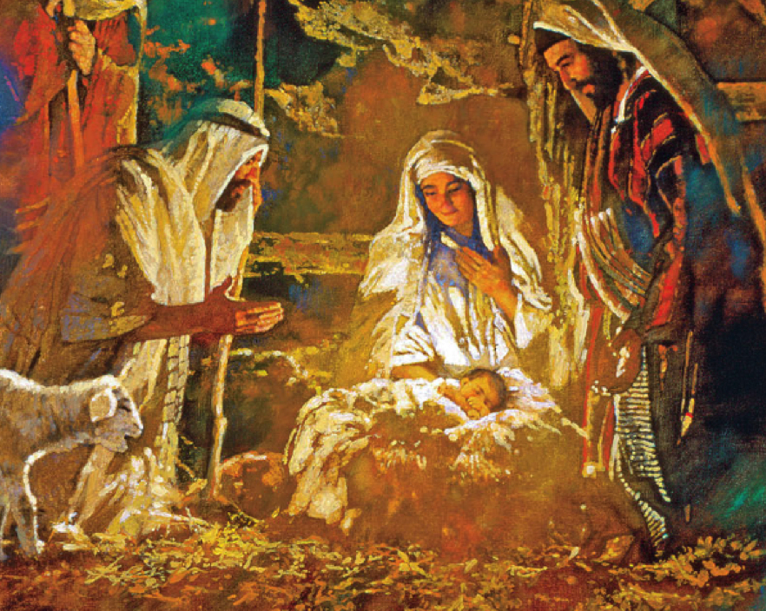
Peace and gladness fill the air
Stars and angels shine His light
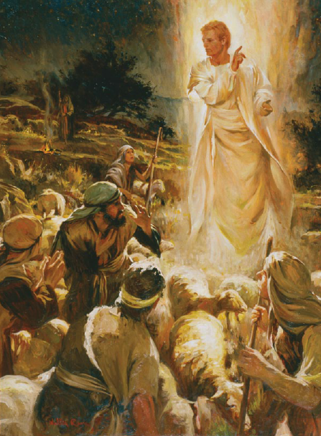
Find the way to Bethlehem tonight
Find your way
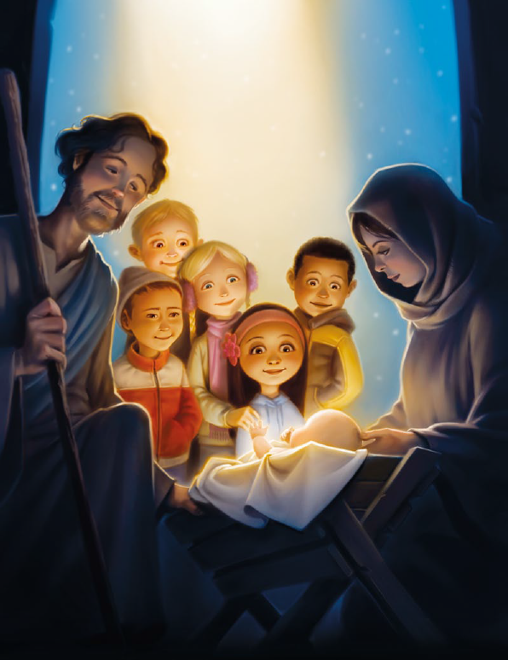
This holy Christmas night

