That silent night!
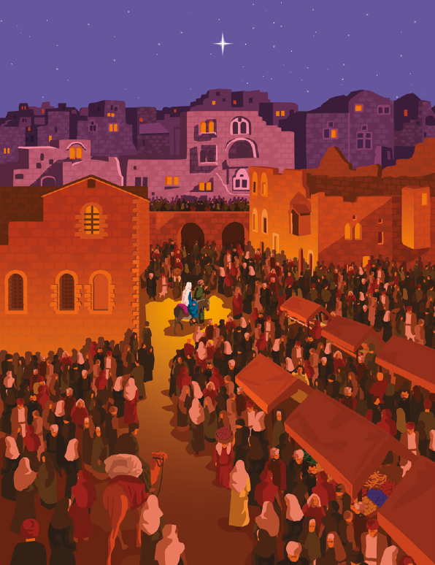
That holy night!
The world was hushed and longing
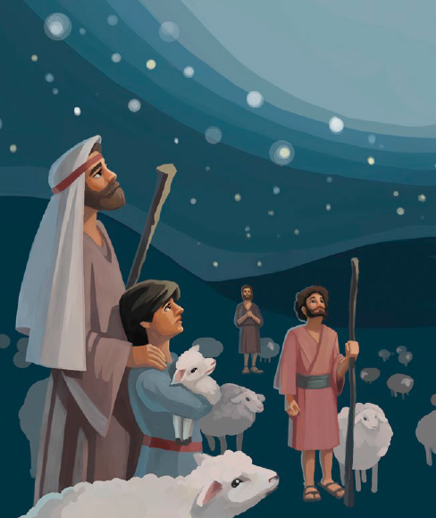
For the gift of God’s eternal light
That child divine, God’s only son
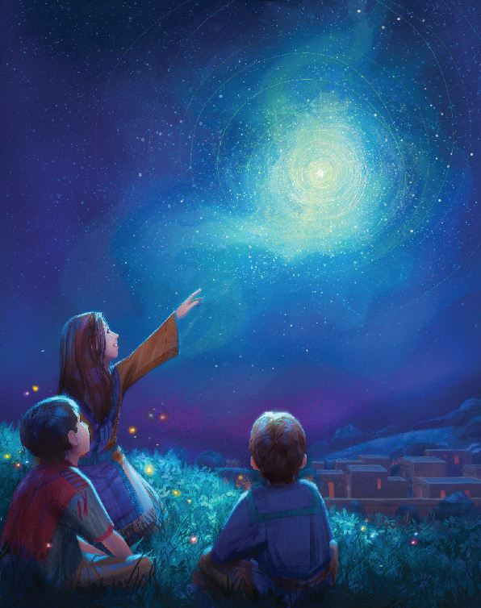
Born this starry night in Bethlehem
Alleluia, Alleluia
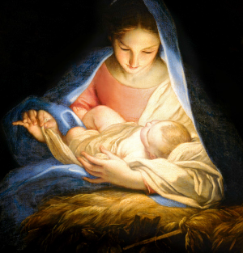
Hearts rejoice in hope and love forever sing
Alleluia, Alleluia
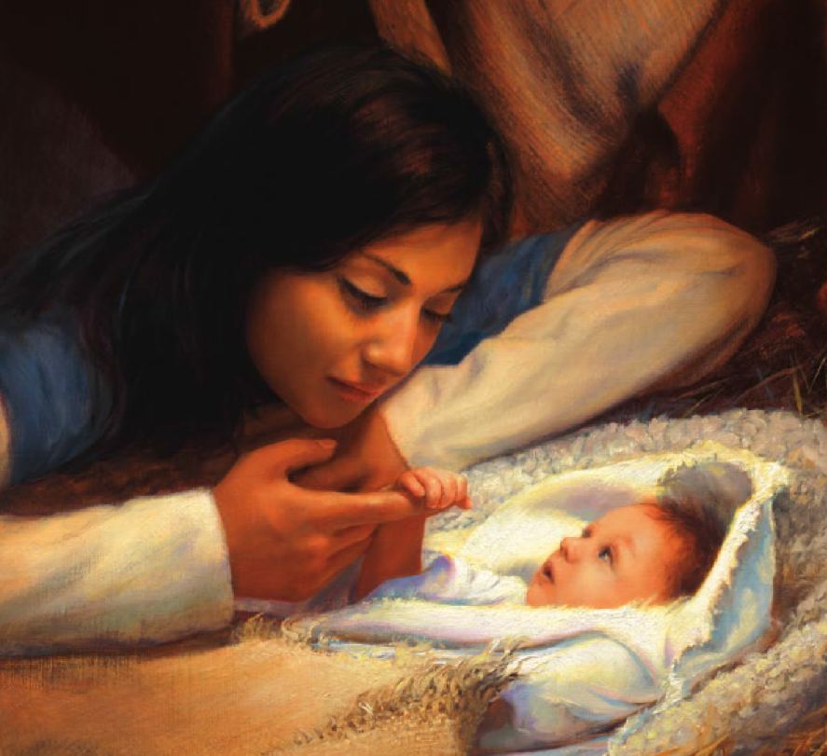
Ever praise and sing for our Eternal King
Alleluia, Alleluia
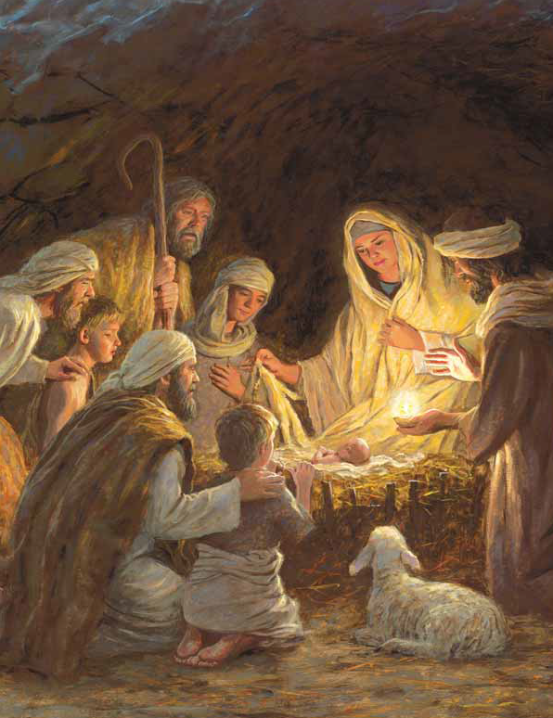

The shepherds came
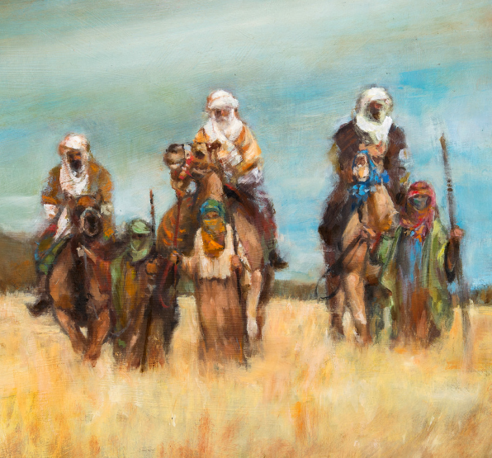
The wise men’s sight
To look upon the precious gift of wonder
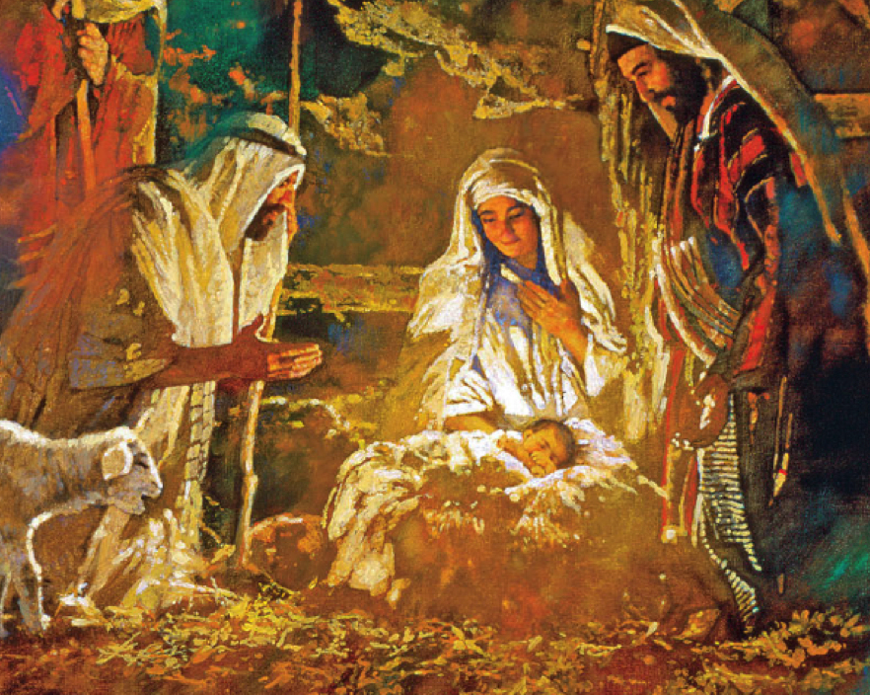
God’s eternal light
That child divine, God’s only son
Born this starry night in Bethlehem
Alleluia, Alleluia
Hearts rejoice in hope and love forever sing
Alleluia, Alleluia
Ever praise and sing for our Eternal King
Alleluia, Alleluia

