- The Spirit of God
- 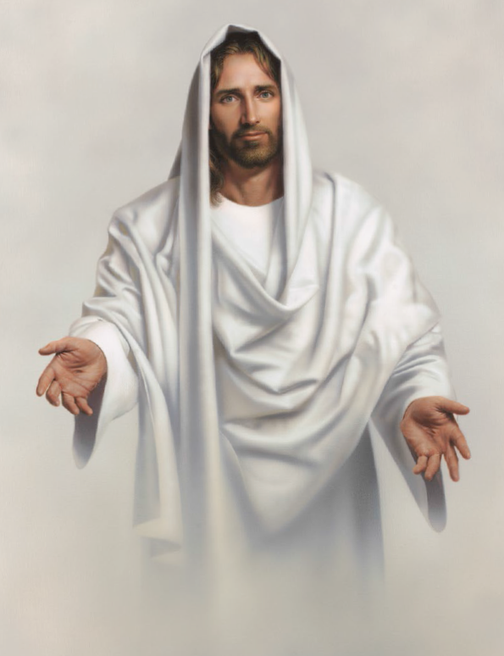
- Like a fire is burning!
- The latter-day glory
- Begins to come forth
- The visions and blessings
- 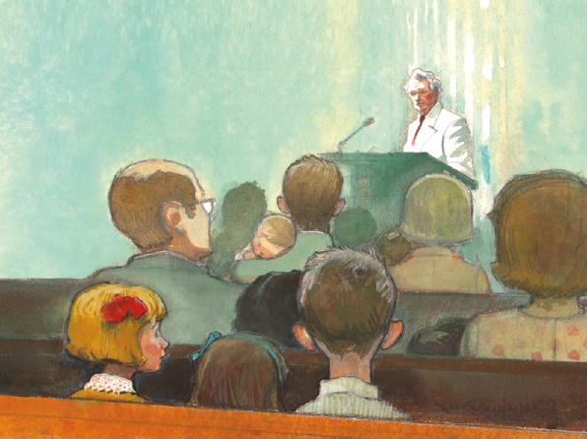
- Of old are returning
- And angels are coming
- 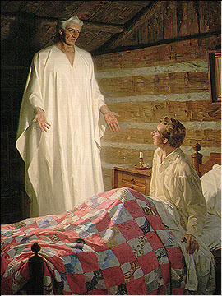
- To visit the earth
We'll sing and we'll shout
With the armies of heaven
Hosanna, hosanna
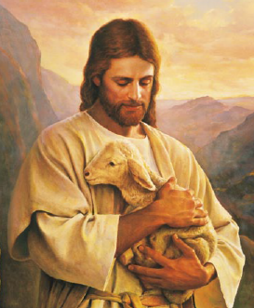
To God and the Lamb!
Let glory to them
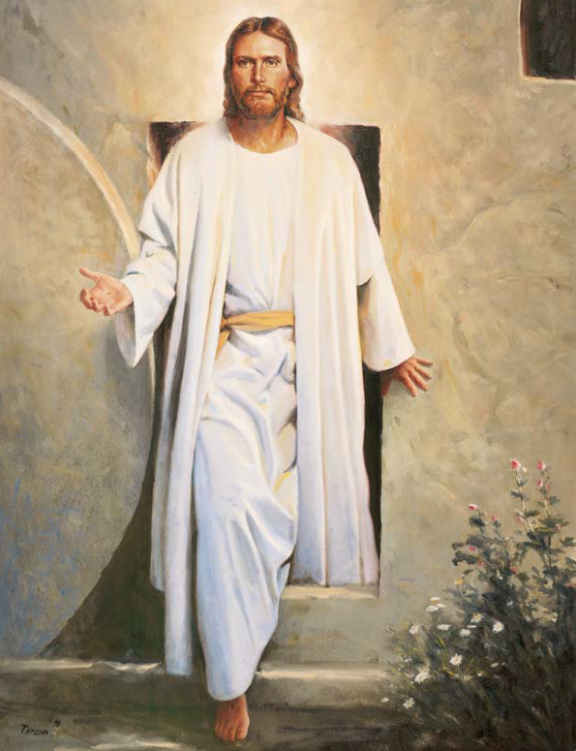
In the highest be given
Henceforth and forever
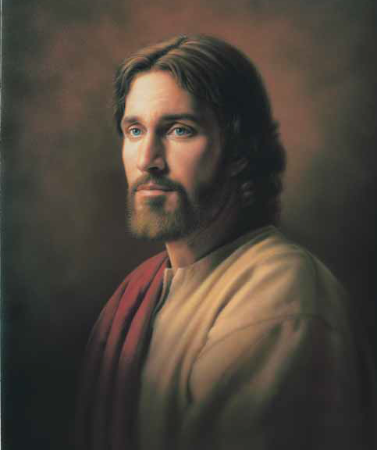
Amen and amen!
- The Lord is extending
- 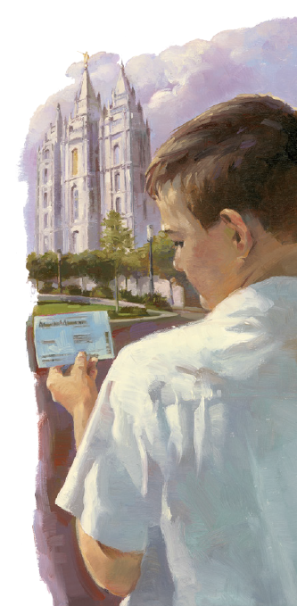
- The Saints' understanding
- Restoring their judges

- 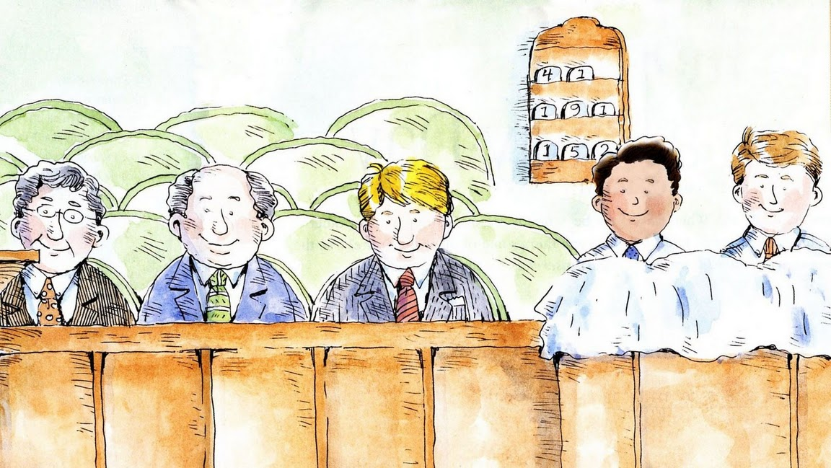

- And all as at first
- The knowledge and power
- Of God are expanding
- The veil o'er the earth
- 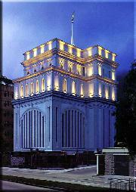
- Is beginning to burst
- We'll call in
- 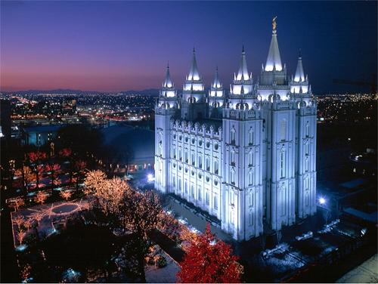
- Our solemn assemblies in spirit
- To spread forth the kingdom
- Of heaven abroad
- That we through our faith
- May begin to inherit
- The visions and blessings
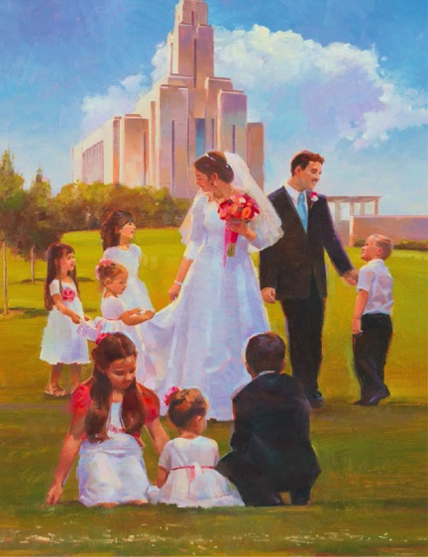
- And glories of God
How blessed the day
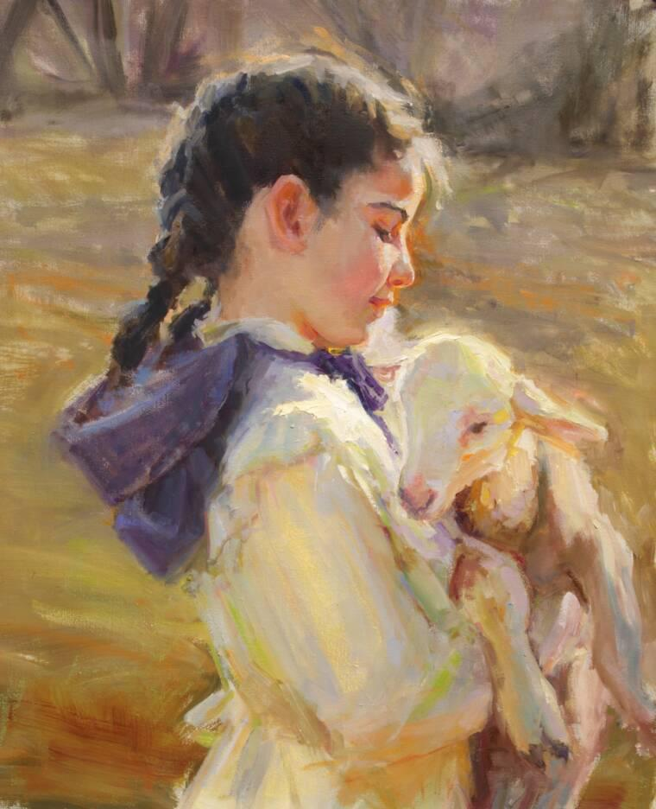
When the lamb and the lion
Shall lie down together
Without any ire
And Ephraim be crowned
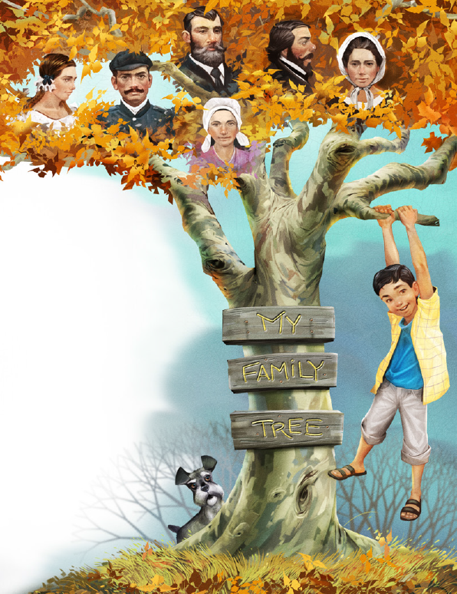
With his blessing in Zion
As Jesus descends
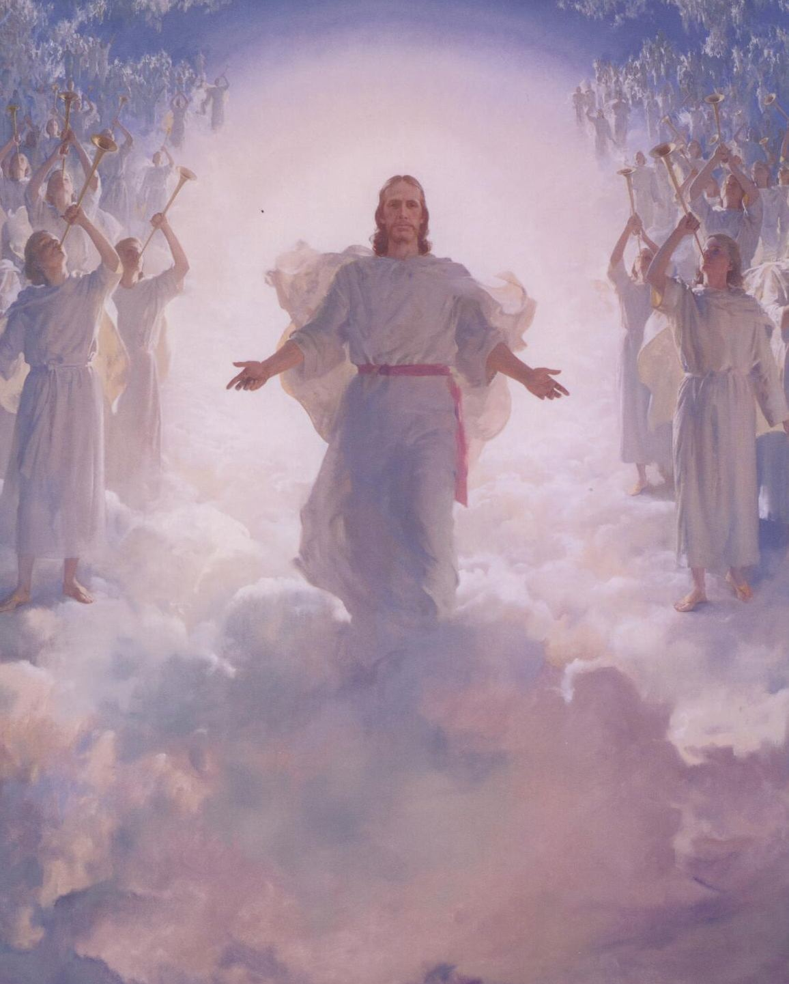
With his chariot of fire!

