The Savior’s Gift to Me

By
Annie Bailey
The Sheet Music is Available at
http://www.anniebailey.com/digital-sheet-music.html

Long ago in Gethsemane
The Savior gave a great gift to me
He paid the price for all my sins
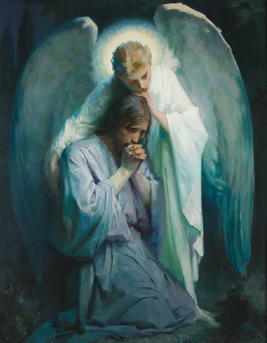
He suffered just for me
He wants me to take His gift and try to do better
Try to do better each day
When I make a mistake
The Savior still loves me
He always loves me
Loves me and wants me to grow each day
Long ago Christ went willingly
To give up his life
To die for me
He paid the price for all my sins
He suffered just for me
He wants me to take His gift and try to do better
Try to do better each day
When I make a mistake
The Savior still loves me
He always loves me
Loves me and wants me to grow each day

