The Sacred Grove
was green and fresh 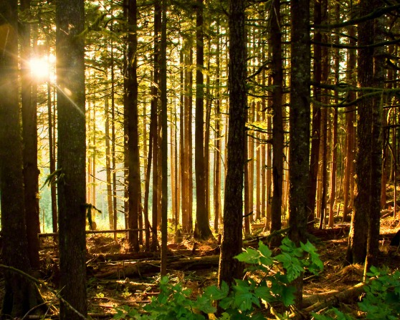
The morning sun shone bright around
As Joseph knelt in fervent prayer
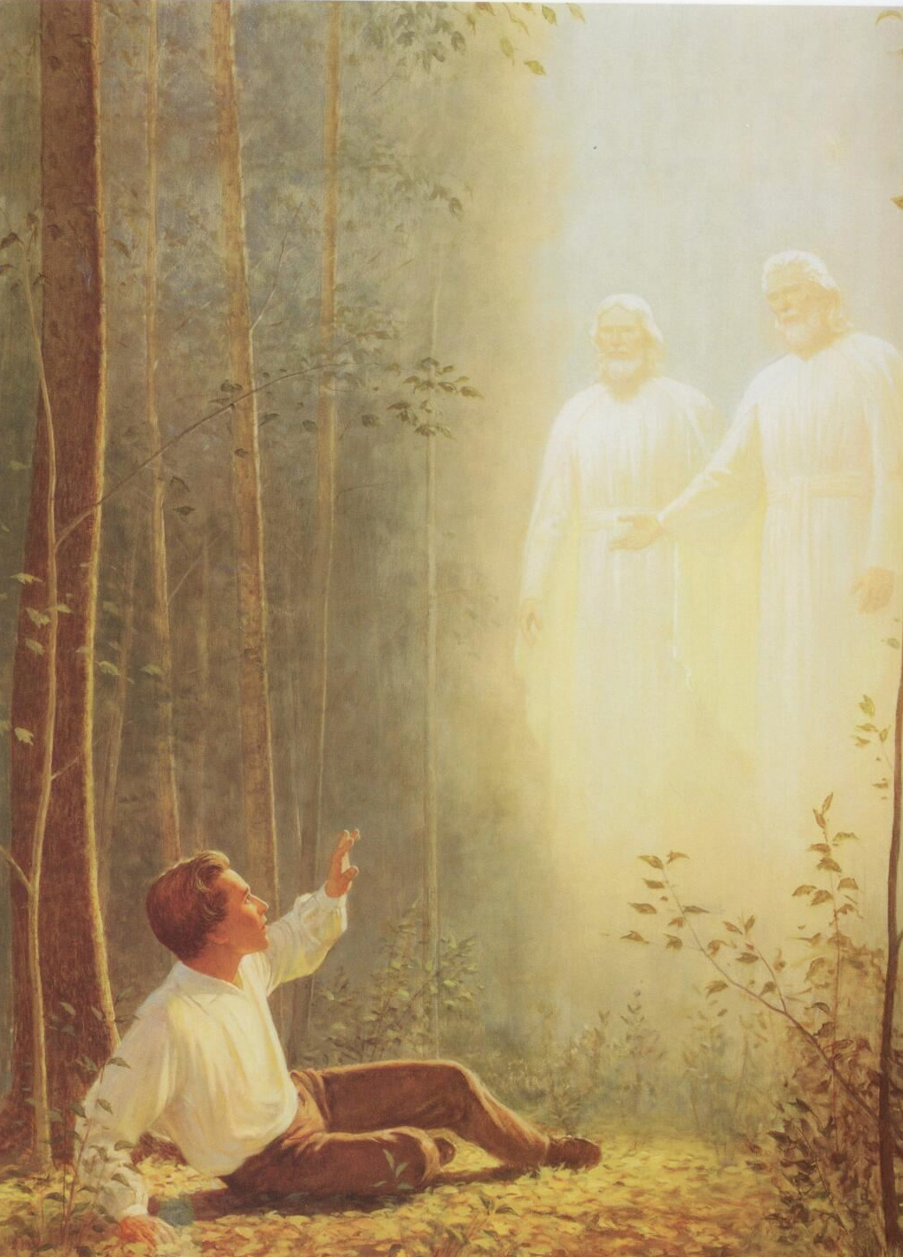
As Joseph knelt in fervent prayer
Upon that sacred ground
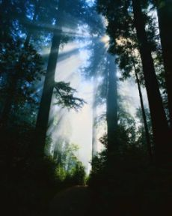
The Father and the Son appeared
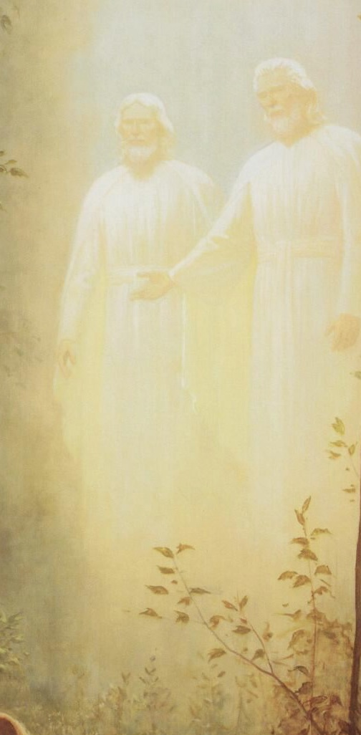
They spoke to him as with one voice
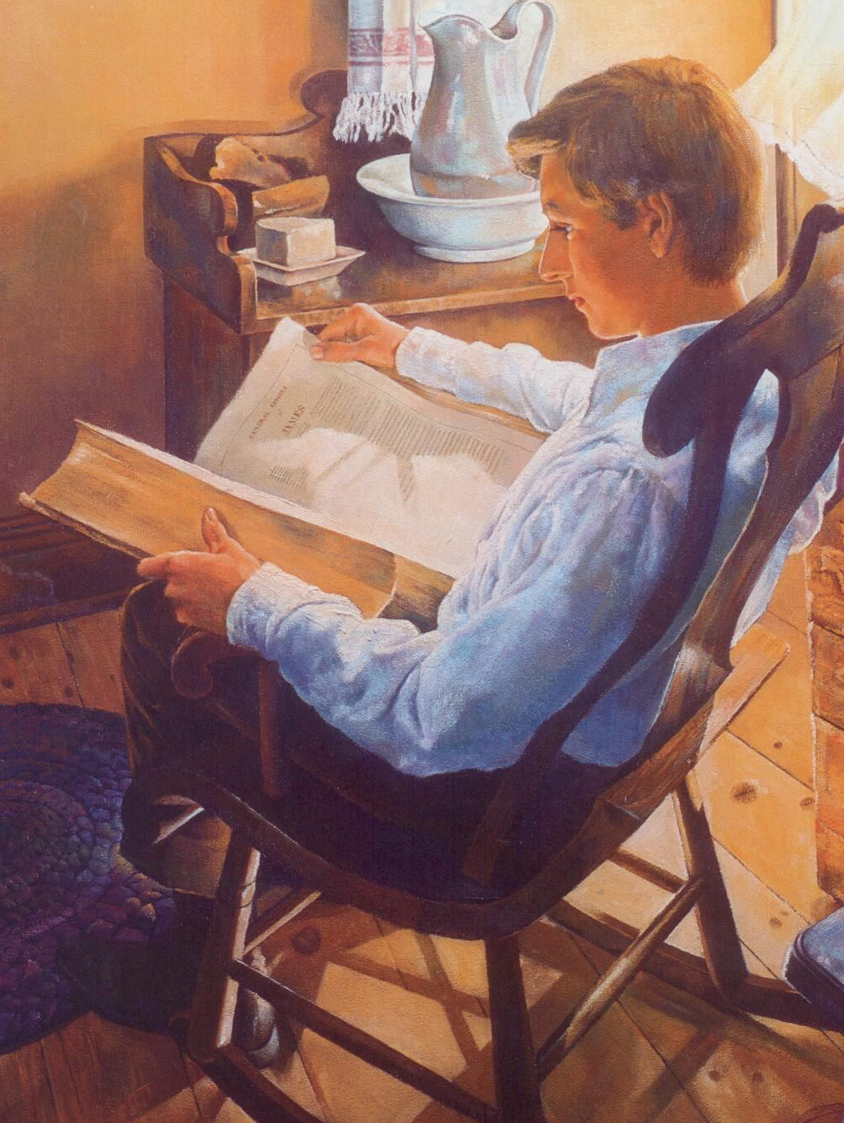
Their message answered all his fears
Their message answered all his fears
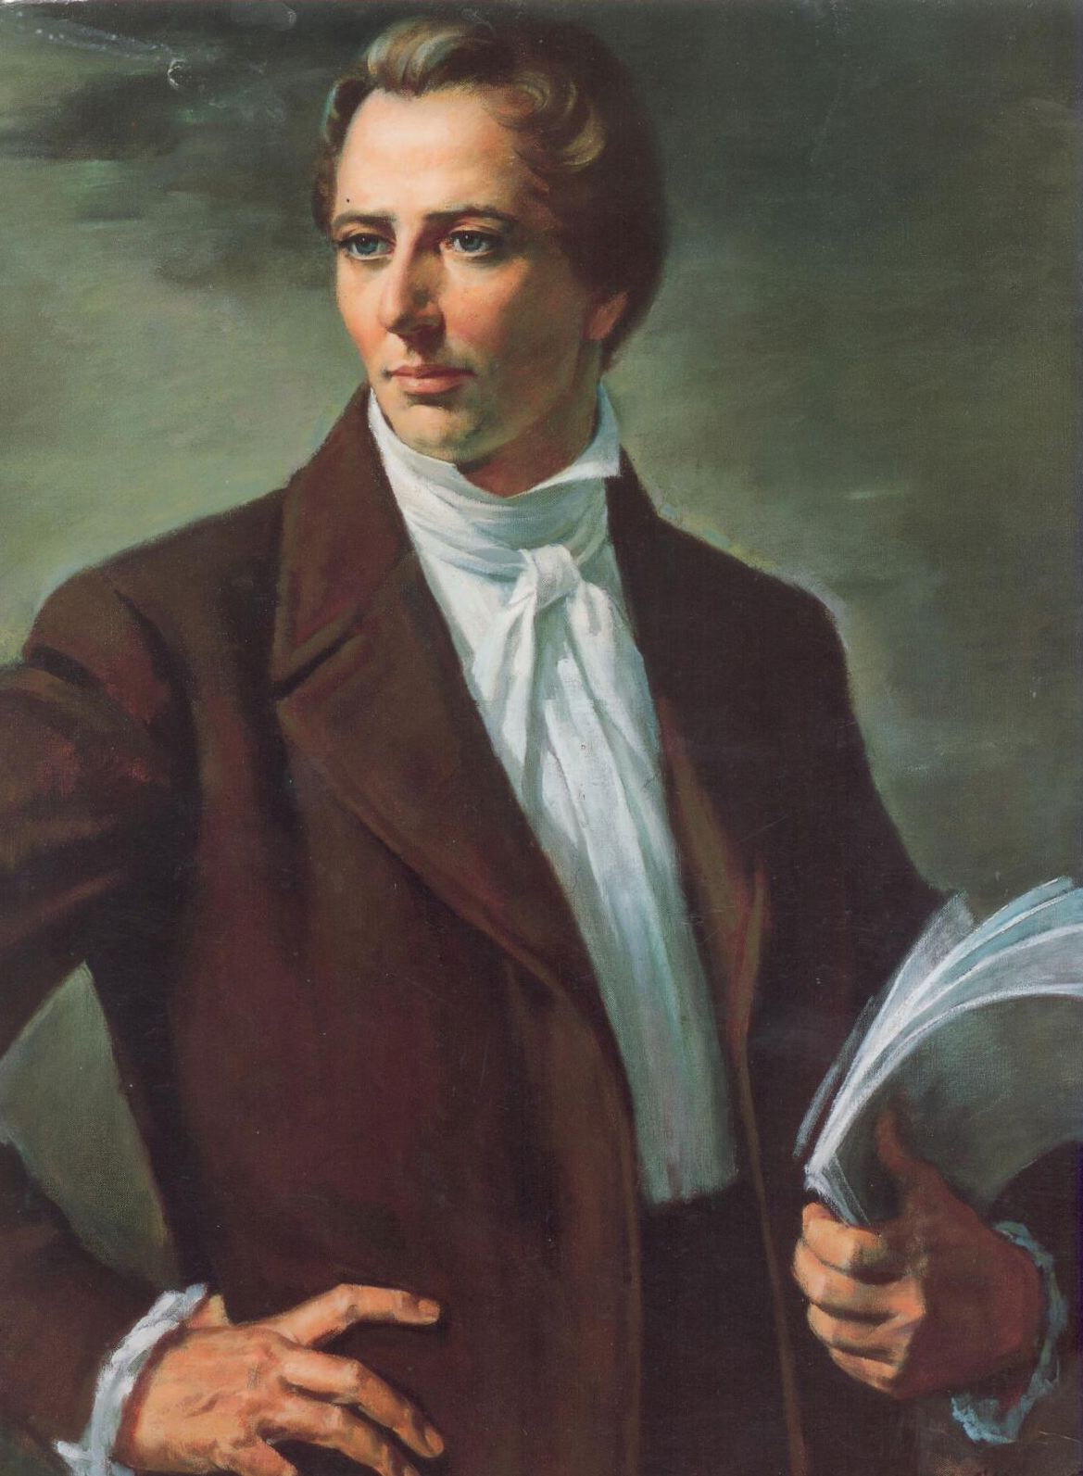
And made his heart rejoice

