Hands are still, heart is full
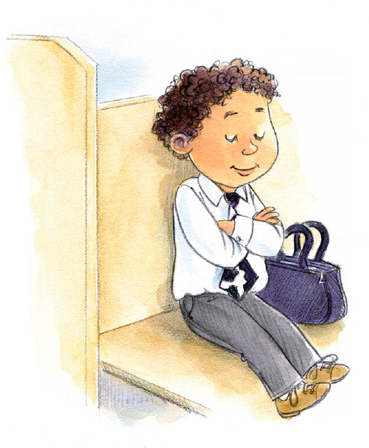
As I think about what I hear
When I take the sacrament
I can feel the Savior near
I prepare long before
Sunday morning comes once again
I am confident and clean
I’ve repented of my sins
In my home, I’ll be kind
And invite the Spirit to stay
Making Sunday a delight
Not like any other day
On this day I’ll choose the right
And remember Jesus Christ
Serve my Savior by the way
That I keep the Sabbath day

