One little shepherd
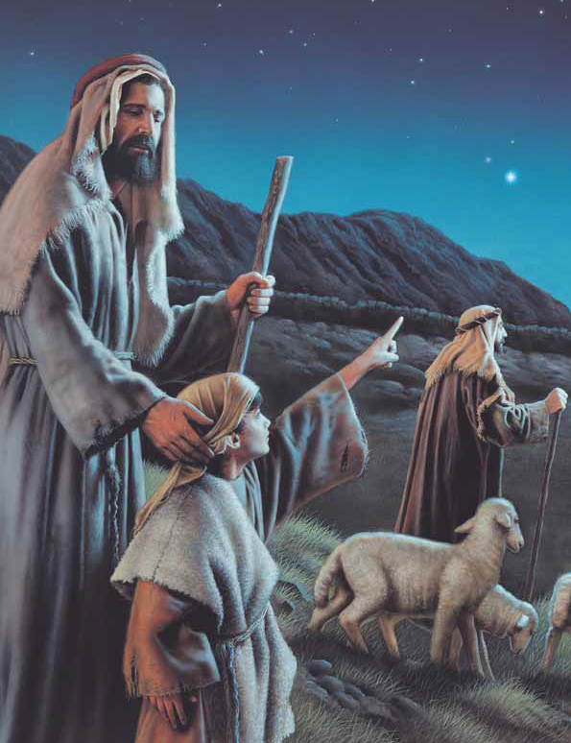
Two baby lambs
Three noble Wise Men
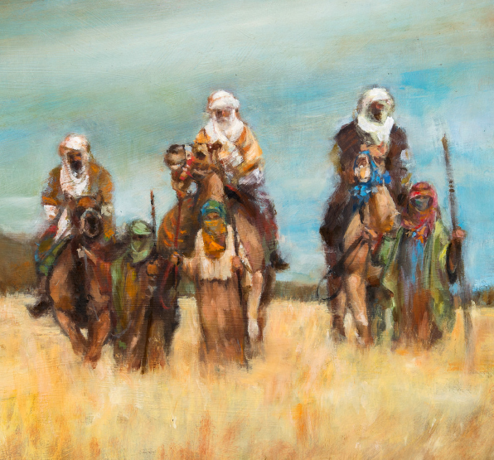
With gifts in their hands
A shining angel watches above
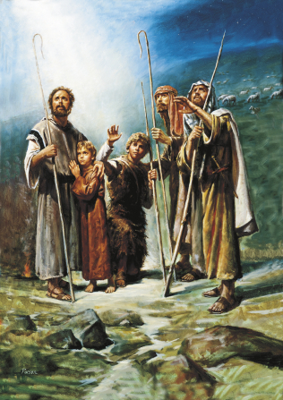
I wish I’d been there
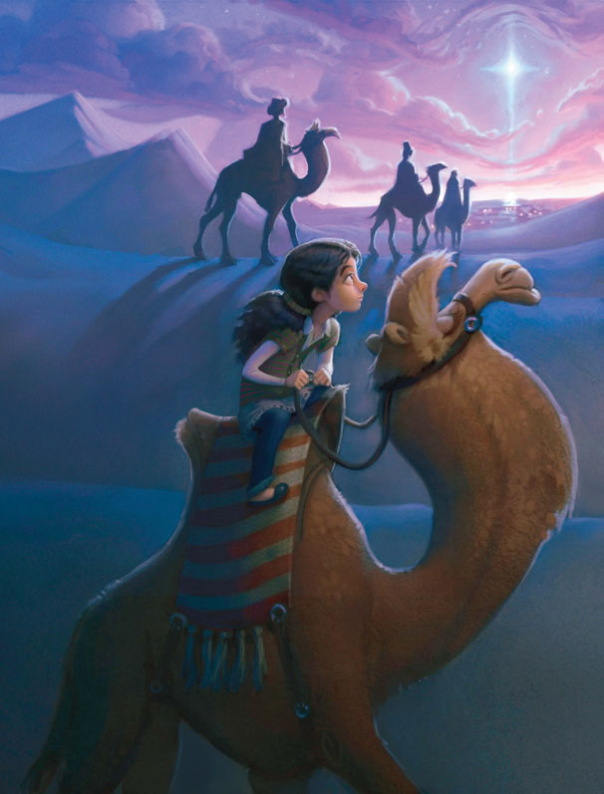
To give Jesus my love
Quick to the stable
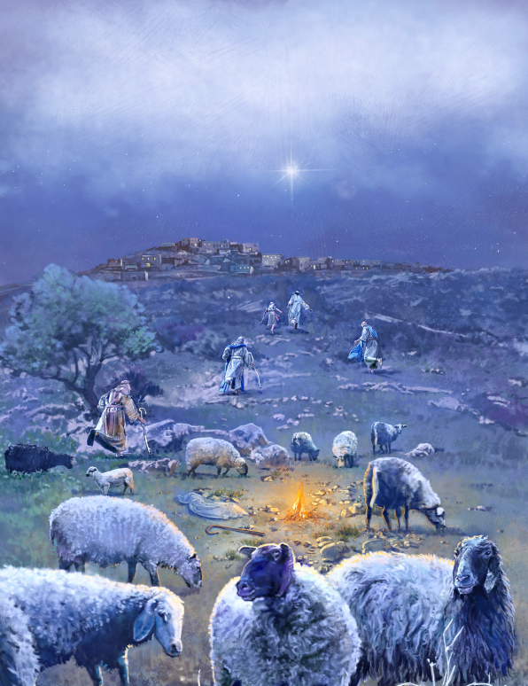
Shepherds make haste
A star through the desert
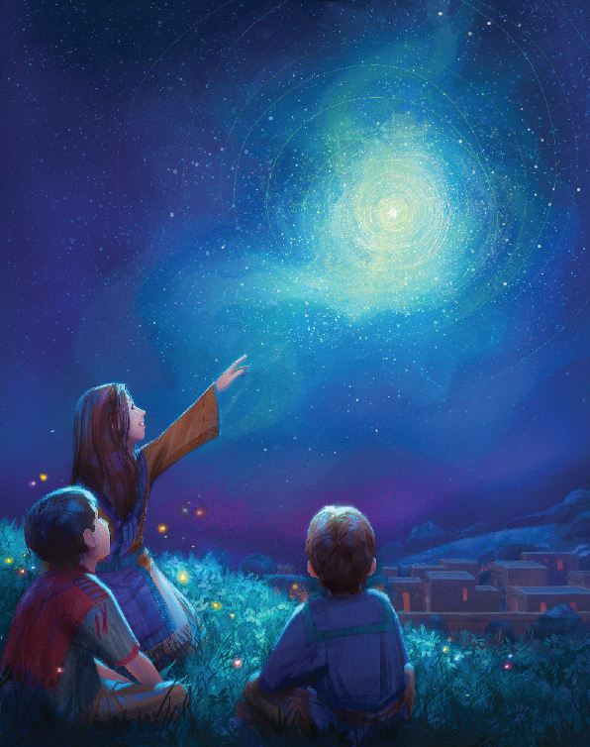
The Wise Men have chased
And down from heav’n
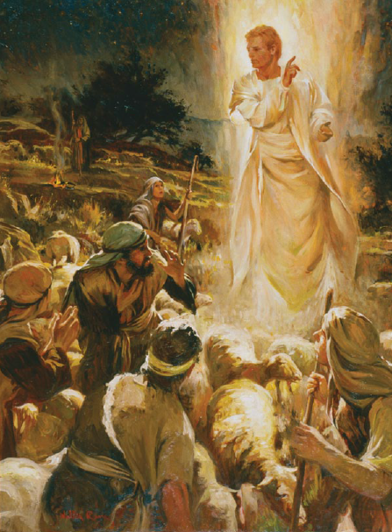
Came angels to call
So I too will seek Him
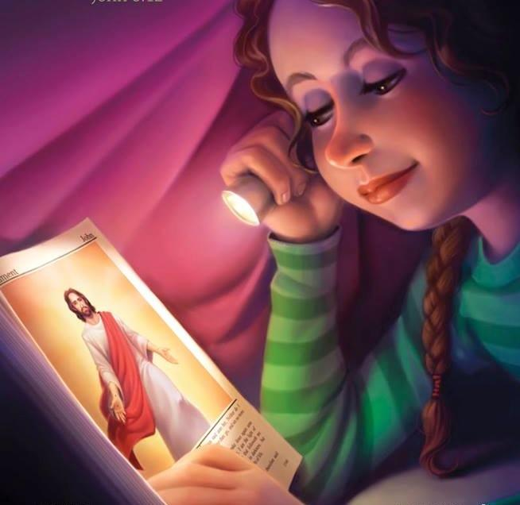
The Savior of all

