The guiding star
The holy star
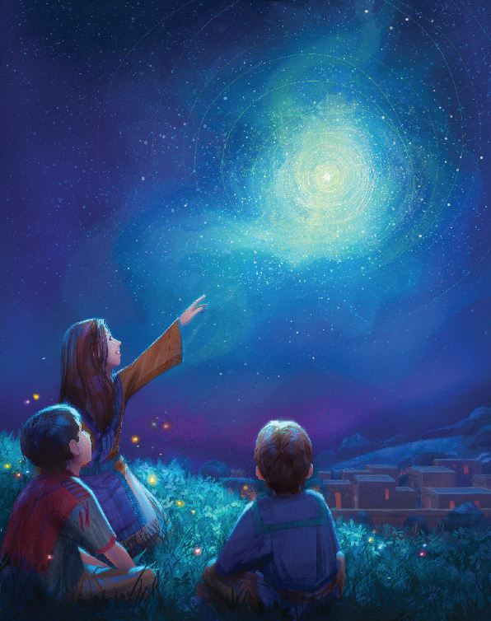
Burst in the sky
The holy night
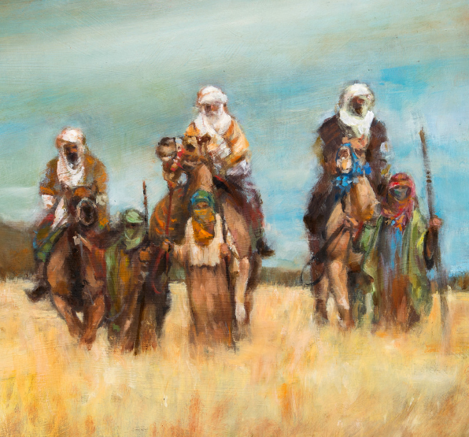
The wise men awaited heaven’s sign
And were amazed at the glorious light
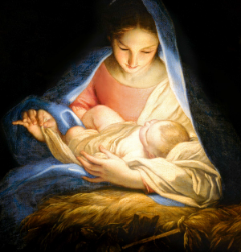
The light will lead you to Jesus
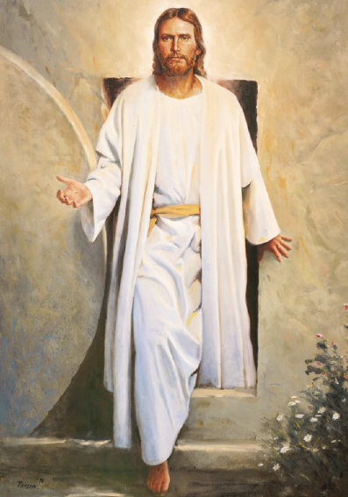
The light will fill your heart
His blessed life was giv’n for us
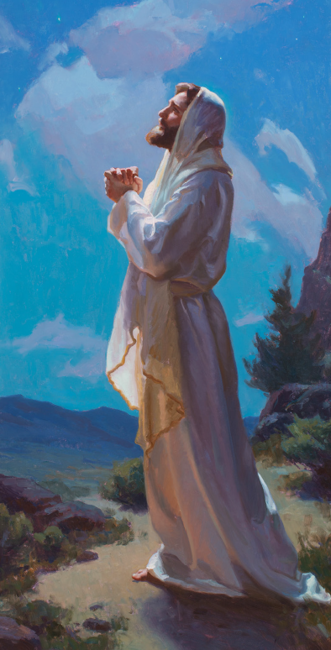
If we but do our part
The guiding star
The Light of Christ
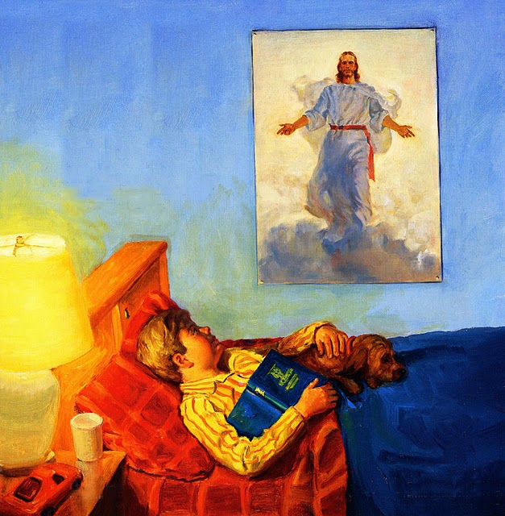
Burst in my heart
I’ll try to live
The way Christ has shown me He would live
And I’m amazed at the glorious light
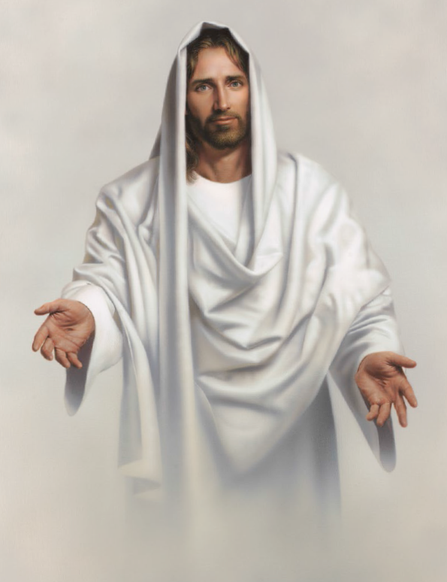
The light will lead you to Jesus
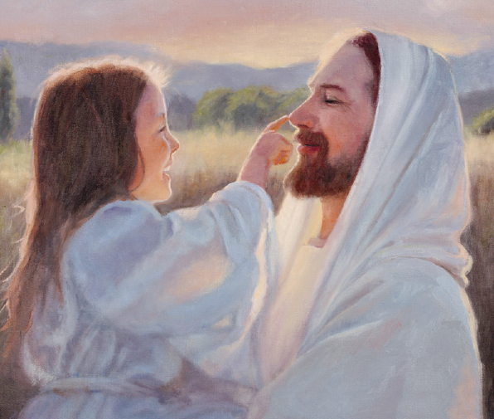
If we but do our part

