To Nephi, seer of olden time
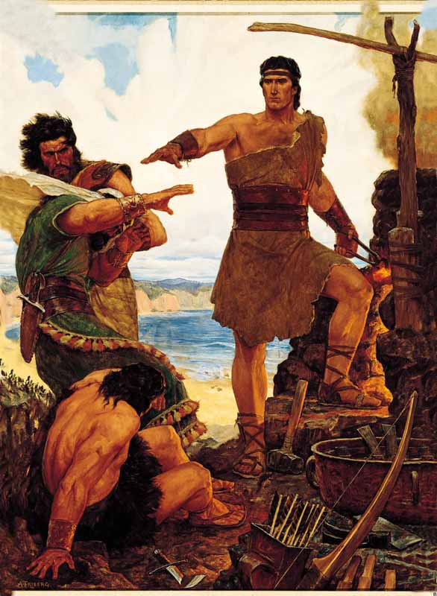
A vision came from God
Wherein the holy word sublime
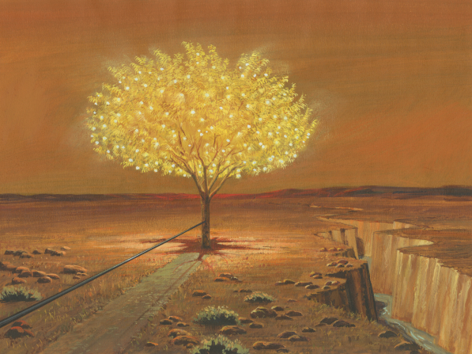
Was shown an iron rod
Hold to the rod, the iron rod
'Tis strong, and bright, and true
The iron rod is the word of God;
'Twill safely guide us through
While on our journey here below
Beneath temptation's pow'r
Through mists of darkness we must go
In peril ev'ry hour
And when temptation's pow'r is nigh
Our pathway clouded o'er
Upon the rod we can rely
And heaven's aid implore
And, hand o'er hand, the rod along
Through each succeeding day
With earnest prayer and hopeful song
We'll still pursue our way
Afar we see the golden rest
To which the rod will guide
Where with the angels bright and blest
Forever we'll abide

