When Christ was on the earth
He promised he would send
The Holy Ghost to comfort us,
Our True eternal friend
The Holy Spirit whispers
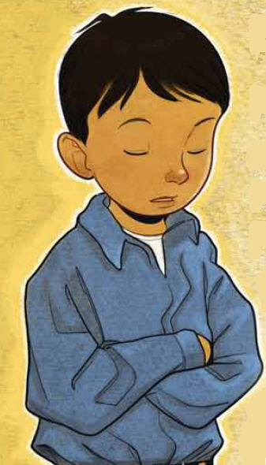
With a still small voice
He testifies of God and Christ
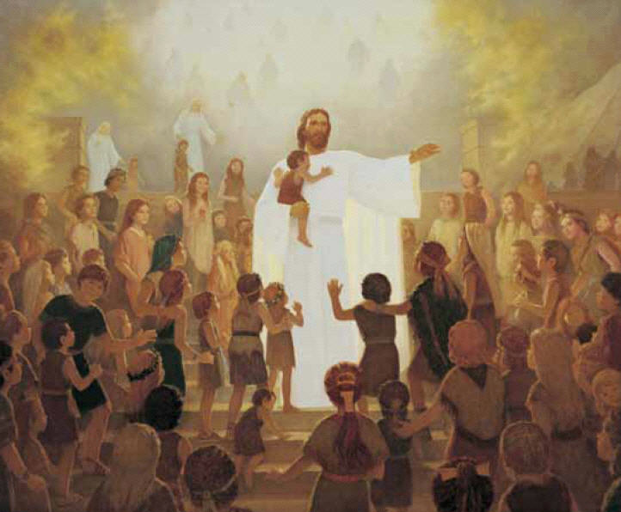
And makes our hearts rejoice
And when we are confirmed
By sacred priesthood pow’r
The Holy Ghost is giv’n to us
To guide us ev’ry hour
Oh, may I always listen
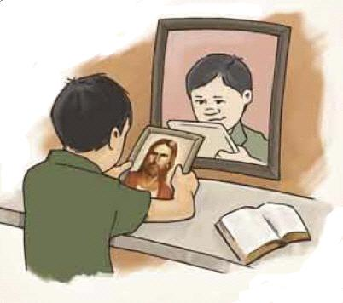
To that still small voice
And with his light,

I’ll do what’s right
Each time I make a choice

