The Gospel is a Great Foundation

By Lina Persson
&
Sheri Rogers
I have a testimony sweet and true
That God the Father lives
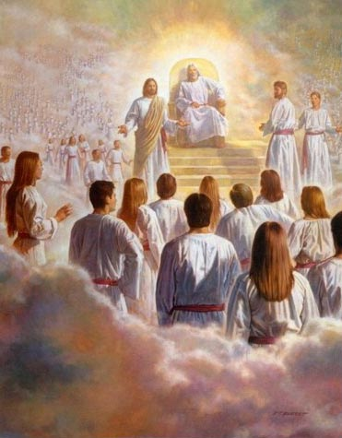
and He loves you
Jesus is the way
the truth and light
Our only way to reach
Our loving Father’s side
The scriptures give me power
Faith in Jesus brings me light
The spirit helps me be careful
and to always know what’s right
Commandments are for my safety
Serving others
always brings me joy
The gospel is a great foundation
It helps me to stay true with love
and brings me salvation
Because I know God lives I want to be
a loving friend to all who are in need
Jesus is the way the truth and light

Our only way to reach
our loving Father’s side
The gospel is a great foundation
It helps me to stay true with love
and brings me salvation

