We’re glad that you were with us
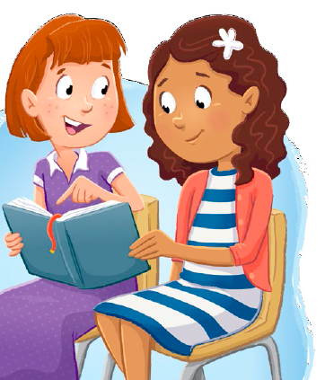
In primary today
We hope you’ll come and visit
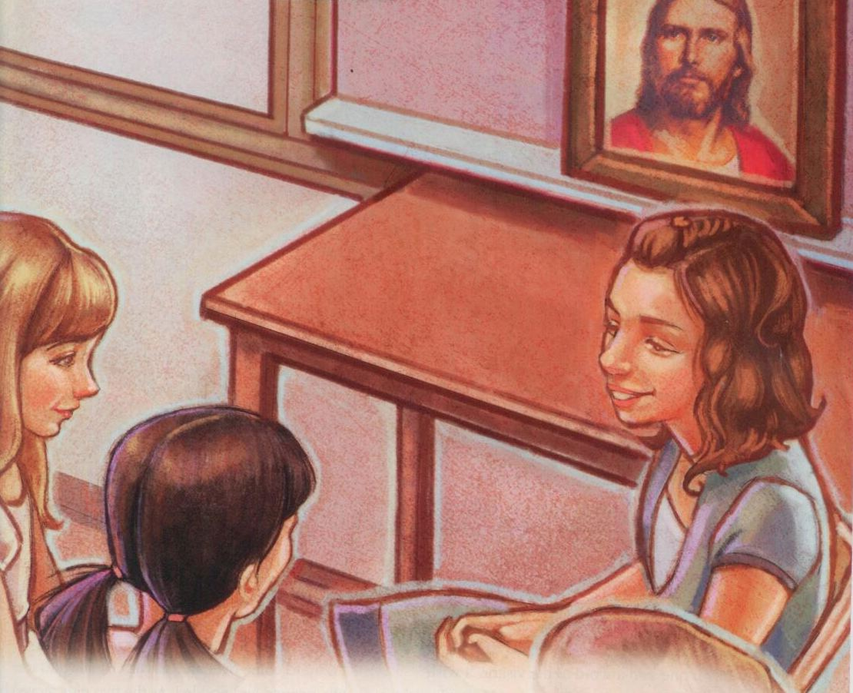
In our class again someday
We’re happy you could join us
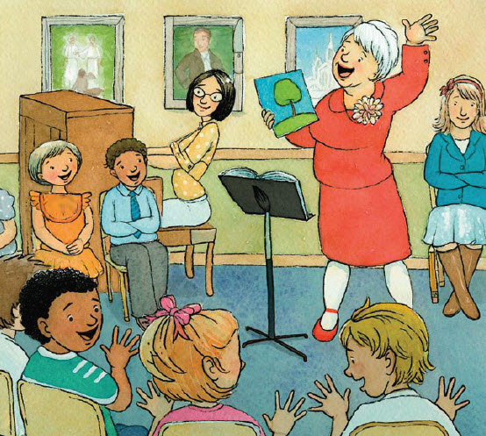
And sing a song or two
We hope that you will cherish
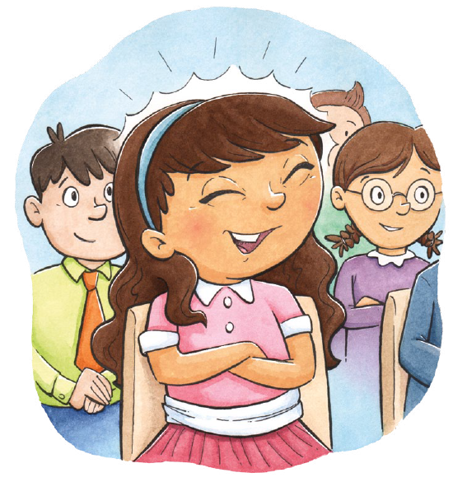
All the time we spent with you
We’re sad to see you leave us
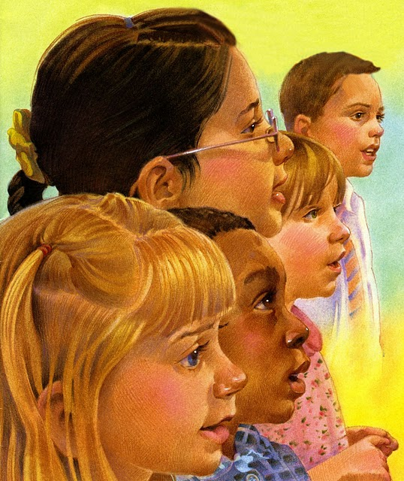
We hope you’ll always know
That you’ll have friends who love you
Ev’rywhere that you may go

