- The first Noel
- 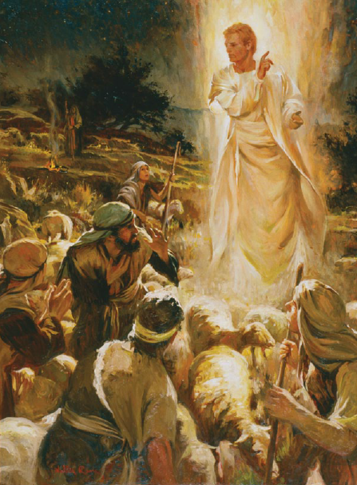
- The angel did say
Was to certain poor shepherds
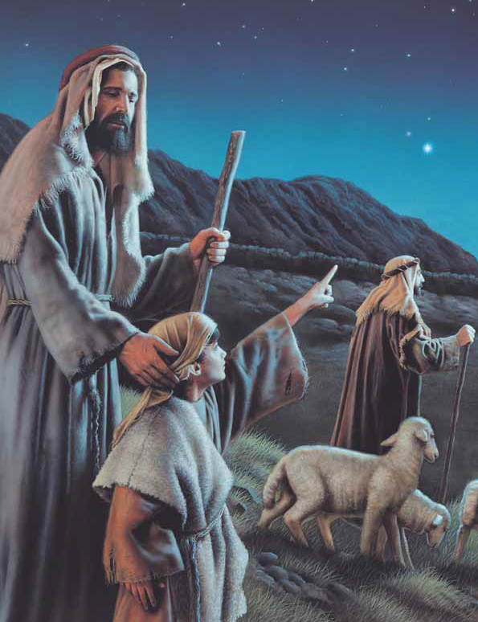
In fields as they lay
In fields where they lay
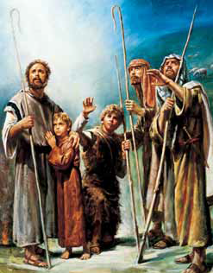
Keeping their sheep
On a cold winter's night
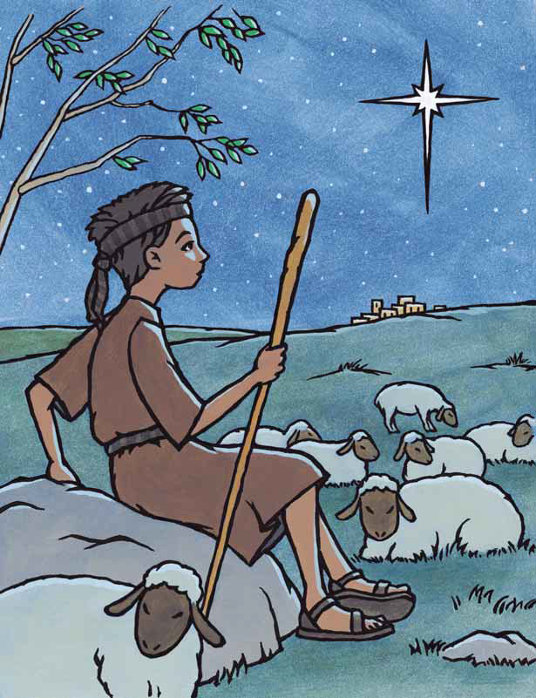
That was so deep
Noel, Noel, Noel, Noel!
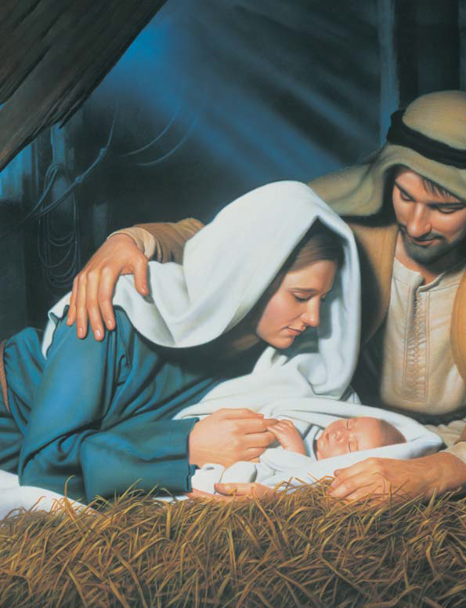
Born is the King of Israel!
That silent night!
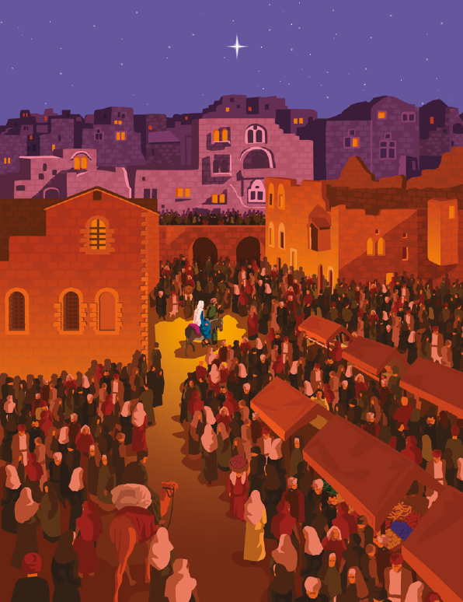
That holy night!
The world was hushed and longing
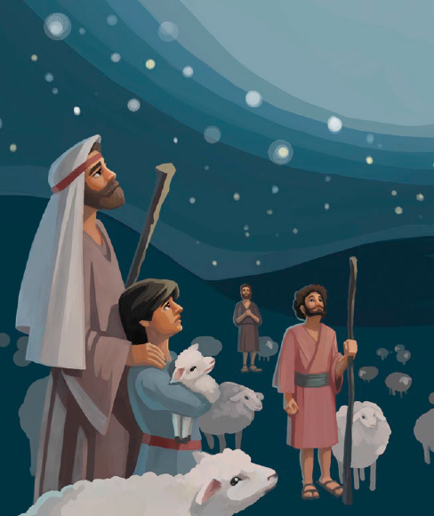
For the gift of God’s eternal light
That child divine, God’s only son
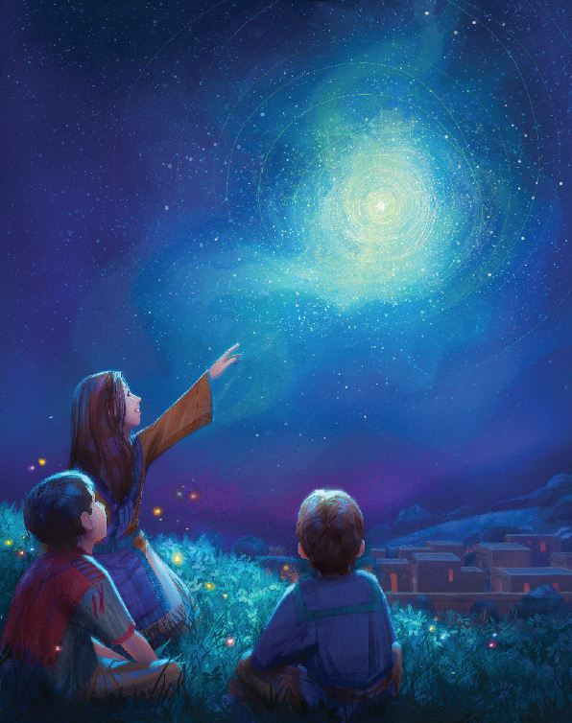
Born this starry night in Bethlehem
Alleluia, Alleluia
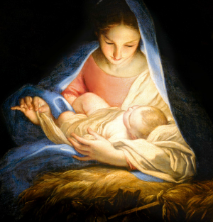
Hearts rejoice in hope and love forever sing
Alleluia, Alleluia
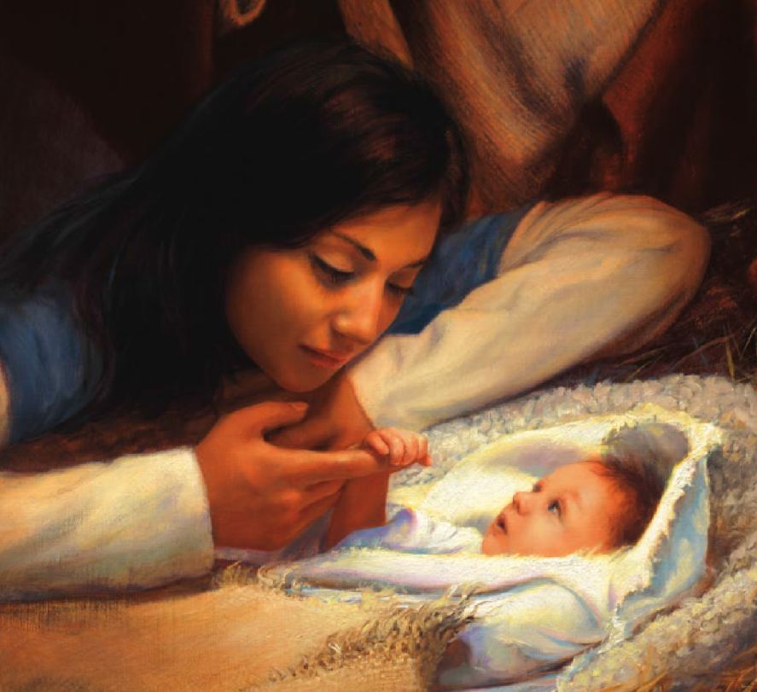
Ever praise and sing for our Eternal King
Alleluia,
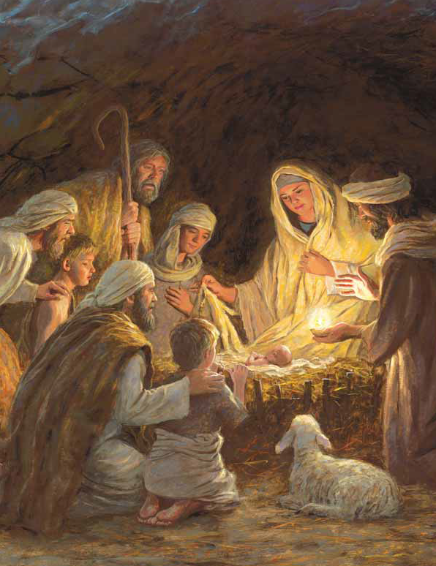
Alle-lu-ia
They looked up
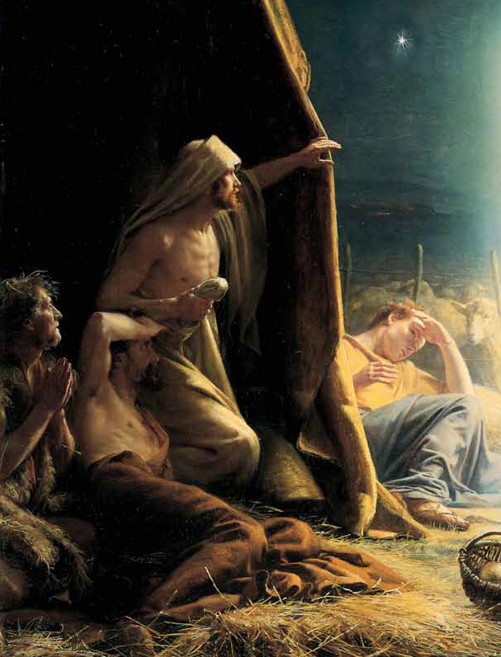
And saw a star
Shining in the East
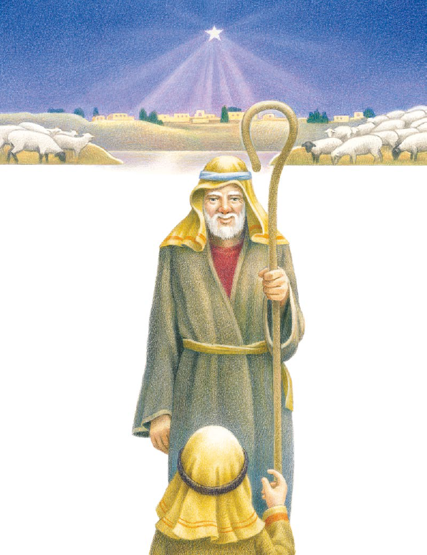
Beyond them far
And to the earth
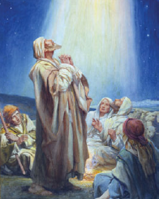
It gave great light
And so it continued
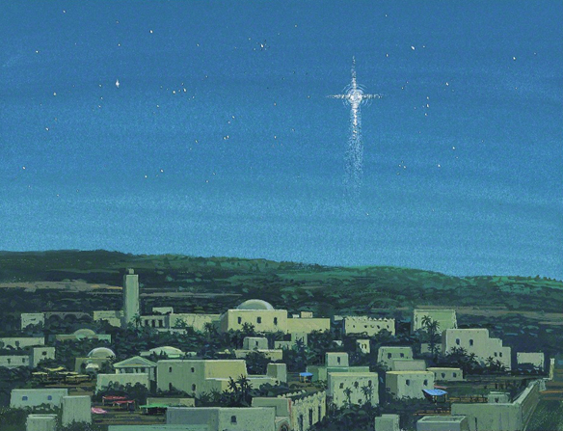
Both day and night

Noel, Noel, Noel, Noel!
Born is the King of Israel!
Alleluia,
Alleluia

