The Creation Song
By
Shawna Edwards

In the first verse of the Bible
We read these wondrous words
In the beginning God created
The heaven and the earth
Every time we look around us
We can see His love displayed
In every single thing He made
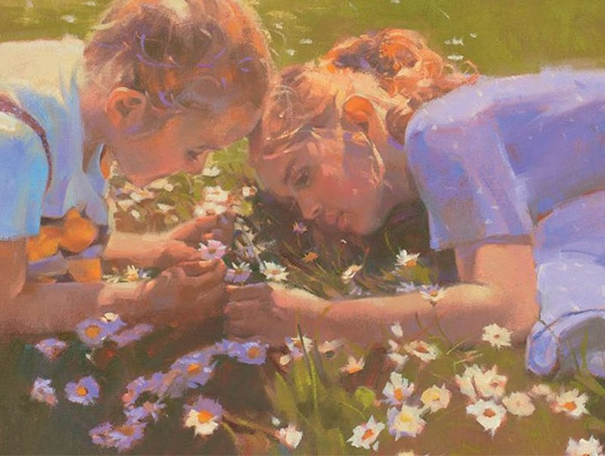
He made the night and the day
The sun and the rain
The mountains and the morning dew
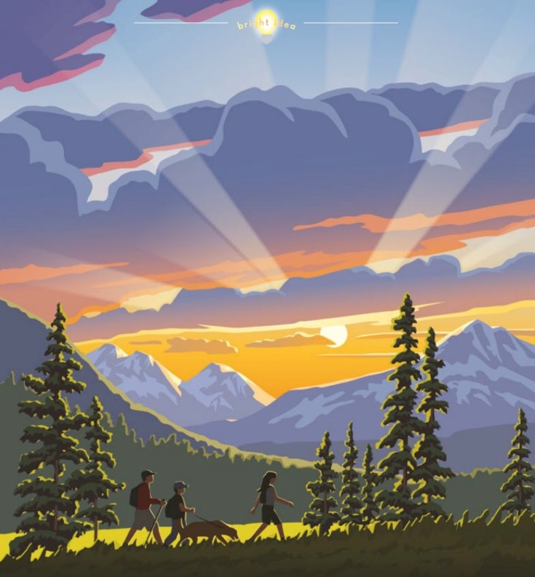
He made the rivers that flow
And the flowers that grow
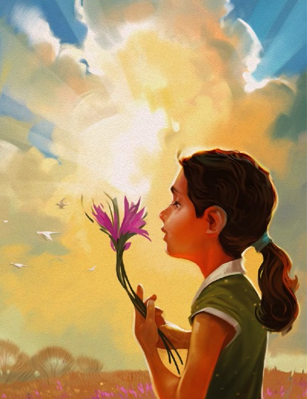
The fireflies and fishes, too
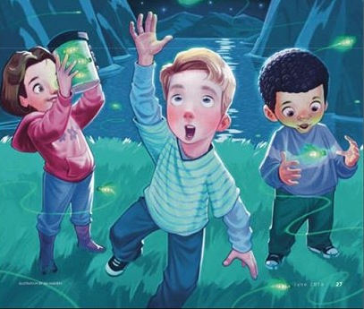
Oh, all the fruit on the trees
Every color you see
The hawks and the hippos
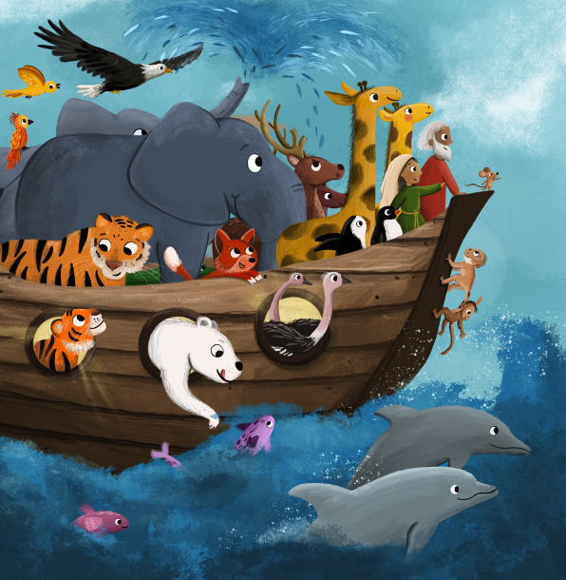
And the honeybees
And last, but not least
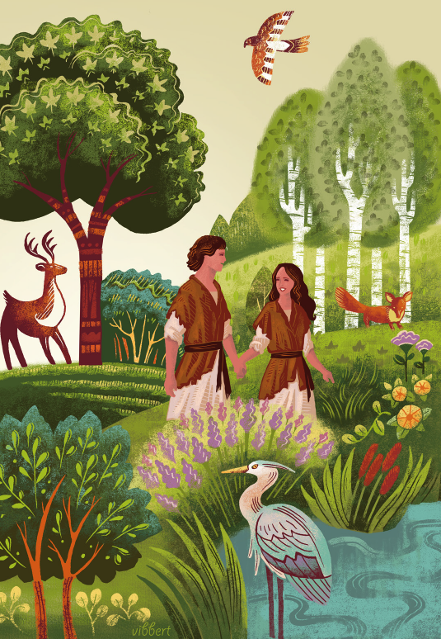
He made Adam and Eve
And then the world was complete!
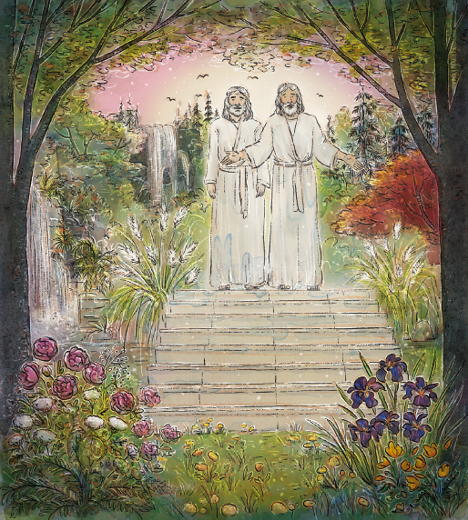
Every seed and stone and season
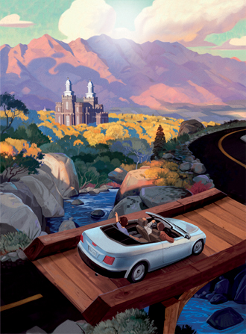
Show more of God’s design
Stunning views and sweeping valleys
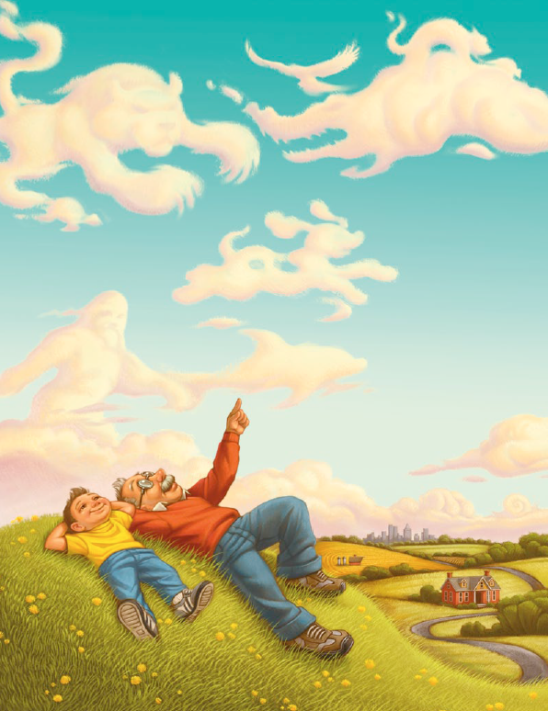
He made with us in mind
We can smell the grass beneath us
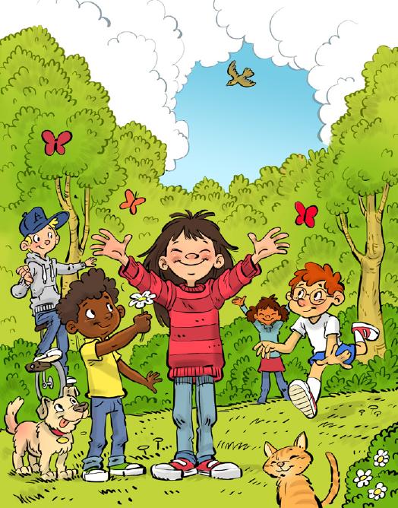
We can hear the birds above
In all these things we feel His Love

