The Covenant

By
Shawna Edwards
&
Linda Urquhart
Music available
At
ShawnaEdwardsMusic.com
A covenant was given a long time ago
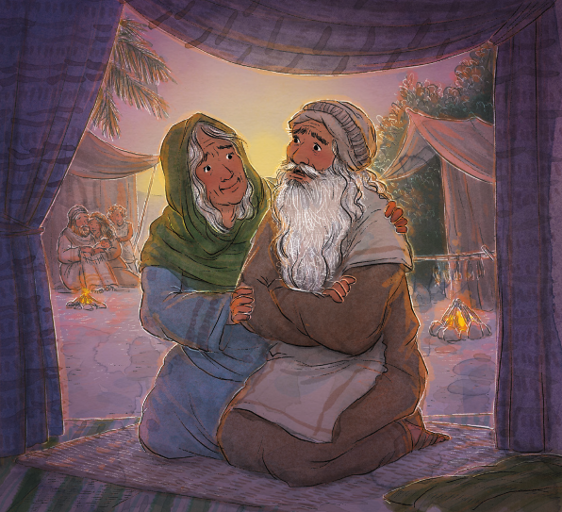
To Abraham, Isaac and Jacob
God promised to bless them
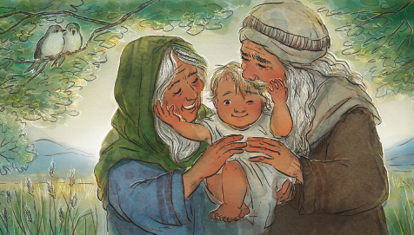
and their families we know
If they would be steadfast
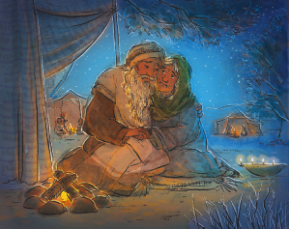
and faithful
As I strive to do God's will every day
Like Jacob of old I can say
"Surely the Lord is in this place"
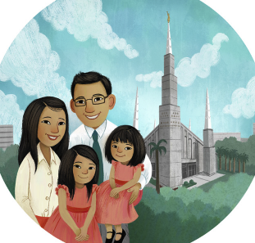
Surely He'll bless me with His grace
And keep me forever safe in His care
Wherever I am He'll be there

A covenant comes from
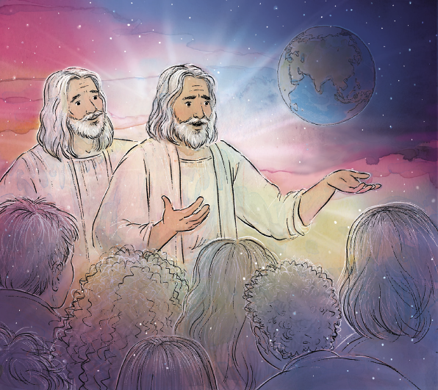
the Lord up above
A promise that goes both directions
It binds us to Him
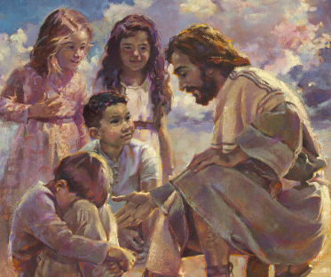
and His unfailing love
And step by step leads us to heaven
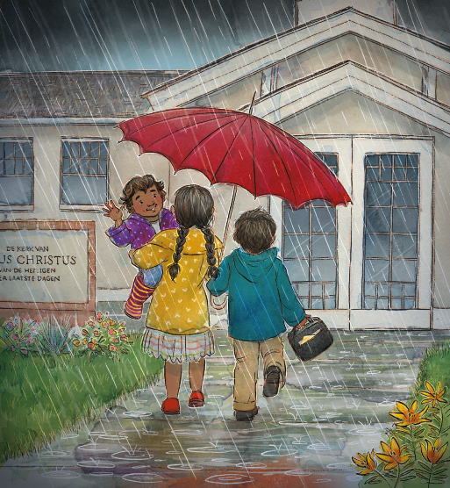
As I strive to do God's will every day
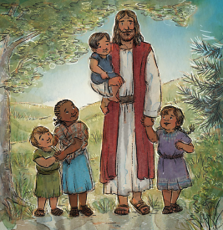

Like Jacob of old, I can say
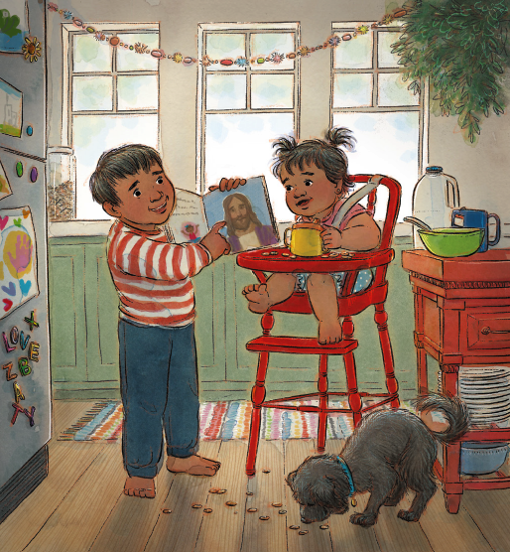
"Surely the Lord is in this place"
Surely He'll bless me with His grace
And keep me
forever safe in His care
Wherever I am, He'll be there
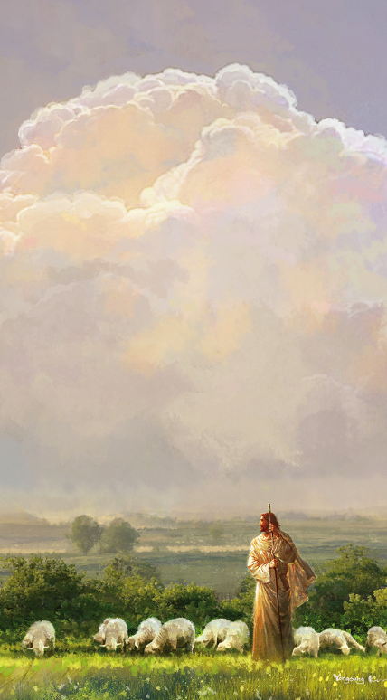
He'll keep me forever safe in His care
Wherever I am He is there
